Family Math Studio Lesson 3.9 · 6.AT.3

Equivalent Ratios
Make and check equivalent ratios by multiplying or dividing both numbers by the same amount.
Name Date

Tonight's spark
Chef Montoya's soup serves 8 people. Her recipe uses 3 cups of tomatoes to 2 cups of broth. Today she must serve 32 people. How many cups of tomatoes does she need? Make a guess first: more than 10 cups of tomatoes, or fewer?
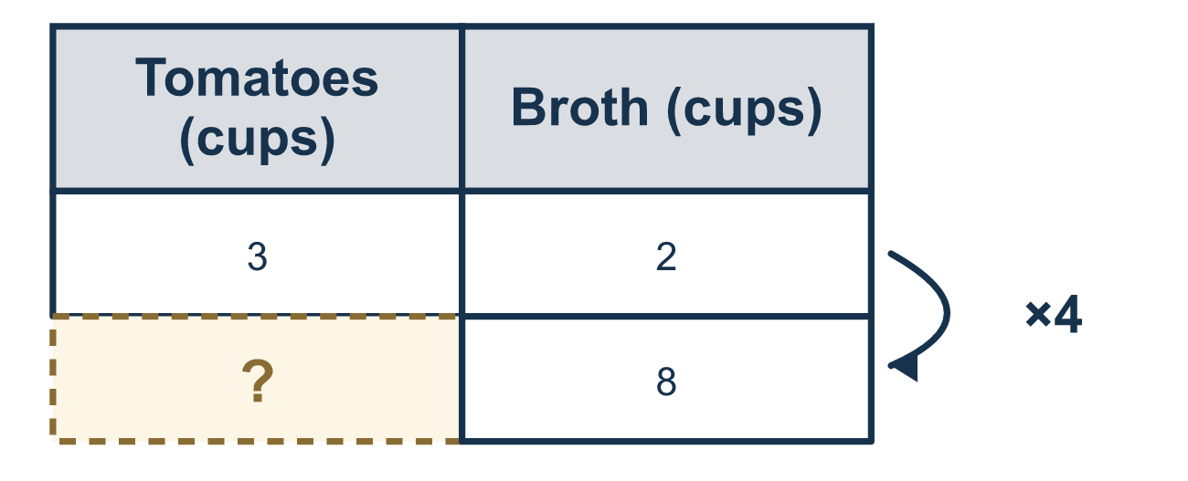
Our class model: the scale factor on a ratio table

Try it
Work it out on paper. Write one answer on each line.
- Which ratio is equivalent to 2:5?
A. 4:7 B. 2:10 C. 4:10 D. 6:10
My answer
- Divide both numbers of 20:30 by 10. What is the ratio?
A. 10:20 B. 2:3 C. 3:2 D. 2:30
My answer
- What is the missing number? 4:5 = 12:?
A. 13 B. 20 C. 15 D. 60
My answer
- Punch uses 2 cups of juice for every 5 cups of soda. Which mix tastes the same?
A. 4 cups juice, 7 cups soda B. 4 cups juice, 10 cups soda C. 2 cups juice, 10 cups soda D. 5 cups juice, 8 cups soda
My answer
- Is 6:15 equivalent to 2:5?
A. No, 6 and 15 are bigger numbers B. No, 2:5 has smaller numbers C. Yes, divide both 6 and 15 by 3 D. Yes, add 4 to both numbers
My answer
- A tape diagram has 3 blue parts and 4 yellow parts, and each part is 5 tiles. What is the ratio of blue tiles to yellow tiles?
A. 8:9 B. 15:20 C. 3:20 D. 15:4
My answer

Talk about it
How do you know 1:4 and your new ratio say the same thing?

Home mission
Pretend to make the soup at the table: 3 spoons of tomato to 2 spoons of broth. Ask your student: what would 4 times as much soup need? What if we only added 2 spoons to each? Does it taste the same?

If we get stuck, ask
- What is the scale factor? Let's divide the big number by the small one.
- Did we do the SAME operation to both numbers?
- Can we simplify to check — do both ratios reduce to the same thing?

Do it on a screen

Scan or type the link. Same lesson, with hints. eduwonderlab.com/lessons/3-9/homework.html
How did it feel? (optional) ☐ Tricky ☐ Getting there ☐ Got it

Family Math Studio · For grown-ups Lesson 3.9 · 6.AT.3

Answers and talk notes
Equivalent Ratios

What your student is learning
Tonight we make and check equivalent ratios — ratios that mean the same thing — using multiplication and division.

Answers
Ask your student to explain before you look.
- C. 4:10. 2 × 2 = 4 and 5 × 2 = 10, so 4:10 is equivalent to 2:5.
- B. 2:3. 20 ÷ 10 = 2 and 30 ÷ 10 = 3, so the ratio is 2:3.
- C. 15. 4 × 3 = 12, so the missing number is 5 × 3 = 15.
- B. 4 cups juice, 10 cups soda. 4 cups juice, 10 cups soda is 2 × 2 and 5 × 2, so it tastes the same.
- C. Yes, divide both 6 and 15 by 3. Yes, divide both 6 and 15 by 3 to get 2:5, so the ratios are equivalent.
- B. 15:20. 3 × 5 = 15 blue tiles and 4 × 5 = 20 yellow tiles, so the ratio is 15:20.

Talk about it
How do you know 1:4 and your new ratio say the same thing?

When they are stuck, ask
- What is the scale factor? Let's divide the big number by the small one.
- Did we do the SAME operation to both numbers?
- Can we simplify to check — do both ratios reduce to the same thing?

Try not to say
- Add the scale factor to both numbers.
- Multiply just one of the numbers.
- When simplifying, divide each number by a different number.

Home mission
Pretend to make the soup at the table: 3 spoons of tomato to 2 spoons of broth. Ask your student: what would 4 times as much soup need? What if we only added 2 spoons to each? Does it taste the same?

