Family Math Studio Lesson 4.1 · Session 2 · 6.AT.4

Understand Percent
Understand that a percent greater than 100% means more than one whole.
Name Date

Tonight's spark
A cornstalk in the school garden counts as 100% of its own height. The sunflower next to it is 1.5 times as tall. What percent of the cornstalk's height is the sunflower? Make a guess first: is it more than 100%, or less?
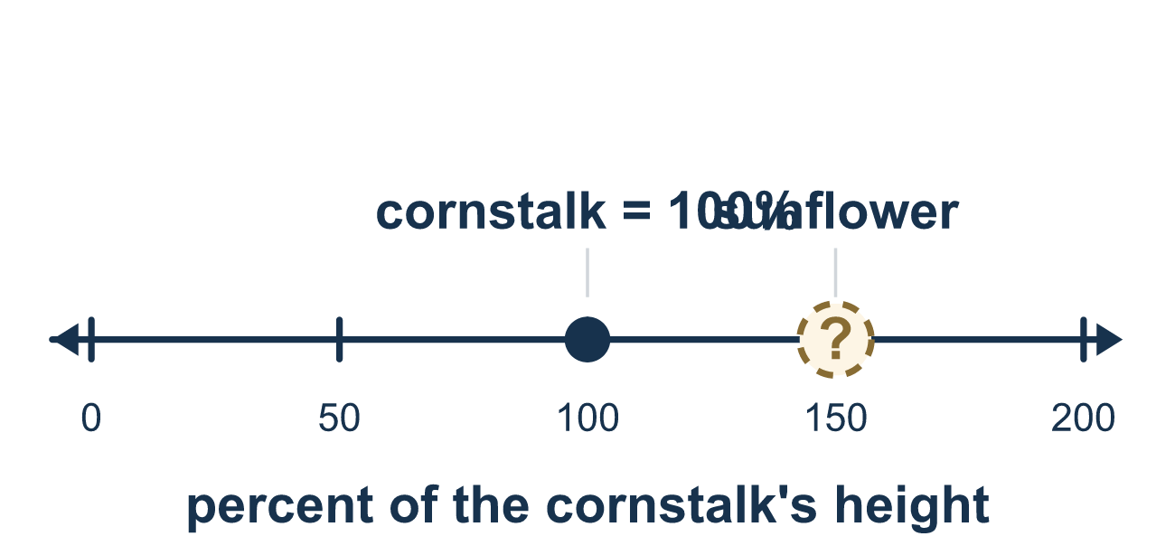
Our class model: one whole is 100%

Try it
Work it out on paper. Write one answer on each line.
- Write 1.5 as a percent.
A. 15% B. 150% C. 1.5% D. 105%
My answer
- Which percent is MORE than one whole?
A. 99% B. 100% C. 125% D. 75%
My answer
- What percent is two whole amounts?
A. 20% B. 102% C. 200% D. 2%
My answer
- A reading goal is 10 pages. Sam reads 25 pages. What percent of the goal did Sam read?
A. 25% B. 250% C. 15% D. 2.5%
My answer
- 300% of an amount is how many wholes?
A. 3 B. 30 C. 0.3 D. 300
My answer
- What is 200% of 15?
A. 7.5 B. 30 C. 200 D. 15
My answer

Talk about it
Which amount is the goal (100%)? Is the new amount more or less than that whole?

Home mission
Hold up one glass of water and call it 100%. Ask your student: if I pour 1 and a half glasses, what percent is that? What about 2 glasses? 2 and a half?

If we get stuck, ask
- What is the whole here? What counts as 100%?
- Is the amount more than one whole or less?
- How many full bars would you draw, and how much of another?

Do it on a screen

Scan or type the link. Same lesson, with hints. eduwonderlab.com/lessons/4-1-part2/homework.html
How did it feel? (optional) ☐ Tricky ☐ Getting there ☐ Got it

Family Math Studio · For grown-ups Lesson 4.1 · Session 2 · 6.AT.4

Answers and talk notes
Understand Percent

What your student is learning
Tonight we work with percents greater than 100% — what "150% of the goal" or "2.5 times as much" really means.

Answers
Ask your student to explain before you look.
- B. 150%. 1.5 is 150 hundredths, so it is 150%. One whole is 100% and a half is 50%.
- C. 125%. One whole is 100%. Only 125% is bigger than 100%.
- C. 200%. Each whole is 100%, so two wholes are 100% + 100% = 200%.
- B. 250%. 25 is 2.5 times 10, and 2.5 times 100% is 250%. Sam read two wholes and a half.
- A. 3. Each 100% is one whole, so 300% is 3 wholes.
- B. 30. 200% is two wholes, so 2 × 15 = 30.

Talk about it
Which amount is the goal (100%)? Is the new amount more or less than that whole?

When they are stuck, ask
- What is the whole here? What counts as 100%?
- Is the amount more than one whole or less?
- How many full bars would you draw, and how much of another?

Try not to say
- A percent can never be more than 100.
- 150% of the goal means 150 points.
- 7 out of 10 is 7%.

Home mission
Hold up one glass of water and call it 100%. Ask your student: if I pour 1 and a half glasses, what percent is that? What about 2 glasses? 2 and a half?

