Family Math Studio Lesson 4.1 · 6.AT.4

Understand Percent
Explain a percent as a rate per 100 and show it on a grid or tape diagram.
Name Date

Tonight's spark
Students voted for a school mascot. 4 out of every 10 voters chose the tiger. The poster needs a percent. What percent of the voters chose the tiger? Make a guess first: is the percent closer to 4% or to 40%?
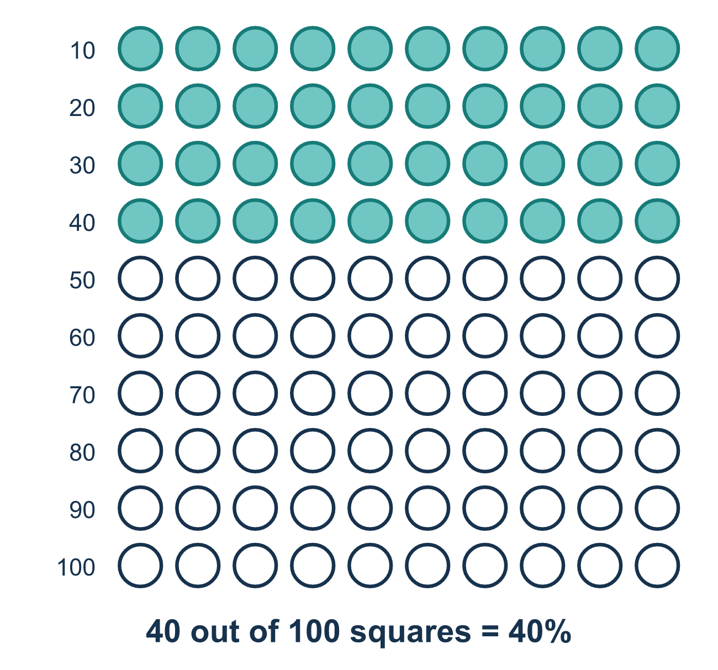
Our class model: the 100-grid

Try it
Work it out on paper. Write one answer on each line.
- Percent means 'per hundred'. 30% means 30 out of what number?
A. 10 B. 100 C. 30 D. 1,000
My answer
- On a 100-grid, 45 squares are shaded. What percent is shaded?
A. 45% B. 55% C. 4.5% D. 100%
My answer
- Write 7 out of 10 as a percent.
A. 7% B. 17% C. 0.7% D. 70%
My answer
- Write 1 out of 20 as a percent.
A. 20% B. 1% C. 5%
My answer
- Which fraction with 100 on the bottom equals 2 out of 5?
A. 25/100 B. 40/100 C. 20/100 D. 52/100
My answer
- 12 out of 20 students bring lunch from home. What percent bring lunch?
A. 60% B. 12% C. 20% D. 32%
My answer

Talk about it
Percent means out of how many?

Home mission
Line up 10 spoons. Say, "4 out of 10 voted for the tiger." Ask your student: if there were 100 spoons, how many would be for the tiger? What percent is that?

If we get stuck, ask
- How many would that be out of 100?
- What do you multiply the bottom number by to reach 100?
- Did you multiply BOTH numbers by that?

Do it on a screen

Scan or type the link. Same lesson, with hints. eduwonderlab.com/lessons/4-1/homework.html
How did it feel? (optional) ☐ Tricky ☐ Getting there ☐ Got it

Family Math Studio · For grown-ups Lesson 4.1 · 6.AT.4

Answers and talk notes
Understand Percent

What your student is learning
Tonight we learn what a percent really means: a comparison to 100. Percent means "per hundred."

Answers
Ask your student to explain before you look.
- B. 100. 30% means 30 out of 100.
- A. 45%. 45 out of 100 squares is 45%.
- D. 70%. Multiply both numbers by 10: 7 out of 10 is 70 out of 100, so it is 70%.
- C. 5%. Multiply both numbers by 5: 1 out of 20 is 5 out of 100, so it is 5%.
- B. 40/100. Multiply both numbers by 20: 2 × 20 = 40 and 5 × 20 = 100, so 40/100.
- A. 60%. Multiply both numbers by 5: 12 out of 20 is 60 out of 100, so 60%.

Talk about it
Percent means out of how many?

When they are stuck, ask
- How many would that be out of 100?
- What do you multiply the bottom number by to reach 100?
- Did you multiply BOTH numbers by that?

Try not to say
- Just move the decimal point and don't worry why.
- A percent can never be more than 100.
- Add the two numbers of the ratio.

Home mission
Line up 10 spoons. Say, "4 out of 10 voted for the tiger." Ask your student: if there were 100 spoons, how many would be for the tiger? What percent is that?

