Family Math Studio Lesson 4.2 · Session 2 · 6.AT.4

Relate Fractions, Decimals, and Percentages
Put fractions, decimals, and percents in order by writing them all in one form.
Name Date

Tonight's spark
Three players tell how they did on free throws. Dee made 0.68 of her shots. Eli made 71%. Fay made 3/4. Who shot best? Make a guess first: which of the three numbers looks greatest?
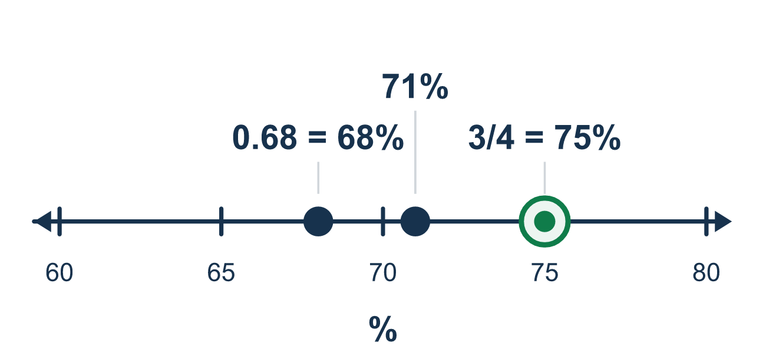
Our class model: one common form

Try it
Work it out on paper. Write one answer on each line.
- Before ordering 0.5, 1/4, and 30%, what should you do first?
A. Order them by how they look B. Rewrite them all in one form, like percent C. Add them together D. Pick the one with the most digits
My answer
- Write 0.5 as a percent.
A. 5% B. 0.5% C. 15% D. 50%
My answer
- Write 4/5 as a percent.
A. 80% B. 45% C. 4.5% D. 20%
My answer
- Which is greater: 0.4 or 35%?
A. 35%, because 35 is greater than 4 B. They are equal C. 0.4, because 0.4 is 40% and 40% is greater than 35%
My answer
- Order 25%, 0.2, and 1/2 from least to greatest.
A. 25%, 0.2, 1/2 B. 0.2, 25%, 1/2 C. 1/2, 25%, 0.2 D. 0.2, 1/2, 25%
My answer
- Order 0.7, 3/5, and 65% from least to greatest.
A. 0.7, 3/5, 65% B. 65%, 3/5, 0.7 C. 3/5, 0.7, 65% D. 3/5, 65%, 0.7
My answer

Talk about it
What common form did you pick, and what order did you get?

Home mission
Pretend three players have these records: 0.8, 7/10, and 75%. Ask your student which form to use for all three. Who has the best record?

If we get stuck, ask
- Which one form will you write all of them in?
- What does this fraction become out of 100?
- Are they all in the same form yet? Then compare.

Do it on a screen

Scan or type the link. Same lesson, with hints. eduwonderlab.com/lessons/4-2-part2/homework.html
How did it feel? (optional) ☐ Tricky ☐ Getting there ☐ Got it

Family Math Studio · For grown-ups Lesson 4.2 · Session 2 · 6.AT.4

Answers and talk notes
Relate Fractions, Decimals, and Percentages

What your student is learning
Tonight we put fractions, decimals, and percents in order — by first rewriting them all in ONE form.

Answers
Ask your student to explain before you look.
- B. Rewrite them all in one form, like percent. Rewrite them all in one form, like percent. Then you can compare them directly.
- D. 50%. 0.5 is 50 hundredths, so it is 50%.
- A. 80%. 4/5 = 80/100 (multiply both by 20), so it is 80%.
- C. 0.4, because 0.4 is 40% and 40% is greater than 35%. 0.4, because 0.4 is 40% and 40% is greater than 35%.
- B. 0.2, 25%, 1/2. As percents: 0.2 = 20%, 25%, and 1/2 = 50%. From least to greatest: 0.2, 25%, 1/2.
- D. 3/5, 65%, 0.7. As percents: 0.7 = 70%, 3/5 = 60%, and 65%. From least to greatest: 3/5, 65%, 0.7.

Talk about it
What common form did you pick, and what order did you get?

When they are stuck, ask
- Which one form will you write all of them in?
- What does this fraction become out of 100?
- Are they all in the same form yet? Then compare.

Try not to say
- 3/5 is 35%, just read the digits.
- Compare them as they are, you can tell by looking.
- A fraction is always smaller than a decimal.

Home mission
Pretend three players have these records: 0.8, 7/10, and 75%. Ask your student which form to use for all three. Who has the best record?

