Family Math Studio Lesson 4.2 · 6.AT.4

Relate Fractions, Decimals, and Percentages
Write the same amount as a fraction, a decimal, and a percent.
Name Date

Tonight's spark
A player scored 3/4 of her team's points. The scoreboard only shows percents. What percent should it show? Make a guess first: is 3/4 more than half of the points, or less?
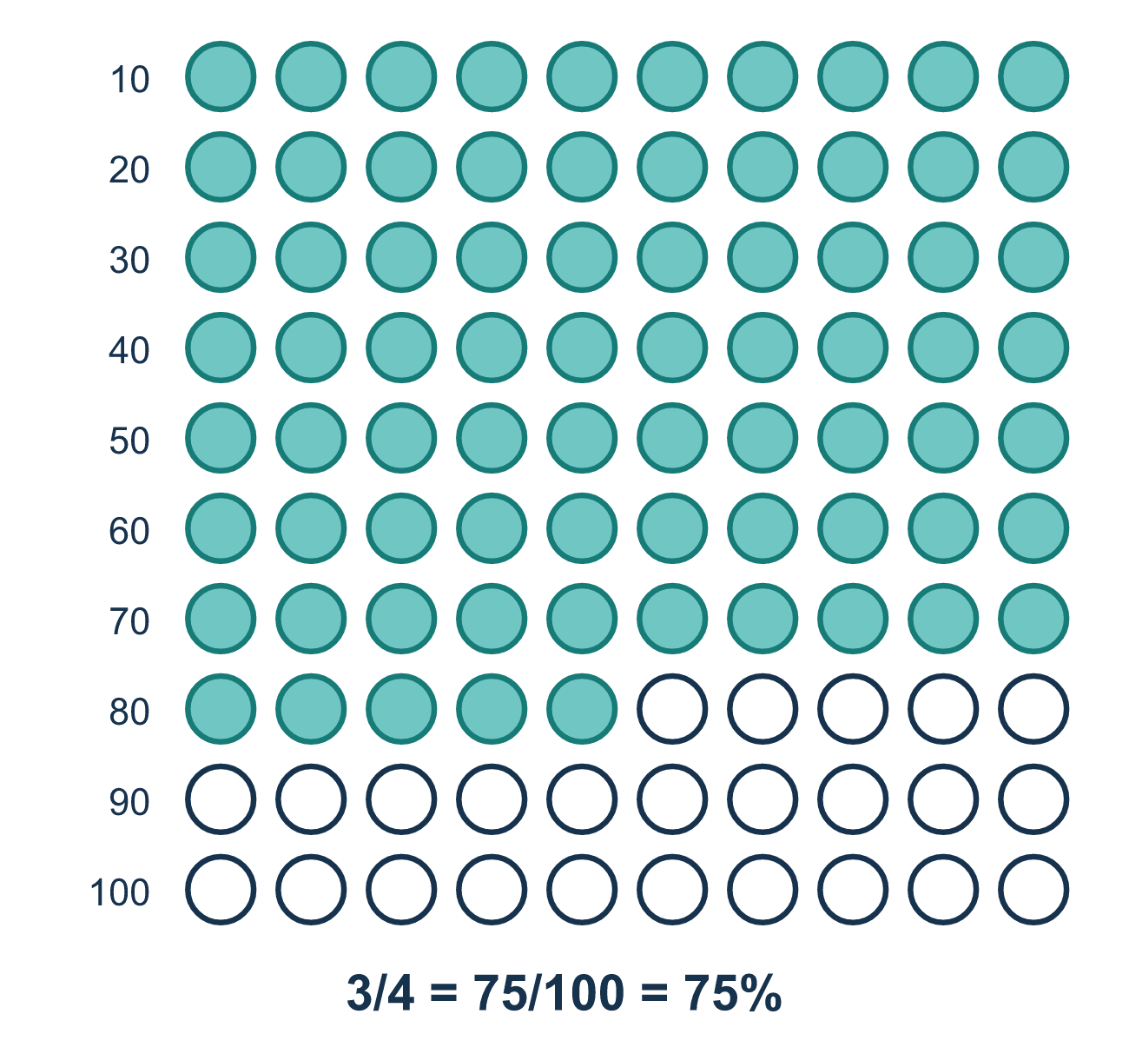
Our class model: the fraction with 100 on the bottom

Try it
Work it out on paper. Write one answer on each line.
- Which decimal equals 1/2?
A. 1.2 B. 0.2 C. 0.5 D. 2.0
My answer
- Write 0.75 as a percent.
A. 75% B. 0.75% C. 7.5% D. 750%
My answer
- Write 3/5 as a percent.
A. 35% B. 6% C. 30% D. 60%
My answer
- Which fraction equals 0.4?
A. 1/4 B. 2/5 C. 4/5 D. 4/100
My answer
- Write 3/20 as a percent.
A. 15% B. 3% C. 20% D. 60%
My answer
- Which three numbers all name the same value?
A. 1/2, 0.2, 20% B. 1/4, 0.4, 14% C. 3/5, 0.6, 60% D. 3/4, 0.34, 34%
My answer

Talk about it
Is 3/4 a small piece of the whole, or most of it?

Home mission
Say, "A player scored 3/4 of the team's points." Can your student say it as a decimal and a percent out loud? Then try 1/2 and 1/5.

If we get stuck, ask
- Which number do we divide first, the top or the bottom?
- After we get the decimal, what do we multiply by to get the percent?
- Is this value more or less than a half? Let's use 50% to check.

Do it on a screen
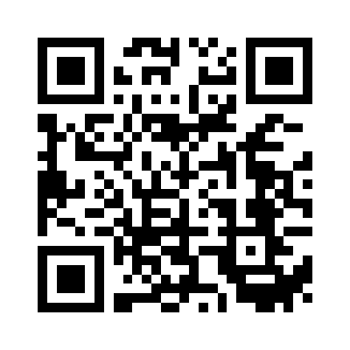
Scan or type the link. Same lesson, with hints. eduwonderlab.com/lessons/4-2/homework.html
How did it feel? (optional) ☐ Tricky ☐ Getting there ☐ Got it

Family Math Studio · For grown-ups Lesson 4.2 · 6.AT.4

Answers and talk notes
Relate Fractions, Decimals, and Percentages

What your student is learning
Tonight we write the same value three ways: as a fraction, as a decimal, and as a percent. They all name the same amount.

Answers
Ask your student to explain before you look.
- C. 0.5. 1/2 means 1 ÷ 2 = 0.5.
- A. 75%. 0.75 is 75 hundredths, so it is 75%.
- D. 60%. 3/5 = 60/100 (multiply both by 20), so it is 60%.
- B. 2/5. 0.4 = 4/10 = 2/5.
- A. 15%. 3/20 = 15/100 (multiply both by 5), so it is 15%.
- C. 3/5, 0.6, 60%. The set 3/5, 0.6, 60% works: 3/5 = 0.6 = 60%, so they all name the same value.

Talk about it
Is 3/4 a small piece of the whole, or most of it?

When they are stuck, ask
- Which number do we divide first, the top or the bottom?
- After we get the decimal, what do we multiply by to get the percent?
- Is this value more or less than a half? Let's use 50% to check.

Try not to say
- Just read the numbers in the fraction as the percent, like 3/5 is 35%.
- Divide the bottom number by the top number.
- A percent can never be more than 100.

Home mission
Say, "A player scored 3/4 of the team's points." Can your student say it as a decimal and a percent out loud? Then try 1/2 and 1/5.

