Family Math Studio Lesson 4.3 · Session 2 · 6.AT.4

Estimate the Percent of a Number
Estimate a percent of a number, and say if the estimate runs a bit high or low.
Name Date

Tonight's spark
A food drive receipt says 412 cans came in. 18.5% were soup. About how many cans of soup is that? Make a guess first: is it more or less than 100 cans?
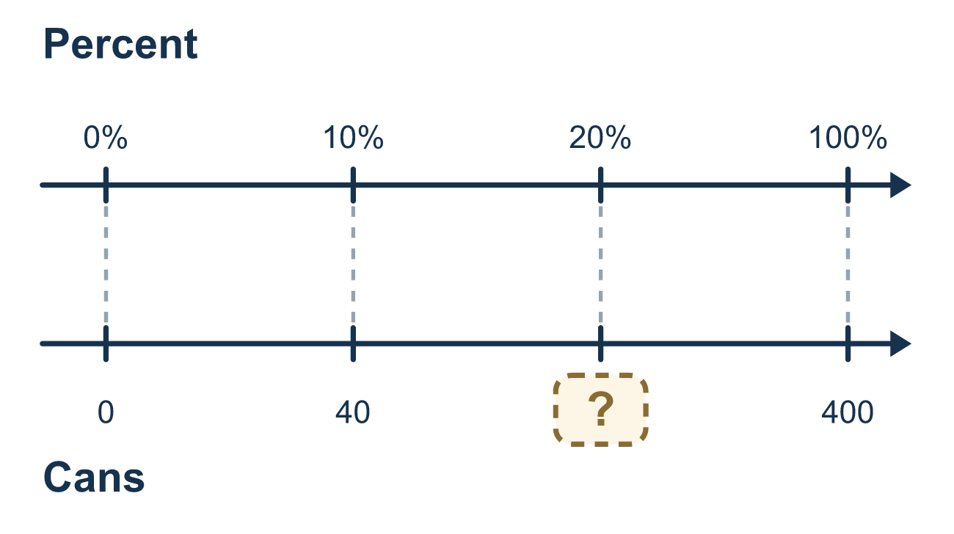
Our class model: round, then lean

Try it
Work it out on paper. Write one answer on each line.
- To estimate 18% of 412, which benchmark percent is best to use?
A. 10% B. 50% C. 25% D. 20%
My answer
- Which compatible number is best for 412?
A. 500 B. 400 C. 41 D. 4,000
My answer
- What is 10% of 300?
A. 30 B. 3 C. 300 D. 3,000
My answer
- 10% of 400 is 40. What is 20% of 400?
A. 44 B. 20 C. 80 D. 160
My answer
- About how much is 20% of 198?
A. About 20 B. About 400 C. About 10 D. About 40
My answer
- You estimate 20% of 78 using 20% of 80. Does the estimate run a little high or a little low?
A. A little low, because 78 is less than 80 B. A little high, because 80 is more than 78 C. Exactly right
My answer

Talk about it
Which way did you round, and does your estimate run a little high or a little low?

Home mission
Count the cans or boxes in a kitchen cabinet. Round the count to a friendly number. Estimate 20% of it. Does your estimate run high or low?

If we get stuck, ask
- What is 10% of that number?
- What friendly percent is this one close to?
- Which way did you round, and what does that do to the estimate?

Do it on a screen

Scan or type the link. Same lesson, with hints. eduwonderlab.com/lessons/4-3-part2/homework.html
How did it feel? (optional) ☐ Tricky ☐ Getting there ☐ Got it

Family Math Studio · For grown-ups Lesson 4.3 · Session 2 · 6.AT.4

Answers and talk notes
Estimate the Percent of a Number

What your student is learning
Tonight we estimate a percent of a number by rounding to friendly values first — and then we explain whether the estimate runs a bit high or a bit low.

Answers
Ask your student to explain before you look.
- D. 20%. 18% is closest to the benchmark 20%.
- B. 400. 412 is close to 400, and 400 is easy to work with.
- A. 30. 10% is one tenth, so 300 ÷ 10 = 30.
- C. 80. 20% is two groups of 10%, so 40 × 2 = 80.
- D. About 40. About 40: round 198 to 200. 10% of 200 is 20, so 20% is double that.
- B. A little high, because 80 is more than 78. A little high, because 80 is more than 78. Rounding the amount up makes the estimate a bit bigger.

Talk about it
Which way did you round, and does your estimate run a little high or a little low?

When they are stuck, ask
- What is 10% of that number?
- What friendly percent is this one close to?
- Which way did you round, and what does that do to the estimate?

Try not to say
- Estimating means just guessing a number.
- Use a calculator, the exact answer is easier.
- The whole is always the first number in the problem.

Home mission
Count the cans or boxes in a kitchen cabinet. Round the count to a friendly number. Estimate 20% of it. Does your estimate run high or low?

