Family Math Studio Lesson 4.3 · 6.AT.4

Estimate the Percent of a Number
Use friendly percents and friendly numbers to estimate a percent of an amount.
Name Date

Tonight's spark
A jacket costs $81. The sign says 23% off, and you have no calculator. About how much will you save? Make a guess first: will you save more or less than $40?
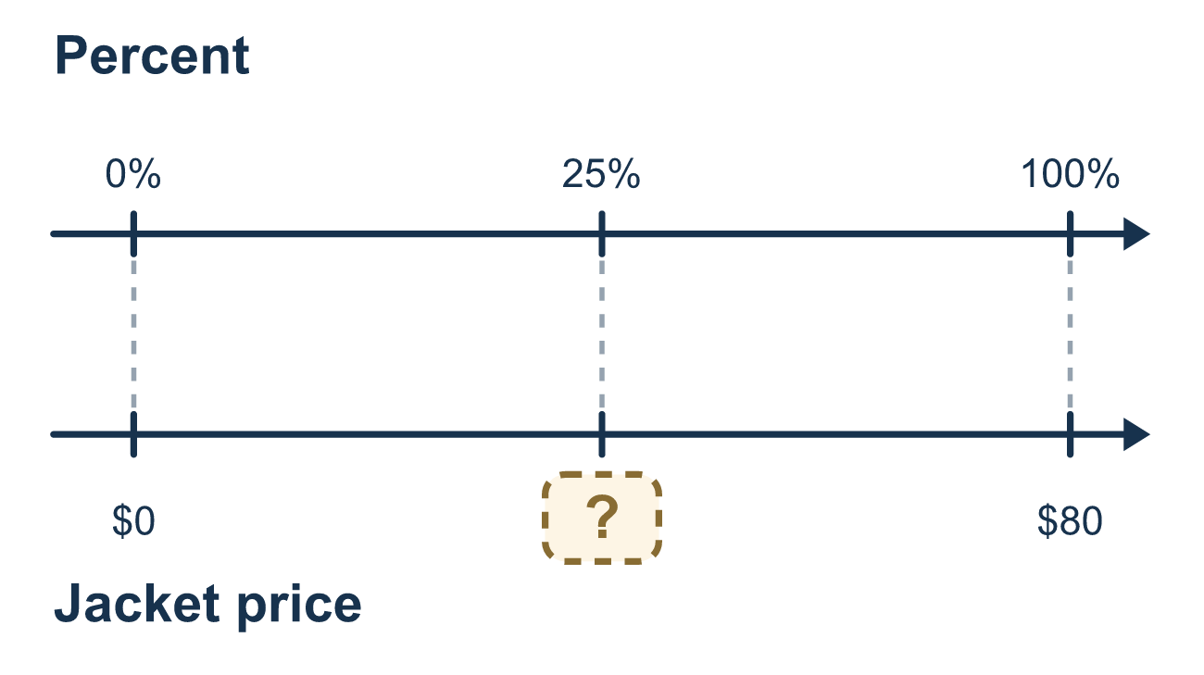
Our class model: the friendly benchmark

Try it
Work it out on paper. Write one answer on each line.
- Which benchmark percent is the same as one half?
A. 50% B. 25% C. 10% D. 75%
My answer
- What is 10% of 80?
A. 800 B. 18 C. 8 D. 0.8
My answer
- Which benchmark percent is closest to 49%?
A. 25% B. 50% C. 75% D. 10%
My answer
- About how much is 50% of $41?
A. $4 B. $10 C. $80 D. $20
My answer
- Estimate 25% of 79.
A. About 20 B. About 80 C. About 4 D. About 40
My answer
- Estimate 20% of $62.
A. About $6 B. About $30 C. About $12
My answer

Talk about it
Is 23% almost all of $81, or only a small part?

Home mission
Look at a price tag at home. Pretend it is 23% off. Round the price to a friendly number. About how much would you save?

If we get stuck, ask
- Which benchmark percent is closest?
- What is 10% of that number?
- Is your estimate a little over or a little under?

Do it on a screen
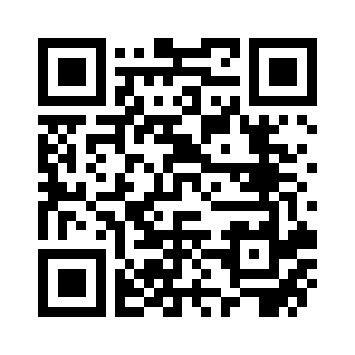
Scan or type the link. Same lesson, with hints. eduwonderlab.com/lessons/4-3/homework.html
How did it feel? (optional) ☐ Tricky ☐ Getting there ☐ Got it

Family Math Studio · For grown-ups Lesson 4.3 · 6.AT.4

Answers and talk notes
Estimate the Percent of a Number

What your student is learning
Tonight we estimate the percent of a number using benchmark percents like 1%, 10%, 25%, 50%, 75%, and 100%.

Answers
Ask your student to explain before you look.
- A. 50%. One half is 50 out of 100, so it is 50%.
- C. 8. 10% is one tenth, so 80 ÷ 10 = 8.
- B. 50%. 49% is just 1 less than 50%, so 50% is closest.
- D. $20. Round $41 to $40. Half of $40 is $20.
- A. About 20. About 20: round 79 to 80. 25% is one fourth, and 80 ÷ 4 = 20.
- C. About $12. About $12: round $62 to $60. 10% of $60 is $6, so 20% is $6 × 2 = $12.

Talk about it
Is 23% almost all of $81, or only a small part?

When they are stuck, ask
- Which benchmark percent is closest?
- What is 10% of that number?
- Is your estimate a little over or a little under?

Try not to say
- Estimating is just guessing.
- You need the exact answer here.
- Use the calculator instead.

Home mission
Look at a price tag at home. Pretend it is 23% off. Round the price to a friendly number. About how much would you save?

