Family Math Studio Lesson 4.4 · Session 2 · 6.AT.4

Find and Compare with Percentages
Compare two part-to-whole scores fairly by turning each one into a percent.
Name Date

Tonight's spark
A class chart shows two quizzes. Quiz 1 is 21 out of 25. Quiz 2 is 16 out of 20. Which quiz went better? Make a guess first: which quiz had the higher percent?
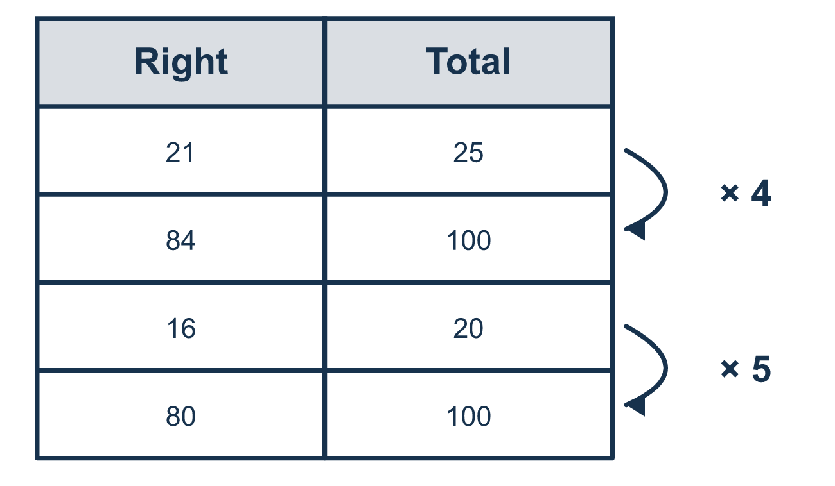
Our class model: scale the whole to 100

Try it
Work it out on paper. Write one answer on each line.
- What is 50% of 30?
A. 60 B. 3 C. 30 D. 15
My answer
- What is 75% of 40?
A. 10 B. 30 C. 160
My answer
- Scale 21/25 to a fraction out of 100.
A. 84/100 B. 21/100 C. 25/100 D. 46/100
My answer
- Write 9 out of 10 as a percent.
A. 9% B. 19% C. 90% D. 10%
My answer
- Score A is 16 out of 20. Score B is 4 out of 5. Which statement is true?
A. Score A is higher because 16 is bigger than 4 B. Score B is higher because 5 is smaller than 20 C. Score A is lower because 20 is bigger than 5 D. The scores are equal: both are 80%
My answer

Talk about it
Why can't we compare the two scores just by looking at the top numbers?

Home mission
Make up two quiz scores with different totals, like 7 out of 10 and 12 out of 20. Can your student scale both to 100 and say which is better?

If we get stuck, ask
- A percent of WHAT? What is the whole for each one?
- Can we write both of these out of 100?
- Now that the wholes match, which is greater?

Do it on a screen

Scan or type the link. Same lesson, with hints. eduwonderlab.com/lessons/4-4-part2/homework.html
How did it feel? (optional) ☐ Tricky ☐ Getting there ☐ Got it

Family Math Studio · For grown-ups Lesson 4.4 · Session 2 · 6.AT.4

Answers and talk notes
Find and Compare with Percentages

What your student is learning
Tonight we compare two records fairly — two quiz scores out of different totals — by turning each into a percent.

Answers
Ask your student to explain before you look.
- D. 15. 50% is half, so half of 30 is 15.
- B. 30. 25% of 40 is 10, so 75% is 3 × 10 = 30.
- A. 84/100. Multiply both numbers by 4: 21 × 4 = 84 and 25 × 4 = 100, so 84/100.
- C. 90%. Multiply both numbers by 10: 9 out of 10 is 90 out of 100, so 90%.
- D. The scores are equal: both are 80%. The scores are equal: both are 80%, because 16/20 = 80/100 and 4/5 = 80/100.

Talk about it
Why can't we compare the two scores just by looking at the top numbers?

When they are stuck, ask
- A percent of WHAT? What is the whole for each one?
- Can we write both of these out of 100?
- Now that the wholes match, which is greater?

Try not to say
- The bigger number of correct answers is the better score.
- A bigger percent always means a bigger amount.
- You can compare percents without knowing the totals.

Home mission
Make up two quiz scores with different totals, like 7 out of 10 and 12 out of 20. Can your student scale both to 100 and say which is better?

