Family Math Studio Lesson 4.4 · 6.AT.4

Find and Compare with Percentages
Find a percent of a number by changing the percent to a decimal and multiplying.
Name Date

Tonight's spark
A claw-machine prize costs 60 tickets. A sign says 25% off. How many tickets do you save? Make a guess first: do you save more or fewer than 20 tickets?
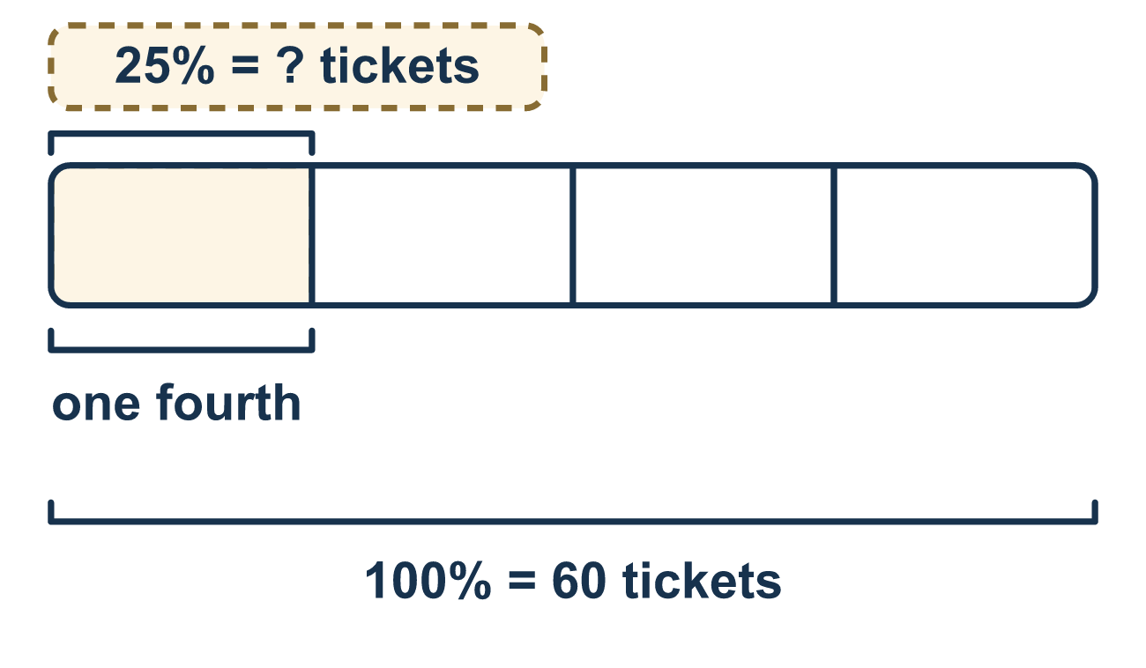
Our class model: the percent as a decimal

Try it
Work it out on paper. Write one answer on each line.
- Write 40% as a decimal.
A. 0.4 B. 4.0 C. 0.04 D. 40
My answer
- What is 50% of 36?
A. 72 B. 3.6 C. 18
My answer
- What is 10% of 90?
A. 900 B. 0.9 C. 99 D. 9
My answer
- What is 25% of 48?
A. 24 B. 12 C. 73 D. 192
My answer
- What is 20% of 70?
A. 14 B. 50 C. 1,400 D. 7
My answer
- A game costs 80 tickets and is 25% off. What is the sale price?
A. 20 tickets B. 105 tickets C. 60 tickets
My answer

Talk about it
Did the problem ask for the amount you saved (the discount) or the amount you have to pay (the sale price)?

Home mission
Count out 60 beans or coins to stand for 60 tickets. Ask your student to make four equal groups to show 25% off. How many tickets are saved? Then try 50% off.

If we get stuck, ask
- What number comes after the word "of"? That is the base we multiply by.
- What is this percent written as a decimal?
- About how big should the answer be? Let's estimate first.

Do it on a screen
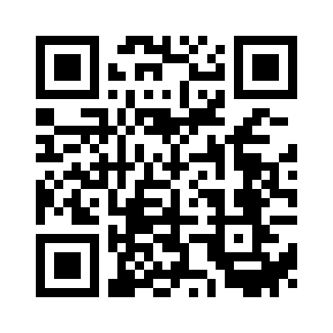
Scan or type the link. Same lesson, with hints. eduwonderlab.com/lessons/4-4/homework.html
How did it feel? (optional) ☐ Tricky ☐ Getting there ☐ Got it

Family Math Studio · For grown-ups Lesson 4.4 · 6.AT.4

Answers and talk notes
Find and Compare with Percentages

What your student is learning
Tonight we find a percent of a number, like a discount on a price. We change the percent to a decimal and multiply.

Answers
Ask your student to explain before you look.
- A. 0.4. 40% is 40 hundredths, which is 0.40 = 0.4.
- C. 18. 50% is half, so half of 36 is 18.
- D. 9. 10% is one tenth, so 90 ÷ 10 = 9.
- B. 12. 25% is one fourth, so 48 ÷ 4 = 12.
- A. 14. 10% of 70 is 7, so 20% is 7 × 2 = 14.
- C. 60 tickets. 25% of 80 is 20 tickets saved. The sale price is 80 − 20 = 60 tickets.

Talk about it
Did the problem ask for the amount you saved (the discount) or the amount you have to pay (the sale price)?

When they are stuck, ask
- What number comes after the word "of"? That is the base we multiply by.
- What is this percent written as a decimal?
- About how big should the answer be? Let's estimate first.

Try not to say
- Just multiply by the percent number, like 25 × 60.
- Multiply by the percent number itself instead of the base.
- To make a percent a decimal, just divide by 10.

Home mission
Count out 60 beans or coins to stand for 60 tickets. Ask your student to make four equal groups to show 25% off. How many tickets are saved? Then try 50% off.

