Family Math Studio Lesson 4.5 · Session 2 · 6.AT.4

Determine the Whole Given the Part and Percent
Find the whole when you know a part and its percent, using an equation.
Name Date

Tonight's spark
A dinner receipt got torn. You can only read the tip: $6. A note says the tip is 15% of the bill. What was the bill? Make a guess first: did the family spend more than $20, or less?
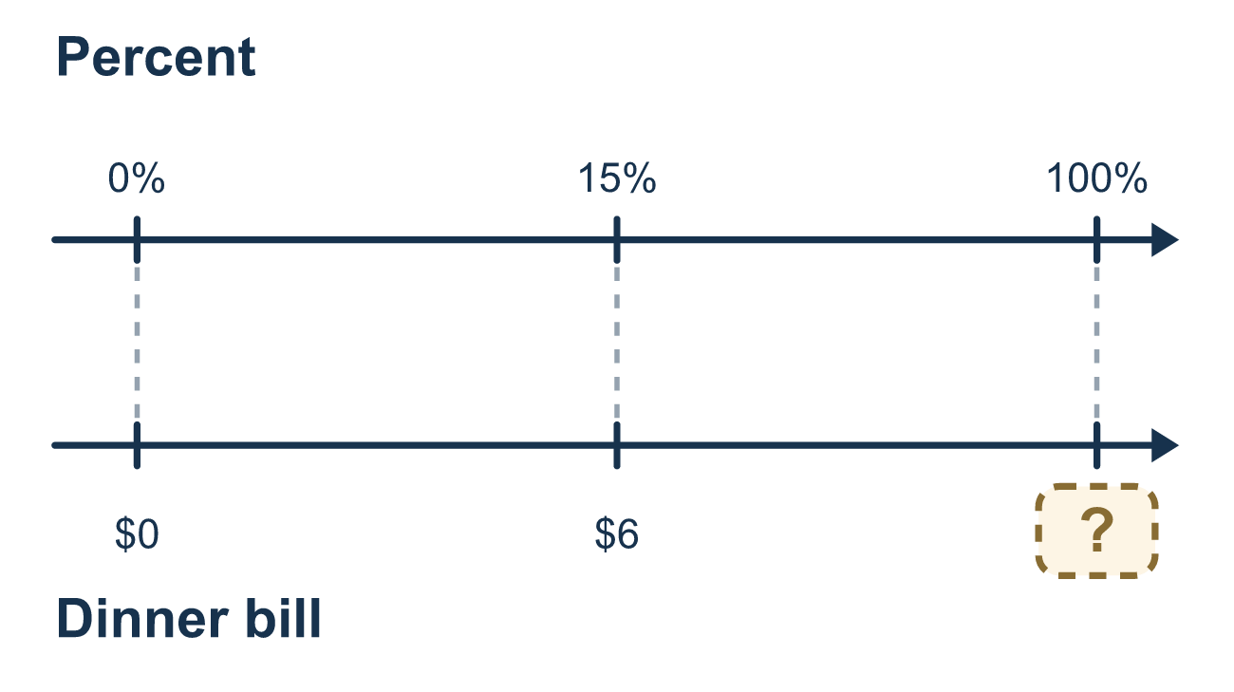
Our class model: the percent equation

Try it
Work it out on paper. Write one answer on each line.
- Which number sentence matches '12 is 40% of a number n'?
A. 12 × n = 0.4 B. n = 12 × 0.4 C. 0.4 × n = 12 D. n ÷ 0.4 = 0.12
My answer
- In 0.5 × w = 8, which operation finds w?
A. Divide 8 by 0.5 B. Multiply 8 by 0.5 C. Add 8 and 0.5 D. Subtract 0.5 from 8
My answer
- Solve 0.5 × w = 7.
A. 3.5 B. 35 C. 7.5 D. 14
My answer
- Solve 0.1 × w = 9.
A. 0.9 B. 90 C. 9.1 D. 900
My answer
- Solve 0.25 × w = 6.
A. 1.5 B. 31 C. 24
My answer
- A $9 tip is 20% of the bill. What was the bill?
A. $45 B. $1.80 C. $29 D. $180
My answer

Talk about it
Is the whole bigger or smaller than the part, and how does your check show the answer is right?

Home mission
Use a real receipt. Pretend the tip was $5 and it was 20% of the bill. Can your student write 0.2 × b = 5 and solve it? Then check: is 20% of the answer really $5?

If we get stuck, ask
- Which part of "percent × whole = part" is missing here?
- Should the whole be bigger or smaller than the part?
- Can you check by finding that percent of your answer?

Do it on a screen

Scan or type the link. Same lesson, with hints. eduwonderlab.com/lessons/4-5-part2/homework.html
How did it feel? (optional) ☐ Tricky ☐ Getting there ☐ Got it

Family Math Studio · For grown-ups Lesson 4.5 · Session 2 · 6.AT.4

Answers and talk notes
Determine the Whole Given the Part and Percent

What your student is learning
Tonight we write a percent equation — part = percent × whole — and solve it for the unknown whole by dividing.

Answers
Ask your student to explain before you look.
- C. 0.4 × n = 12. Percent times whole equals part, so 0.4 × n = 12.
- A. Divide 8 by 0.5. Divide 8 by 0.5. Division undoes multiplication, so w = 8 ÷ 0.5.
- D. 14. w = 7 ÷ 0.5 = 14, because there are 2 halves in each whole.
- B. 90. w = 9 ÷ 0.1 = 90, because there are 10 tenths in each whole.
- C. 24. w = 6 ÷ 0.25 = 24, because there are 4 fourths in each whole.
- A. $45. 0.2 × b = 9, so b = 9 ÷ 0.2 = 45. The bill was $45.

Talk about it
Is the whole bigger or smaller than the part, and how does your check show the answer is right?

When they are stuck, ask
- Which part of "percent × whole = part" is missing here?
- Should the whole be bigger or smaller than the part?
- Can you check by finding that percent of your answer?

Try not to say
- Multiply the part by the percent to find the whole.
- Just move the decimal point and you are done.
- Checking is optional if the answer looks fine.

Home mission
Use a real receipt. Pretend the tip was $5 and it was 20% of the bill. Can your student write 0.2 × b = 5 and solve it? Then check: is 20% of the answer really $5?

