Family Math Studio Lesson 4.5 · 6.AT.4

Determine the Whole Given the Part and Percent
Find the whole when you know a part and its percent.
Name Date

Tonight's spark
A sweater tag says $42 after a sale. The sign says $42 is 60% of the regular price. What was the regular price? Make a guess first: is the regular price more or less than $42?
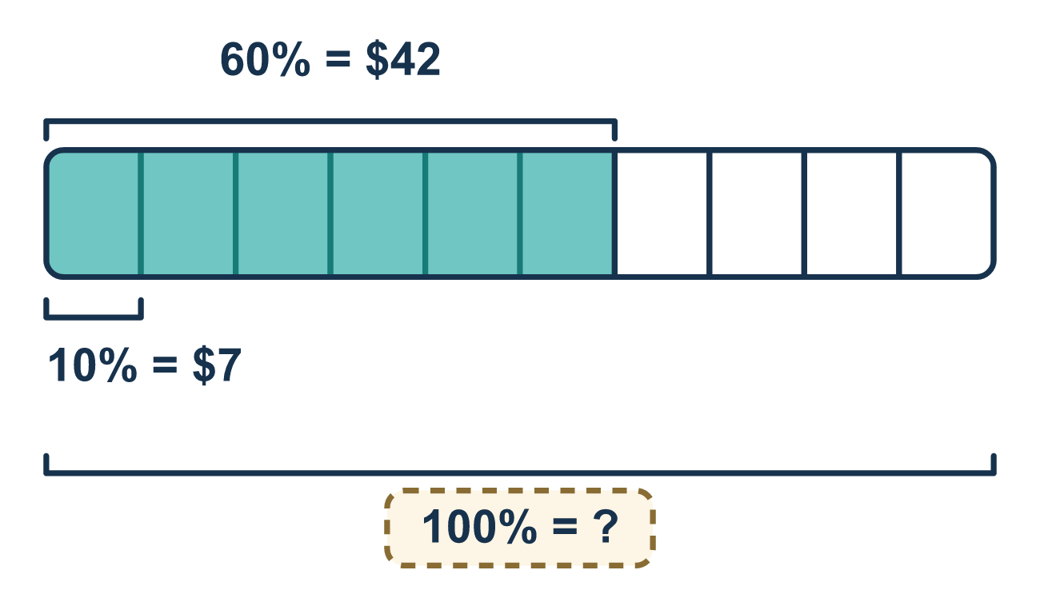
Our class model: the 10% stepping stone

Try it
Work it out on paper. Write one answer on each line.
- 10% of a number is 5. What is 100% of that number?
A. 15 B. 50 C. 0.5
My answer
- 30 is 50% of a number. What is the number?
A. 60 B. 15 C. 80 D. 30
My answer
- 20 is 25% of a number. What is the number?
A. 5 B. 45 C. 100 D. 80
My answer
- 8 is 20% of the whole. What is 10% of the whole?
A. 16 B. 2 C. 4
My answer
- A shirt on sale costs $30, which is 50% of the original price. What was the original price?
A. $15 B. $60 C. $80 D. $30
My answer
- 18 is 30% of a number. What is the number?
A. 60 B. 5.4 C. 48 D. 540
My answer

Talk about it
When the whole is missing, why do we divide by the decimal percent instead of multiplying?

Home mission
Pick any price on a receipt. Say, "This is 50% of the full price." Can your student find the full price out loud? Then try 25%.

If we get stuck, ask
- Which amount is the part, and which is missing?
- What is that percent as a decimal?
- Should the whole be bigger or smaller than the part?

Do it on a screen

Scan or type the link. Same lesson, with hints. eduwonderlab.com/lessons/4-5/homework.html
How did it feel? (optional) ☐ Tricky ☐ Getting there ☐ Got it

Family Math Studio · For grown-ups Lesson 4.5 · 6.AT.4

Answers and talk notes
Determine the Whole Given the Part and Percent

What your student is learning
Tonight we work backwards: when we know a part and the percent that part represents, we find the whole amount it came from.

Answers
Ask your student to explain before you look.
- B. 50. In a ratio table, multiply both terms by 10 to scale from 10% to 100%: 5 × 10 = 50.
- A. 60. In a ratio table, scale from 50% to 100% by multiplying by 2: 30 × 2 = 60.
- D. 80. In a ratio table, scale from 25% to 100% by multiplying both terms by 4: 20 × 4 = 80.
- C. 4. In a ratio table, divide both terms by 2 to step down from 20% to 10%: 8 ÷ 2 = 4.
- B. $60. In a ratio table, scale from 50% to 100% by multiplying by 2: $30 × 2 = $60.
- A. 60. In a ratio table, step down to 10% by dividing by 3 (18 ÷ 3 = 6), then scale up to 100% by multiplying by 10 (6 × 10 = 60).

Talk about it
When the whole is missing, why do we divide by the decimal percent instead of multiplying?

When they are stuck, ask
- Which amount is the part, and which is missing?
- What is that percent as a decimal?
- Should the whole be bigger or smaller than the part?

Try not to say
- Multiply the part by the percent.
- Add the part and the percent.
- The whole is always 100 of something.

Home mission
Pick any price on a receipt. Say, "This is 50% of the full price." Can your student find the full price out loud? Then try 25%.

