Family Math Studio Lesson 5.1 · Session 2 · 6.GR.1

Determine the Area of Parallelograms and Rhombuses
Find the area of a rhombus. It is a parallelogram, so use base × straight-up height.
Name Date

Tonight's spark
A hardware store sells diamond-shaped floor tiles. The sign says every side is 13 cm. A ruler straight up from the bottom edge to the top edge reads 8 cm. How much floor does one tile cover? Guess first: is it more or less than 150 square centimeters?
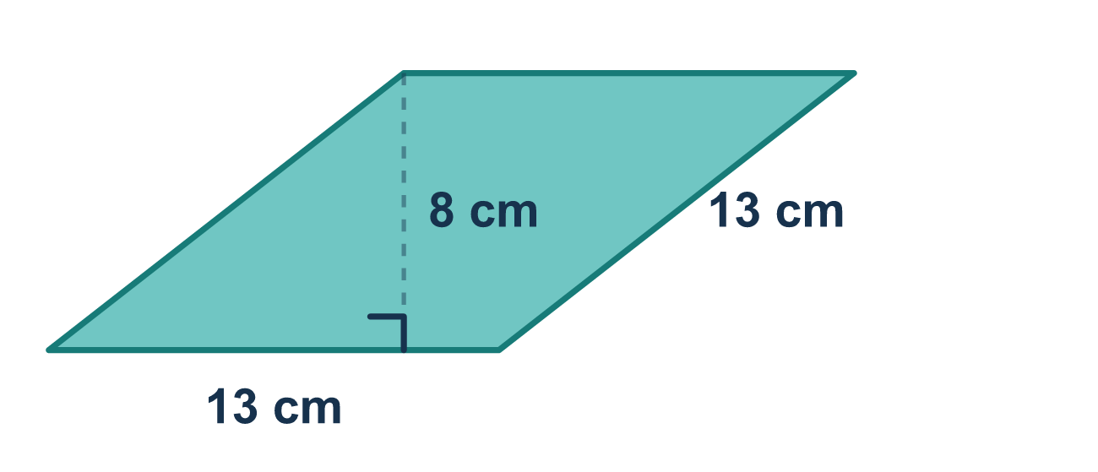
Our class model: a rhombus is a parallelogram

Try it
Work it out on paper. Write one answer on each line.
- Which statement about a rhombus is true?
A. It has no parallel sides B. It is a parallelogram with four equal sides C. It has only two equal sides D. Its height is always the same as its side
My answer
- A rhombus has a base of 7 cm and a height of 5 cm. What is its area?
A. 12 cm² B. 28 cm² C. 17.5 cm² D. 35 cm²
My answer
- A rhombus has sides of 10 in. and a straight-up height of 8 in. What is its area?
A. 80 in² B. 100 in² C. 18 in² D. 40 in²
My answer
- A rhombus has four sides of 15 cm. A segment from the top side straight down to the base, at a right angle, measures 9 cm. Which number is the height?
A. 15, the side printed on the picture B. 24, the two numbers added C. 9, the straight-up distance D. 6, the difference of the two numbers
My answer
- A rhombus-shaped sign has a base of 12 in. and a height of 9 in. What is its area?
A. 21 in² B. 108 in² C. 54 in² D. 144 in²
My answer

Talk about it
A rhombus has four equal sides. Which measurement is its height, and why is the side not the height?

Home mission
A different situation: lay four pencils of the same length into a square. Gently push one corner so it leans into a diamond. The sides stay the same. Which measure got smaller: the side, or the straight-up height?

If we get stuck, ask
- Is that measurement straight up from the base, or slanted?
- A rhombus is which bigger family of shapes?
- What unit does an area answer use?

Do it on a screen

Scan or type the link. Same lesson, with hints. eduwonderlab.com/lessons/5-1-part2/homework.html
How did it feel? (optional) ☐ Tricky ☐ Getting there ☐ Got it

Family Math Studio · For grown-ups Lesson 5.1 · Session 2 · 6.GR.1

Answers and talk notes
Determine the Area of Parallelograms and Rhombuses

What your student is learning
Tonight we find the area of a rhombus — and see why the parallelogram formula we learned in Part 1 still works on it.

Answers
Ask your student to explain before you look.
- B. It is a parallelogram with four equal sides. It is a parallelogram with four equal sides: that is what a rhombus is.
- D. 35 cm². A = b × h = 7 × 5 = 35 cm².
- A. 80 in². Use a side as the base: A = 10 × 8 = 80 in².
- C. 9, the straight-up distance. The height is 9, the straight-up distance that meets the base at a right angle.
- B. 108 in². A = 12 × 9 = 108 in².

Talk about it
A rhombus has four equal sides. Which measurement is its height, and why is the side not the height?

When they are stuck, ask
- Is that measurement straight up from the base, or slanted?
- A rhombus is which bigger family of shapes?
- What unit does an area answer use?

Try not to say
- Multiply the two side lengths, that is the area.
- Any number on the picture can be the height.
- The units do not matter for area.

Home mission
A different situation: lay four pencils of the same length into a square. Gently push one corner so it leans into a diamond. The sides stay the same. Which measure got smaller: the side, or the straight-up height?

