Family Math Studio Lesson 5.1 · 6.GR.1

Determine the Area of Parallelograms and Rhombuses
Find the area of a parallelogram by multiplying its base by its straight-up height.
Name Date

Tonight's spark
Mr. Reyes is tiling a backyard patio shaped like a leaning rectangle. It is 14 feet along the bottom and 9 feet straight up. Each tile covers 1 square foot. How many tiles does he need? Guess first: more than 100 tiles, or fewer?
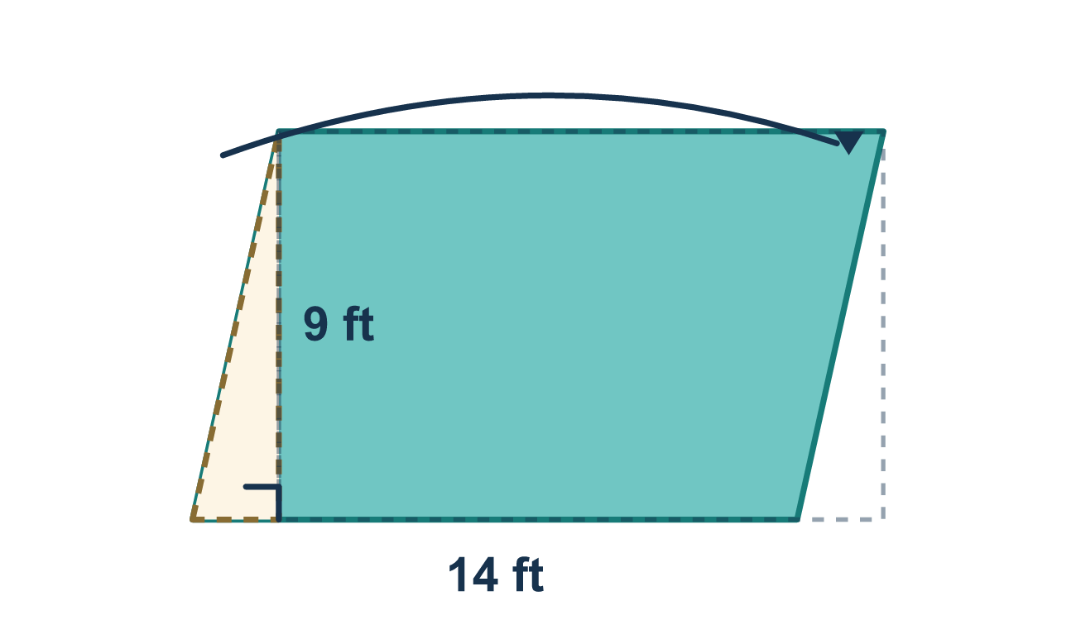
Our class model: cut and slide

Try it
Work it out on paper. Write one answer on each line.
- What is the height of a parallelogram?
A. The length of the slanted side B. The straight-up distance from the base to the opposite side C. The distance around the shape D. The sum of the base and the slanted side
My answer
- A parallelogram has a base of 6 cm and a height of 4 cm. What is its area?
A. 24 cm² B. 10 cm² C. 20 cm² D. 12 cm²
My answer
- A parallelogram has a base of 9 in., a height of 5 in. and a slanted side of 6 in. What is its area?
A. 54 in² B. 30 in² C. 45 in² D. 20 in²
My answer
- A parallelogram has a base of 8 m and a height of 3 m. Which expression gives its area?
A. 8 + 3 B. ½ × 8 × 3 C. 2 × (8 + 3) D. 8 × 3
My answer
- Parallelogram A has a base of 7 and a height of 6. Parallelogram B has a base of 5 and a height of 9. Which has the greater area?
A. A, 42 square units B. B, 45 square units C. They are equal D. A, because its base is longer
My answer

Talk about it
Which measurement is the height: the slanted side or the straight-up distance? How do you know?

Home mission
A different situation: stack 10 or more cards or sticky notes into a neat block. Look at it from the side. Now push the top sideways so the stack leans. Did the base or the height change? Did the amount of paper change?

If we get stuck, ask
- Which number is the height — the straight-up one or the slanted side?
- Let's write the rule first: area = base × height.
- What is the base times the height?

Do it on a screen

Scan or type the link. Same lesson, with hints. eduwonderlab.com/lessons/5-1/homework.html
How did it feel? (optional) ☐ Tricky ☐ Getting there ☐ Got it

Family Math Studio · For grown-ups Lesson 5.1 · 6.GR.1

Answers and talk notes
Determine the Area of Parallelograms and Rhombuses

What your student is learning
Tonight we find the area of a parallelogram. A parallelogram is a slanted four-sided shape, like a leaning rectangle. We use the rule: area = base × height.

Answers
Ask your student to explain before you look.
- B. The straight-up distance from the base to the opposite side. The straight-up distance from the base to the opposite side is the height, at a right angle to the base.
- A. 24 cm². A = b × h = 6 × 4 = 24 cm².
- C. 45 in². A = 9 × 5 = 45 in². The slanted side is not used.
- D. 8 × 3. Area = base × height, so the expression is 8 × 3.
- B. B, 45 square units. B, 45 square units: A is 7 × 6 = 42 and B is 5 × 9 = 45.

Talk about it
Which measurement is the height: the slanted side or the straight-up distance? How do you know?

When they are stuck, ask
- Which number is the height — the straight-up one or the slanted side?
- Let's write the rule first: area = base × height.
- What is the base times the height?

Try not to say
- Use the slanted side as the height.
- Add the base and the height together.
- Just memorize the answer.

Home mission
A different situation: stack 10 or more cards or sticky notes into a neat block. Look at it from the side. Now push the top sideways so the stack leans. Did the base or the height change? Did the amount of paper change?

