Family Math Studio Lesson 5.10 · Session 2 · 6.GR.2

Volume of Rectangular Prisms
Find the volume of several boxes, with exact decimal edges, and use the volumes to choose.
Name Date

Tonight's spark
A class needs a storage box that holds at least 5 cubic feet. Small is 2 × 1 × 1 ft. Medium is 2 × 1.5 × 1 ft. Large is 2 × 2 × 1.5 ft. Which box works? Guess first: does the Medium box hold enough?
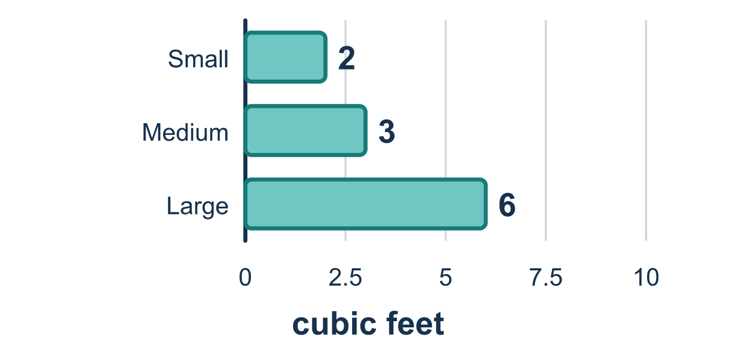
Our class model: exact edges, then compare

Try it
Work it out on paper. Write one answer on each line.
- What is the volume of a box that is 3 m by 2 m by 4 m?
A. 9 m³ B. 24 m³ C. 14 m³
My answer
- A box is 2 ft by 5 ft by 1.5 ft. What is its volume?
A. 15 ft³ B. 10 ft³ C. 20 ft³ D. 8.5 ft³
My answer
- Box P is 3 by 2 by 1.5. Box Q is 2 by 2 by 2. Which holds more?
A. Box Q, because 8 is greater than 6 B. They hold the same C. Box P, 9 cubic units to 8 cubic units D. Box Q, because it has no fractions
My answer
- A shop needs a box that holds MORE than 20 cubic feet. Which box works?
A. 4 × 2 × 2 B. 3 × 3 × 2 C. 2 × 2 × 5 D. 5 × 2 × 2.5
My answer
- Box M is 6 by 3 by 1.5. Box N is 5 by 4 by 1. Which holds more, and by how much?
A. Box N, by 7 cubic units B. Box M, by 7 cubic units C. Box M, by 1 cubic unit D. Box N, because its base is bigger
My answer

Talk about it
Which box holds more, and how much more does it hold?

Home mission
Pick two boxes, like a cereal box and a snack box. Measure each edge to the nearest half inch. Find each volume without rounding. Which holds more?

If we get stuck, ask
- Did you use the exact edge, or did you round it?
- How many edges go into a volume?
- What number does the problem say we have to reach?

Do it on a screen
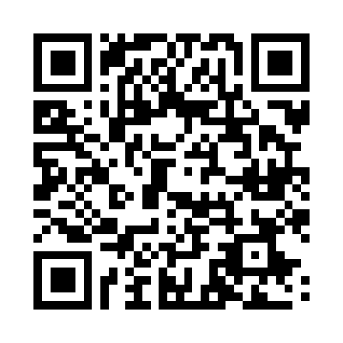
Scan or type the link. Same lesson, with hints. eduwonderlab.com/lessons/5-10-part2/homework.html
How did it feel? (optional) ☐ Tricky ☐ Getting there ☐ Got it

Family Math Studio · For grown-ups Lesson 5.10 · Session 2 · 6.GR.2

Answers and talk notes
Volume of Rectangular Prisms

What your student is learning
Tonight we compute the volume of several boxes — fractional edges and all — and use the results to choose one.

Answers
Ask your student to explain before you look.
- B. 24 m³. 24 m³: 3 × 2 × 4 = 24.
- A. 15 ft³. 15 ft³: 2 × 5 = 10, and 10 × 1.5 = 15.
- C. Box P, 9 cubic units to 8 cubic units. Box P, 9 cubic units to 8 cubic units: P is 3 × 2 × 1.5 = 9 and Q is 2 × 2 × 2 = 8.
- D. 5 × 2 × 2.5. 5 × 2 × 2.5 is 25 cubic feet, which is more than 20.
- B. Box M, by 7 cubic units. Box M, by 7 cubic units: M is 6 × 3 × 1.5 = 27, N is 5 × 4 × 1 = 20, and 27 − 20 = 7.

Talk about it
Which box holds more, and how much more does it hold?

When they are stuck, ask
- Did you use the exact edge, or did you round it?
- How many edges go into a volume?
- What number does the problem say we have to reach?

Try not to say
- Round the decimal first, it is easier that way.
- Pick the biggest box, that is always the answer.
- Square units are fine for a box.

Home mission
Pick two boxes, like a cereal box and a snack box. Measure each edge to the nearest half inch. Find each volume without rounding. Which holds more?

