Family Math Studio Lesson 5.2 · Session 2 · 6.GR.1

Determine the Area of Triangles
Find a missing base or height of a triangle when you know its area.
Name Date

Tonight's spark
A triangular flag has a tag that says 45 square inches. The flag is 9 inches tall. How long is its base? Make a guess first: is the base longer or shorter than the height?
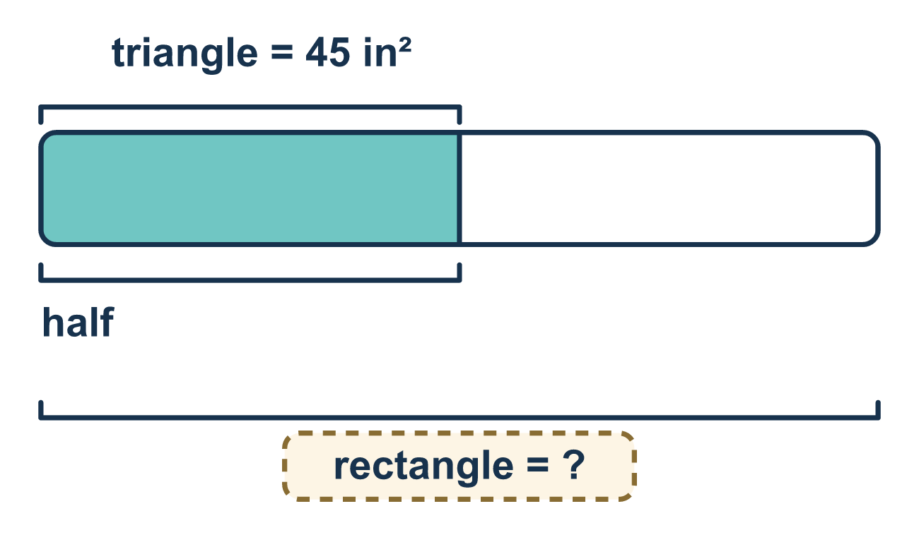
Our class model: work the formula backwards

Try it
Work it out on paper. Write one answer on each line.
- To undo the ½ in A = ½ × b × h, what do you do to the area first?
A. Halve it B. Subtract 2 C. Double it D. Add the base
My answer
- A triangle has an area of 12 cm² and a base of 6 cm. What is its height?
A. 4 cm B. 2 cm C. 72 cm D. 18 cm
My answer
- A triangle has an area of 30 m² and a height of 5 m. What is its base?
A. 6 m B. 150 m C. 35 m D. 12 m
My answer
- A triangle has an area of 18 and a base of 9. Which equation can you use to find its height h?
A. ½ × 9 × h = 18 B. 9 × h = 18 C. ½ × 18 × h = 9 D. 9 + h = 18
My answer
- A triangle has an area of 28 cm² and a base of 7 cm. What is its height?
A. 4 cm B. 21 cm C. 8 cm D. 196 cm
My answer

Talk about it
The area of a triangle is 12 and its base is 8. What do you do first to undo the half?

Home mission
Say, "A flag has an area of 45 square inches and a height of 9 inches." Ask your student to explain how to find the base. What do you do first? Then ask them to check the answer in the formula.

If we get stuck, ask
- What does the formula say, and which part is missing?
- What undoes taking half of something?
- Put your answer back in. Does the area come out right?

Do it on a screen

Scan or type the link. Same lesson, with hints. eduwonderlab.com/lessons/5-2-part2/homework.html
How did it feel? (optional) ☐ Tricky ☐ Getting there ☐ Got it

Family Math Studio · For grown-ups Lesson 5.2 · Session 2 · 6.GR.1

Answers and talk notes
Determine the Area of Triangles

What your student is learning
Tonight we work the triangle area formula BACKWARDS — given the area and one measure, we find the other.

Answers
Ask your student to explain before you look.
- C. Double it. Double it: doubling the area undoes the half.
- A. 4 cm. Double 12 to get 24, then 24 ÷ 6 = 4 cm.
- D. 12 m. Double 30 to get 60, then 60 ÷ 5 = 12 m.
- A. ½ × 9 × h = 18. Put the known numbers into the formula: ½ × 9 × h = 18.
- C. 8 cm. Double 28 to get 56, then 56 ÷ 7 = 8 cm.

Talk about it
The area of a triangle is 12 and its base is 8. What do you do first to undo the half?

When they are stuck, ask
- What does the formula say, and which part is missing?
- What undoes taking half of something?
- Put your answer back in. Does the area come out right?

Try not to say
- Divide the area by the height and you are done.
- Forget the half, it barely changes anything.
- You do not need to check, the arithmetic was easy.

Home mission
Say, "A flag has an area of 45 square inches and a height of 9 inches." Ask your student to explain how to find the base. What do you do first? Then ask them to check the answer in the formula.

