Family Math Studio Lesson 5.2 · 6.GR.1

Determine the Area of Triangles
Find the area of a triangle by taking half of base times height.
Name Date

Tonight's spark
A garden plan is a triangle with a base of 12 feet and a height of 8 feet. How many square feet does it cover? Make a guess first: is the triangle bigger or smaller than a 12 by 8 foot rectangle?
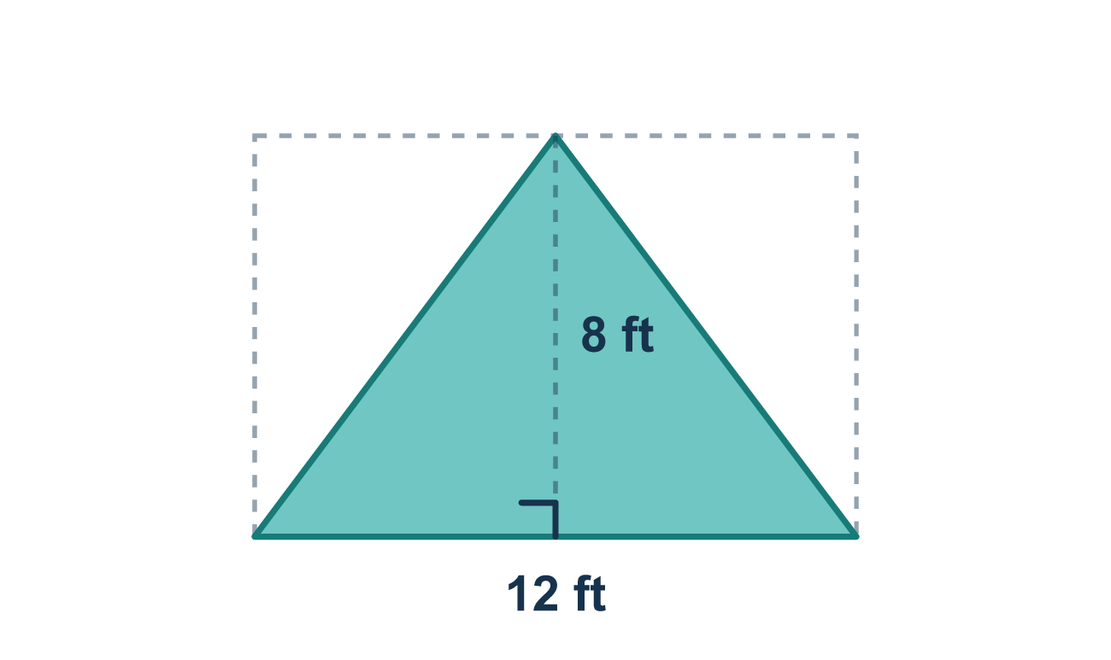
Our class model: half of a rectangle

Try it
Work it out on paper. Write one answer on each line.
- A triangle is what part of a rectangle that has the same base and height?
A. One half B. The same as the rectangle C. Twice the rectangle D. One quarter
My answer
- A triangle has a base of 10 cm and a height of 6 cm. What is its area?
A. 60 cm² B. 30 cm² C. 16 cm²
My answer
- Which formula gives the area of a triangle?
A. A = b + h B. A = b × h C. A = 2 × b × h D. A = ½ × b × h
My answer
- A triangle has a base of 9 in., a height of 4 in. and another side of 6 in. What is its area?
A. 36 in² B. 27 in² C. 18 in² D. 19 in²
My answer
- A triangle has a base of 12 m and a height of 7 m. What is its area?
A. 84 m² B. 42 m² C. 19 m²
My answer
- A triangular sail has a base of 5 ft and a height of 8 ft. How much cloth does it need?
A. 20 ft² B. 40 ft² C. 13 ft² D. 26 ft²
My answer

Talk about it
Does the triangle fill the whole 12 by 8 rectangle, or only part of it?

Home mission
Cut a sheet of paper in half, corner to corner. Lay the two triangles on top of each other. What do you notice? How is each triangle related to the whole sheet?

If we get stuck, ask
- Which number is the height — the straight-up one or the slanted side?
- Let's multiply the base and height first, then take half.
- Did we remember to take half at the end?

Do it on a screen

Scan or type the link. Same lesson, with hints. eduwonderlab.com/lessons/5-2/homework.html
How did it feel? (optional) ☐ Tricky ☐ Getting there ☐ Got it

Family Math Studio · For grown-ups Lesson 5.2 · 6.GR.1

Answers and talk notes
Determine the Area of Triangles

What your student is learning
Tonight we find the area of a triangle. A triangle is a shape with three sides. We use the rule: area = ½ × base × height.

Answers
Ask your student to explain before you look.
- A. One half. One half of the rectangle: the triangle fills half of it.
- B. 30 cm². A = ½ × 10 × 6 = 30 cm².
- D. A = ½ × b × h. The area of a triangle is A = ½ × b × h.
- C. 18 in². A = ½ × 9 × 4 = 18 in².
- B. 42 m². A = ½ × 12 × 7 = 42 m².
- A. 20 ft². A = ½ × 5 × 8 = 20 ft².

Talk about it
Does the triangle fill the whole 12 by 8 rectangle, or only part of it?

When they are stuck, ask
- Which number is the height — the straight-up one or the slanted side?
- Let's multiply the base and height first, then take half.
- Did we remember to take half at the end?

Try not to say
- You don't need the half — just multiply base times height.
- Take half of the base and half of the height both.
- Use the slanted side as the height.

Home mission
Cut a sheet of paper in half, corner to corner. Lay the two triangles on top of each other. What do you notice? How is each triangle related to the whole sheet?

