Family Math Studio Lesson 5.3 · Session 2 · 6.GR.1

Determine the Area of Trapezoids
Use the trapezoid formula, and know why it has a half.
Name Date

Tonight's spark
A sewing club cuts the side of a tote bag. It is a trapezoid. The top is 13 inches, the bottom is 19 inches, and it is 6 inches tall. How much cloth is that? Guess first: is the cloth more or less than 100 square inches?
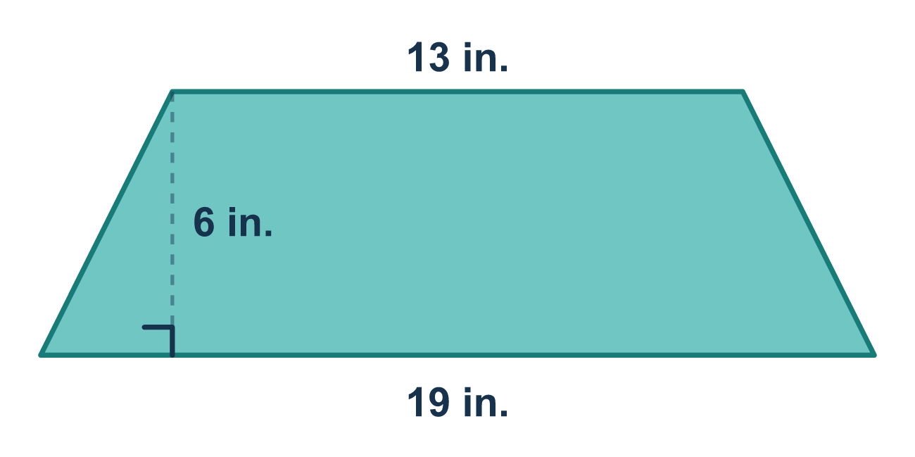
Our class model: two trapezoids make a parallelogram

Try it
Work it out on paper. Write one answer on each line.
- In A = ½ × (b1 + b2) × h, what do you do with the two bases first?
A. Subtract b2 from b1 B. Multiply b1 by b2 C. Multiply them by h D. Add them
My answer
- Why is there a ½ in the trapezoid area formula?
A. Two identical trapezoids make one parallelogram, so one trapezoid is half B. Every trapezoid has two bases C. A trapezoid has half as many sides as a rectangle D. The height is always cut in half
My answer
- A trapezoid has bases of 3 and 9 and a height of 4. What is its area?
A. 48 B. 54 C. 24 D. 16
My answer
- A trapezoid has bases of 7 and 5 and a height of 6. What is its area?
A. 72 B. 36 C. 18 D. 210
My answer
- A trapezoid has bases of 10 and 6 and a height of 4. The product (10 + 6) × 4 is 64. What is the area of the trapezoid?
A. 64 square units B. 16 square units C. 24 square units D. 32 square units
My answer

Talk about it
Which two sides are the bases, and why do we add them before multiplying by the height?

Home mission
Cut two same trapezoids from scrap paper. Flip one over and fit the two together. What shape do they make? Can your student say why that explains the ½?

If we get stuck, ask
- Which two sides are parallel? Those are the bases.
- What is inside the parentheses? Do that first.
- Did you take half of your last answer?

Do it on a screen

Scan or type the link. Same lesson, with hints. eduwonderlab.com/lessons/5-3-part2/homework.html
How did it feel? (optional) ☐ Tricky ☐ Getting there ☐ Got it

Family Math Studio · For grown-ups Lesson 5.3 · Session 2 · 6.GR.1

Answers and talk notes
Determine the Area of Trapezoids

What your student is learning
Tonight we use the trapezoid area formula A = ½ × (b1 + b2) × h — the shortcut for what we did by cutting shapes apart in Part 1.

Answers
Ask your student to explain before you look.
- D. Add them. Add them first, because b1 and b2 are in parentheses.
- A. Two identical trapezoids make one parallelogram, so one trapezoid is half. Two identical trapezoids make one parallelogram, so one trapezoid is half.
- C. 24. A = ½ × (3 + 9) × 4 = ½ × 12 × 4 = 24.
- B. 36. A = ½ × (7 + 5) × 6 = 6 × 6 = 36.
- D. 32 square units. Half of 64 is 32 square units.

Talk about it
Which two sides are the bases, and why do we add them before multiplying by the height?

When they are stuck, ask
- Which two sides are parallel? Those are the bases.
- What is inside the parentheses? Do that first.
- Did you take half of your last answer?

Try not to say
- Multiply the bases together, then by the height.
- The half is optional if the numbers are big.
- Use the slanted side as the height.

Home mission
Cut two same trapezoids from scrap paper. Flip one over and fit the two together. What shape do they make? Can your student say why that explains the ½?

