Family Math Studio Lesson 5.3 · 6.GR.1

Determine the Area of Trapezoids
Find the area of a trapezoid by adding its two bases, multiplying by the height, and taking half.
Name Date

Tonight's spark
A corner store has a trapezoid window. The top is 4 feet, the bottom is 8 feet, and it is 5 feet tall. How many square feet of glass is that? Guess first: is the window more or less than 40 square feet?
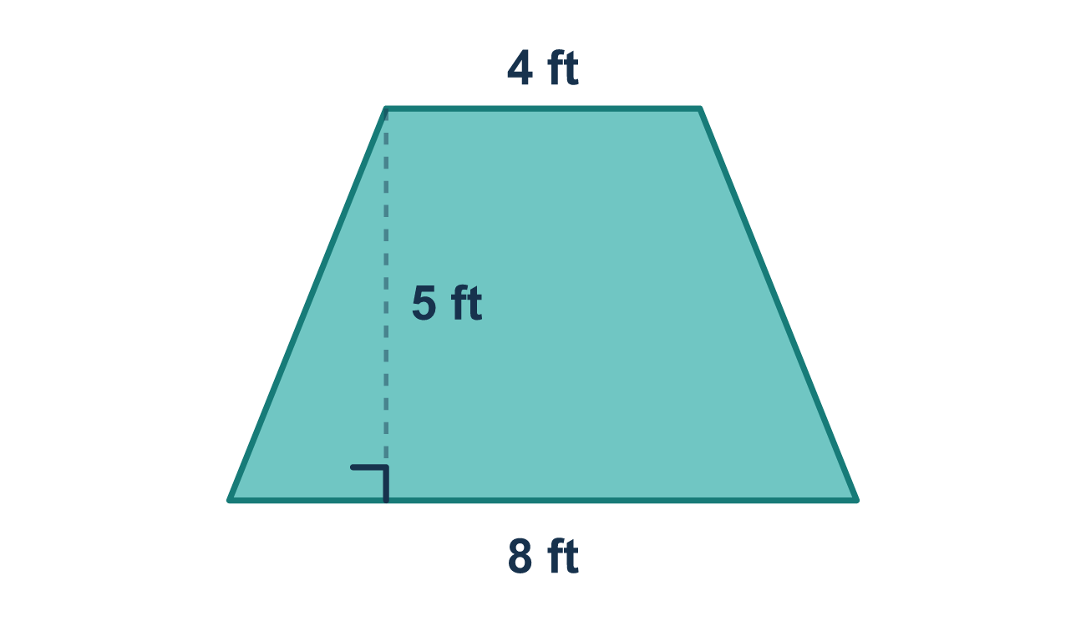
Our class model: add, multiply, take half

Try it
Work it out on paper. Write one answer on each line.
- Which sides are the bases of a trapezoid?
A. The two slanted sides B. The two parallel sides C. The two shortest sides D. Any two neighboring sides
My answer
- A trapezoid has bases of 4 and 6. What is b1 + b2?
A. 10 B. 24 C. 2 D. 46
My answer
- A trapezoid has bases of 5 and 7 and a height of 4. What is its area?
A. 48 square units B. 12 square units C. 24 square units
My answer
- Which formula gives the area of a trapezoid?
A. A = b1 × b2 × h B. A = b1 + b2 + h C. A = (b1 + b2) × h D. A = ½ × (b1 + b2) × h
My answer
- A trapezoid has bases of 8 and 12 and a height of 5. What is its area?
A. 100 square units B. 25 square units C. 50 square units D. 60 square units
My answer

Talk about it
What does the ½ at the start of the formula tell you to do?

Home mission
Look for a trapezoid at home: a tote bag side, a lampshade, or a roof in a picture. Pretend the top is 3 feet, the bottom is 7 feet, and the height is 4 feet. Can your student explain each step out loud?

If we get stuck, ask
- What are the two bases? Let's add them first.
- Did we remember to take half at the end?
- Read the steps out loud: add, multiply, then take half.

Do it on a screen

Scan or type the link. Same lesson, with hints. eduwonderlab.com/lessons/5-3/homework.html
How did it feel? (optional) ☐ Tricky ☐ Getting there ☐ Got it

Family Math Studio · For grown-ups Lesson 5.3 · 6.GR.1

Answers and talk notes
Determine the Area of Trapezoids

What your student is learning
Tonight we find the area of a trapezoid. A trapezoid is a four-sided shape with one pair of parallel sides. Those two sides are the bases, and they have different lengths.

Answers
Ask your student to explain before you look.
- B. The two parallel sides. The two parallel sides are the bases of a trapezoid.
- A. 10. b1 + b2 = 4 + 6 = 10.
- C. 24 square units. A = ½ × (5 + 7) × 4 = ½ × 12 × 4 = 24 square units.
- D. A = ½ × (b1 + b2) × h. The area of a trapezoid is A = ½ × (b1 + b2) × h.
- C. 50 square units. A = ½ × (8 + 12) × 5 = 10 × 5 = 50 square units.

Talk about it
What does the ½ at the start of the formula tell you to do?

When they are stuck, ask
- What are the two bases? Let's add them first.
- Did we remember to take half at the end?
- Read the steps out loud: add, multiply, then take half.

Try not to say
- Just use one base instead of both.
- You don't need the half — just multiply.
- Multiply the two bases together.

Home mission
Look for a trapezoid at home: a tote bag side, a lampshade, or a roof in a picture. Pretend the top is 3 feet, the bottom is 7 feet, and the height is 4 feet. Can your student explain each step out loud?

