Family Math Studio Lesson 5.4 · Session 2 · 6.GR.1

Apply Area Concepts to Solve Problems
Decide for each piece of a shape whether to add it or subtract it.
Name Date

Tonight's spark
A painter will paint a wall that is 12 feet wide and 9 feet tall. The wall has a window that is 3 feet by 4 feet and a door that is 2 feet by 5 feet. How many square feet need paint? Guess first: the whole wall is 108 square feet. Will the painted part be more or less?
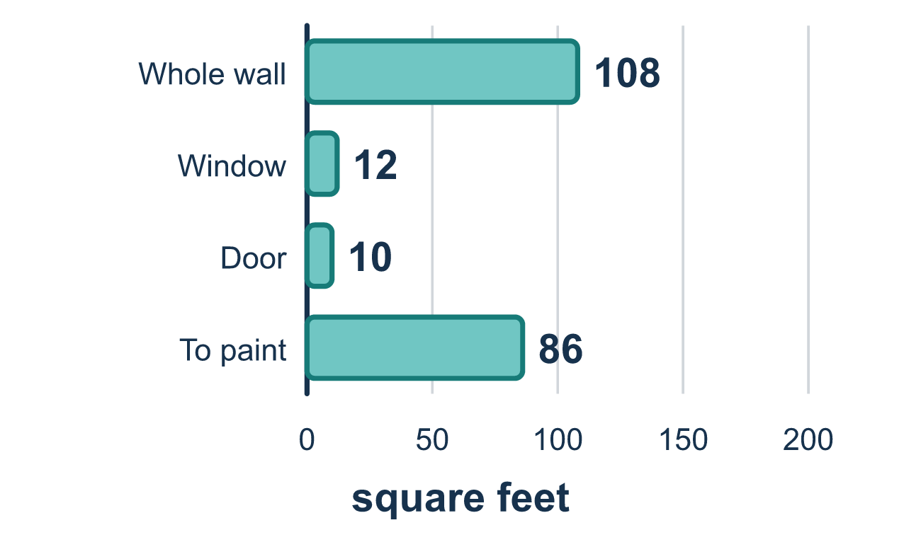
Our class model: part of it or missing from it

Try it
Work it out on paper. Write one answer on each line.
- A piece that has been CUT OUT of a figure gets what?
A. Subtracted B. Added C. Multiplied D. Doubled
My answer
- A 7 by 5 rectangle has a 3 by 2 rectangle joined to its side. What is the total area?
A. 29 square units B. 35 square units C. 41 square units D. 12 square units
My answer
- A 10 by 6 rectangle has a 4 by 3 hole. What is the area of what is left?
A. 72 square units B. 48 square units C. 12 square units D. 60 square units
My answer
- A house shape is an 8 by 5 rectangle with a triangle roof on top. The roof has a base of 8 and a height of 3. What is the total area?
A. 64 square units B. 28 square units C. 43 square units D. 52 square units
My answer

Talk about it
Which piece did you add, which did you subtract, and how did you decide?

Home mission
Look at a wall at home. Pretend it is 10 feet wide and 8 feet tall with one window that is 3 feet by 3 feet. How much wall needs paint? Which piece do you subtract?

If we get stuck, ask
- Is this piece part of the figure, or missing from it?
- What simple shapes can you break this into?
- Did every piece get counted exactly once?

Do it on a screen

Scan or type the link. Same lesson, with hints. eduwonderlab.com/lessons/5-4-part2/homework.html
How did it feel? (optional) ☐ Tricky ☐ Getting there ☐ Got it

Family Math Studio · For grown-ups Lesson 5.4 · Session 2 · 6.GR.1

Answers and talk notes
Apply Area Concepts to Solve Problems

What your student is learning
Tonight we find the area of shapes made from other shapes — and decide for each piece whether to ADD it or SUBTRACT it.

Answers
Ask your student to explain before you look.
- A. Subtracted. Subtracted: a cut-out piece is taken away from the total.
- C. 41 square units. 41 square units: 7 × 5 = 35, 3 × 2 = 6, and 35 + 6 = 41.
- B. 48 square units. 48 square units: 10 × 6 = 60, 4 × 3 = 12, and 60 − 12 = 48.
- D. 52 square units. 52 square units: 8 × 5 = 40, ½ × 8 × 3 = 12, and 40 + 12 = 52.

Talk about it
Which piece did you add, which did you subtract, and how did you decide?

When they are stuck, ask
- Is this piece part of the figure, or missing from it?
- What simple shapes can you break this into?
- Did every piece get counted exactly once?

Try not to say
- Add all the pieces, that is what composite means.
- Find the big rectangle and stop there.
- Overlapping pieces are fine, just add them.

Home mission
Look at a wall at home. Pretend it is 10 feet wide and 8 feet tall with one window that is 3 feet by 3 feet. How much wall needs paint? Which piece do you subtract?

