Family Math Studio Lesson 5.4 · 6.GR.1

Apply Area Concepts to Solve Problems
Find the area of a shape made of simple shapes by finding each piece, then adding or subtracting.
Name Date

Tonight's spark
An L-shaped room splits into two rectangles. One is 12 feet by 8 feet. The other is 6 feet by 5 feet. How many one-foot floor tiles cover the whole room? Guess first: more than 100 tiles, or fewer?
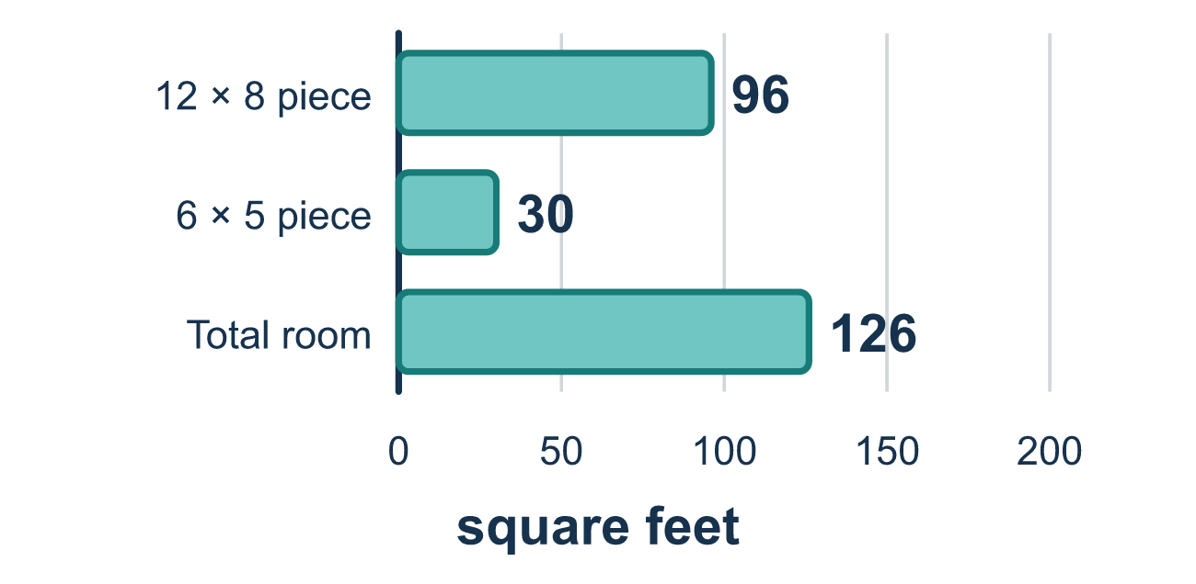
Our class model: break it apart, then add or subtract

Try it
Work it out on paper. Write one answer on each line.
- What is a composite figure?
A. Only one rectangle B. A shape made of two or more simple shapes joined together C. A shape with curved sides only D. A shape with no area
My answer
- An L-shape is split into a 5 by 2 rectangle and a 3 by 2 rectangle. What is the total area?
A. 16 square units B. 8 square units C. 30 square units
My answer
- A 9 by 4 rectangle has a 3 by 2 rectangle cut out. What area is left?
A. 42 B. 30 C. 6 D. 36
My answer
- To find the area of a figure with a hole cut out, what do you do with the hole's area?
A. Add it B. Ignore it C. Subtract it D. Multiply it
My answer
- A regular hexagon is split into 6 equal triangles. Each triangle has an area of 9 cm². What is the area of the hexagon?
A. 15 cm² B. 9 cm² C. 45 cm² D. 54 cm²
My answer

Talk about it
Which pieces did you add, and which piece did you subtract?

Home mission
Cut a square out of one corner of a sheet of paper to make an L. How could you split the L into two rectangles? Is there a second way to find its area?

If we get stuck, ask
- What simple shapes can we break this into?
- Are the pieces joined, or is one cut out?
- Let's find each area first, then decide to add or subtract.

Do it on a screen

Scan or type the link. Same lesson, with hints. eduwonderlab.com/lessons/5-4/homework.html
How did it feel? (optional) ☐ Tricky ☐ Getting there ☐ Got it

Family Math Studio · For grown-ups Lesson 5.4 · 6.GR.1

Answers and talk notes
Apply Area Concepts to Solve Problems

What your student is learning
Tonight we find the area of a composite figure — a shape made of two or more simple shapes joined together, like an L-shaped room. We break it apart, find each piece, then add or subtract.

Answers
Ask your student to explain before you look.
- B. A shape made of two or more simple shapes joined together. A shape made of two or more simple shapes joined together is a composite figure, like an L-shaped room.
- A. 16 square units. 16 square units: 5 × 2 = 10, 3 × 2 = 6, and 10 + 6 = 16.
- B. 30. 30 is what is left: 9 × 4 = 36, 3 × 2 = 6, and 36 − 6 = 30.
- C. Subtract it. Subtract it: the hole is empty space, so take its area away.
- D. 54 cm². 54 cm²: 6 triangles × 9 cm² = 54 cm².

Talk about it
Which pieces did you add, and which piece did you subtract?

When they are stuck, ask
- What simple shapes can we break this into?
- Are the pieces joined, or is one cut out?
- Let's find each area first, then decide to add or subtract.

Try not to say
- Multiply the two pieces together.
- Always add — never subtract.
- Just measure around the outside edge.

Home mission
Cut a square out of one corner of a sheet of paper to make an L. How could you split the L into two rectangles? Is there a second way to find its area?

