Family Math Studio Lesson 5.5 · Session 2 · 6.GR.2

Determine the Volume of Rectangular Prisms
Find a missing edge of a box when you know its volume and two edges.
Name Date

Tonight's spark
The label on a storage box is torn. It says the box holds 720 cubic centimeters. The box is 15 cm wide and 12 cm tall. How long is the box? Guess first: is the box longer or shorter than 15 cm?
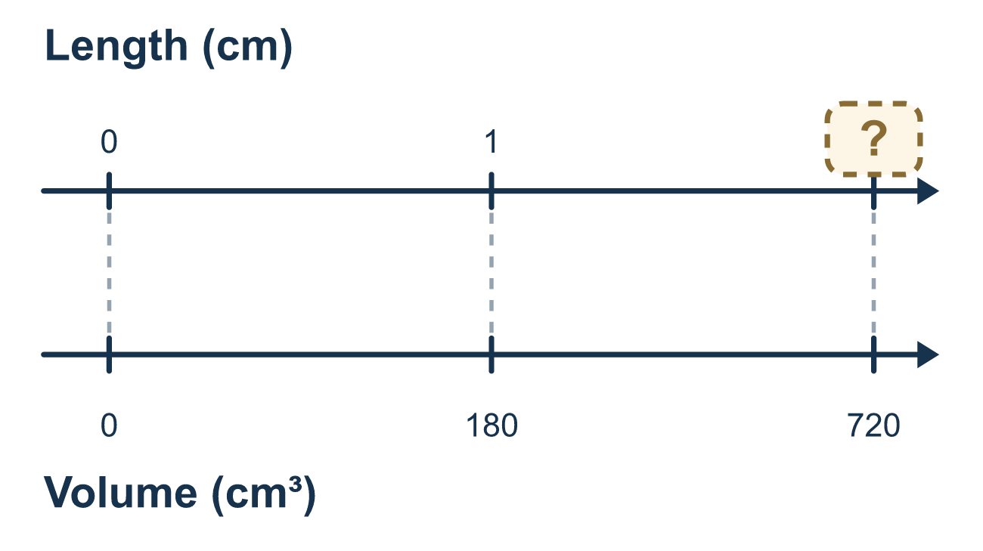
Our class model: work the formula backwards

Try it
Work it out on paper. Write one answer on each line.
- A box has a volume of 30, a length of 5 and a width of 3. What do you do first to find the height?
A. Add 5 and 3 B. Divide 30 by 5 only C. Multiply 5 × 3 D. Subtract 3 from 30
My answer
- A box has a volume of 24 cm³, a length of 4 cm and a width of 3 cm. What is its height?
A. 2 cm B. 6 cm C. 8 cm D. 12 cm
My answer
- A box has a volume of 72 in³ and a base area of 18 in². What is its height?
A. 54 in. B. 4 in. C. 90 in. D. 1,296 in.
My answer
- A box is 2 ft long, 3 ft wide and 1.5 ft tall. What is its volume?
A. 6 cubic ft B. 12 cubic ft C. 6.5 cubic ft D. 9 cubic ft
My answer
- A box has a volume of 45 cm³, a length of 5 cm and a height of 3 cm. What is its width?
A. 9 cm B. 3 cm C. 15 cm D. 30 cm
My answer
- A box is 4 in. by 2 in. by 2.5 in. If 2.5 is rounded down to 2 before multiplying, how many cubic inches are lost?
A. 4 cubic in. B. 0.5 cubic in. C. 2 cubic in. D. 8 cubic in.
My answer

Talk about it
How do you find a missing edge when you know the volume and two other edges?

Home mission
Pick a small box. Pretend its volume is 100 cubic centimeters and two edges are 5 cm and 4 cm. Can your student find the third edge, then check by multiplying all three?

If we get stuck, ask
- How many edges does the formula use? Did you use all of them?
- What do the two edges you know multiply to?
- Did you round a fraction? Put the exact value back in.

Do it on a screen
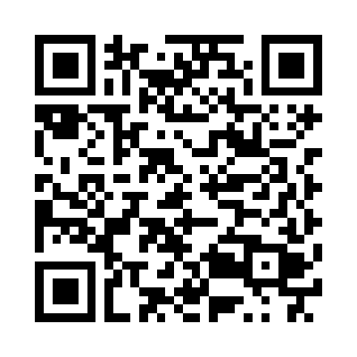
Scan or type the link. Same lesson, with hints. eduwonderlab.com/lessons/5-5-part2/homework.html
How did it feel? (optional) ☐ Tricky ☐ Getting there ☐ Got it

Family Math Studio · For grown-ups Lesson 5.5 · Session 2 · 6.GR.2

Answers and talk notes
Determine the Volume of Rectangular Prisms

What your student is learning
Tonight we work the volume formula backwards to find a missing edge — and we keep fractional edges exact instead of rounding them away.

Answers
Ask your student to explain before you look.
- C. Multiply 5 × 3. Multiply 5 × 3 to get the base area, then divide the volume by it.
- A. 2 cm. 2 cm: the base area is 4 × 3 = 12, and 24 ÷ 12 = 2.
- B. 4 in.. 4 in.: 72 ÷ 18 = 4.
- D. 9 cubic ft. 9 cubic ft: 2 × 3 = 6 and 6 × 1.5 = 9.
- B. 3 cm. 3 cm: 5 × 3 = 15 and 45 ÷ 15 = 3.
- A. 4 cubic in.. 4 cubic in.: exact is 4 × 2 × 2.5 = 20, rounded is 4 × 2 × 2 = 16, and 20 − 16 = 4.

Talk about it
How do you find a missing edge when you know the volume and two other edges?

When they are stuck, ask
- How many edges does the formula use? Did you use all of them?
- What do the two edges you know multiply to?
- Did you round a fraction? Put the exact value back in.

Try not to say
- Add the three edges to get the volume.
- Round the half foot, it will not matter.
- Two edges is close enough for a box.

Home mission
Pick a small box. Pretend its volume is 100 cubic centimeters and two edges are 5 cm and 4 cm. Can your student find the third edge, then check by multiplying all three?

