Family Math Studio Lesson 5.5 · 6.GR.2

Determine the Volume of Rectangular Prisms
Find the volume of a box by multiplying its length, width, and height.
Name Date

Tonight's spark
A class fills a time capsule box. The box is 6 units long, 4 units wide, and 3 units tall. Each small cube is 1 unit on every side. How many cubes fit inside? Guess first: more or fewer than 50 cubes?
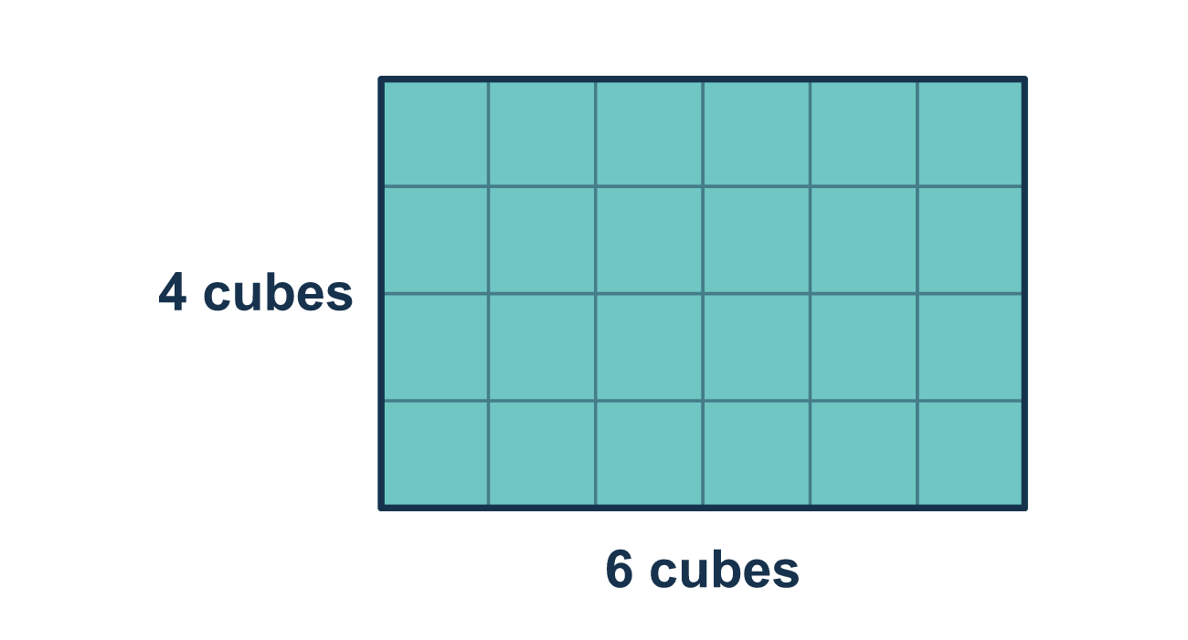
Our class model: layers of cubes

Try it
Work it out on paper. Write one answer on each line.
- What does volume measure?
A. The distance around a shape B. How much space is inside a solid C. The area of one face D. The length of one edge
My answer
- A box is 4 units long, 3 units wide and 2 units tall. What is its volume?
A. 9 cubic units B. 12 cubic units C. 24 cubic units
My answer
- A box is measured in centimeters. What unit goes with its volume?
A. cm³ B. cm C. cm²
My answer
- A box has a base area of 20 square feet and a height of 3 feet. What is its volume?
A. 23 cubic feet B. 60 cubic feet C. 17 cubic feet
My answer
- A box is 10 in. long, 2 in. wide and 5 in. tall. What is its volume?
A. 17 in³ B. 20 in³ C. 50 in³ D. 100 in³
My answer

Talk about it
Why is the volume written in cubic units instead of square units?

Home mission
Find a small box, like a tissue box. Pretend its edges are 3, 3 and 2 units. Can your student say how many unit cubes fill it? Why is the answer in cubic units?

If we get stuck, ask
- What are the three numbers — the length, the width, and the height?
- Let's multiply two of them first, then multiply by the third.
- What units should the answer have? Why cubic?

Do it on a screen

Scan or type the link. Same lesson, with hints. eduwonderlab.com/lessons/5-5/homework.html
How did it feel? (optional) ☐ Tricky ☐ Getting there ☐ Got it

Family Math Studio · For grown-ups Lesson 5.5 · 6.GR.2

Answers and talk notes
Determine the Volume of Rectangular Prisms

What your student is learning
Tonight we find the volume of a box. Volume is how much space fits inside. We multiply the three edges: length, width, and height.

Answers
Ask your student to explain before you look.
- B. How much space is inside a solid. How much space is inside a solid is what volume measures.
- C. 24 cubic units. 24 cubic units: 4 × 3 × 2 = 24.
- A. cm³. cm³ are cubic centimeters, the unit for volume.
- B. 60 cubic feet. 60 cubic feet: 20 × 3 = 60.
- D. 100 in³. 100 in³: 10 × 2 × 5 = 100.

Talk about it
Why is the volume written in cubic units instead of square units?

When they are stuck, ask
- What are the three numbers — the length, the width, and the height?
- Let's multiply two of them first, then multiply by the third.
- What units should the answer have? Why cubic?

Try not to say
- Just add the three edges together.
- You only need the length and the width.
- Volume uses square units.

Home mission
Find a small box, like a tissue box. Pretend its edges are 3, 3 and 2 units. Can your student say how many unit cubes fill it? Why is the answer in cubic units?

