Family Math Studio Lesson 5.6 · Session 2 · 6.GR.4

Represent Three-Dimensional Figures in Two Dimensions
Read a flat net and name the solid it folds into by counting its pieces.
Name Date

Tonight's spark
A craft kit comes with a flat paper pattern. It has 1 square and 4 identical triangles. You fold it up. What solid do you get? Guess first: does it have two bases or one?
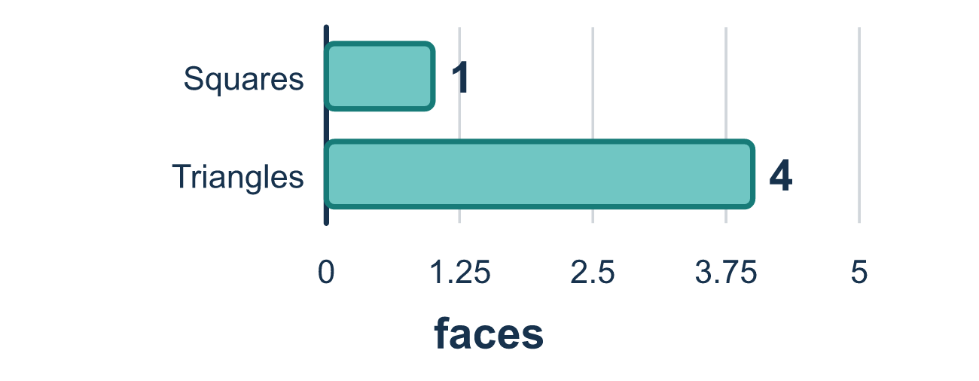
Our class model: count the bases to name the solid

Try it
Work it out on paper. Write one answer on each line.
- How many bases does a prism have?
A. One B. Two C. Three D. Four
My answer
- How many bases does a pyramid have?
A. Two B. Three C. Four D. One
My answer
- A net has 4 triangles and 1 square. What solid does it fold into?
A. Square pyramid B. Triangular prism C. Cube D. Square prism
My answer
- A net has 2 triangles and 3 rectangles. What solid does it fold into?
A. Triangular pyramid B. Rectangular prism C. Triangular prism D. Square pyramid
My answer
- A net has 6 rectangles in three matching pairs. What solid does it fold into?
A. Rectangular pyramid B. Rectangular prism C. Triangular prism
My answer
- How many faces does the net of a triangular prism have?
A. 3 B. 4 C. 6 D. 5
My answer

Talk about it
How many bases does the net have, and what shape are they? What does that tell you about the solid?

Home mission
Open an empty box flat and point to its two matching bases. Can your student say how they know this net folds into a prism and not a pyramid?

If we get stuck, ask
- How many pieces match each other exactly?
- Does this solid have one base or two?
- What shape is the base? That goes in the name.

Do it on a screen

Scan or type the link. Same lesson, with hints. eduwonderlab.com/lessons/5-6-part2/homework.html
How did it feel? (optional) ☐ Tricky ☐ Getting there ☐ Got it

Family Math Studio · For grown-ups Lesson 5.6 · Session 2 · 6.GR.4

Answers and talk notes
Represent Three-Dimensional Figures in Two Dimensions

What your student is learning
Tonight we look at a flat net and name the solid it folds into — by counting its pieces and their shapes.

Answers
Ask your student to explain before you look.
- B. Two. Two: a prism has two matching bases.
- D. One. One: a pyramid has one base and its other faces meet at a point.
- A. Square pyramid. Square pyramid: one square base and four triangles that meet at a point.
- C. Triangular prism. Triangular prism: two triangle bases and three rectangle sides.
- B. Rectangular prism. Rectangular prism: all six faces are rectangles in matching pairs.
- D. 5. 5 faces: 2 triangle bases and 3 rectangles.

Talk about it
How many bases does the net have, and what shape are they? What does that tell you about the solid?

When they are stuck, ask
- How many pieces match each other exactly?
- Does this solid have one base or two?
- What shape is the base? That goes in the name.

Try not to say
- Count one face from each pair, the rest are the same.
- Any net with triangles is a pyramid.
- The number of faces does not matter for naming it.

Home mission
Open an empty box flat and point to its two matching bases. Can your student say how they know this net folds into a prism and not a pyramid?

