Family Math Studio Lesson 5.6 · 6.GR.4

Represent Three-Dimensional Figures in Two Dimensions
Find the surface area of a box by unfolding it into a net and adding all six faces.
Name Date

Tonight's spark
A box is 8 inches long, 5 inches wide, and 3 inches tall. You want to wrap it in paper with no gaps and no overlap. How many square inches of paper do you need? Guess first: more or less than 100 square inches?
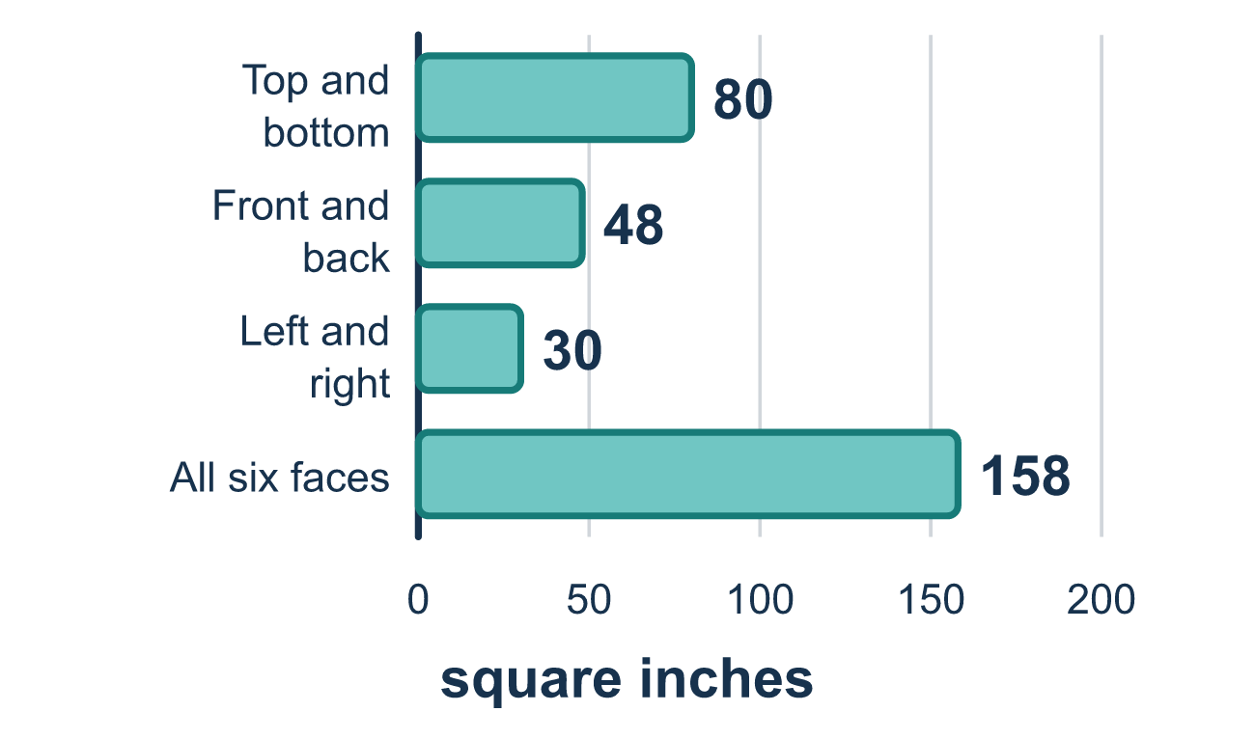
Our class model: unfold the box into a net

Try it
Work it out on paper. Write one answer on each line.
- How many faces does a rectangular box have?
A. 4 B. 6 C. 8 D. 12
My answer
- What is a net?
A. A flat pattern that folds into a solid B. The space inside a solid C. The sum of all the edges D. A picture of a box from the side
My answer
- One face of a box is 5 cm by 2 cm. What is the area of that face?
A. 7 cm² B. 14 cm² C. 10 cm² D. 20 cm²
My answer
- A box's net has 2 faces of 12 square units, 2 faces of 8 square units and 2 faces of 6 square units. What is the surface area?
A. 26 square units B. 46 square units C. 104 square units D. 52 square units
My answer
- A cube has edges of 3 cm. What is its surface area?
A. 9 cm² B. 54 cm² C. 14 square units D. 27 cm²
My answer

Talk about it
How many faces does your box have, and which faces match each other?

Home mission
Open an empty cereal box flat along its seams. Count the faces. Which faces match? Can your student fold it back and say why the box has 6 faces?

If we get stuck, ask
- How many faces does the box have? Let's find each one.
- Each face has a matching face. Did we double every pair?
- What units should the answer have — square or cubic?

Do it on a screen

Scan or type the link. Same lesson, with hints. eduwonderlab.com/lessons/5-6/homework.html
How did it feel? (optional) ☐ Tricky ☐ Getting there ☐ Got it

Family Math Studio · For grown-ups Lesson 5.6 · 6.GR.4

Answers and talk notes
Represent Three-Dimensional Figures in Two Dimensions

What your student is learning
Tonight we find the surface area of a box — how much paper it takes to cover the outside. We unfold the box into a flat net and add up all six faces.

Answers
Ask your student to explain before you look.
- B. 6. A rectangular box has 6 faces: top, bottom, front, back and two sides.
- A. A flat pattern that folds into a solid. A flat pattern that folds into a solid is called a net.
- C. 10 cm². 10 cm²: 5 × 2 = 10.
- D. 52 square units. 52 square units: 12 + 12 + 8 + 8 + 6 + 6 = 52.
- B. 54 cm². 54 cm²: one face is 3 × 3 = 9, and 6 × 9 = 54.

Talk about it
How many faces does your box have, and which faces match each other?

When they are stuck, ask
- How many faces does the box have? Let's find each one.
- Each face has a matching face. Did we double every pair?
- What units should the answer have — square or cubic?

Try not to say
- Just multiply the three edges together.
- A box only has 5 faces, so count five.
- You only need to count one face from each pair.

Home mission
Open an empty cereal box flat along its seams. Count the faces. Which faces match? Can your student fold it back and say why the box has 6 faces?

