Family Math Studio Lesson 5.7 · Session 2 · 6.GR.4

Determine Surface Area of Prisms
Find the surface area of a triangular prism by adding its two triangles and three rectangles.
Name Date

Tonight's spark
A craft shop sells a tent-shaped wooden box. It is 11 cm long. Each triangle end is a right triangle with sides of 6, 8 and 10 cm. Paper covers every face. How many square centimeters of paper? Guess first: is it more than 200 square centimeters, or less?
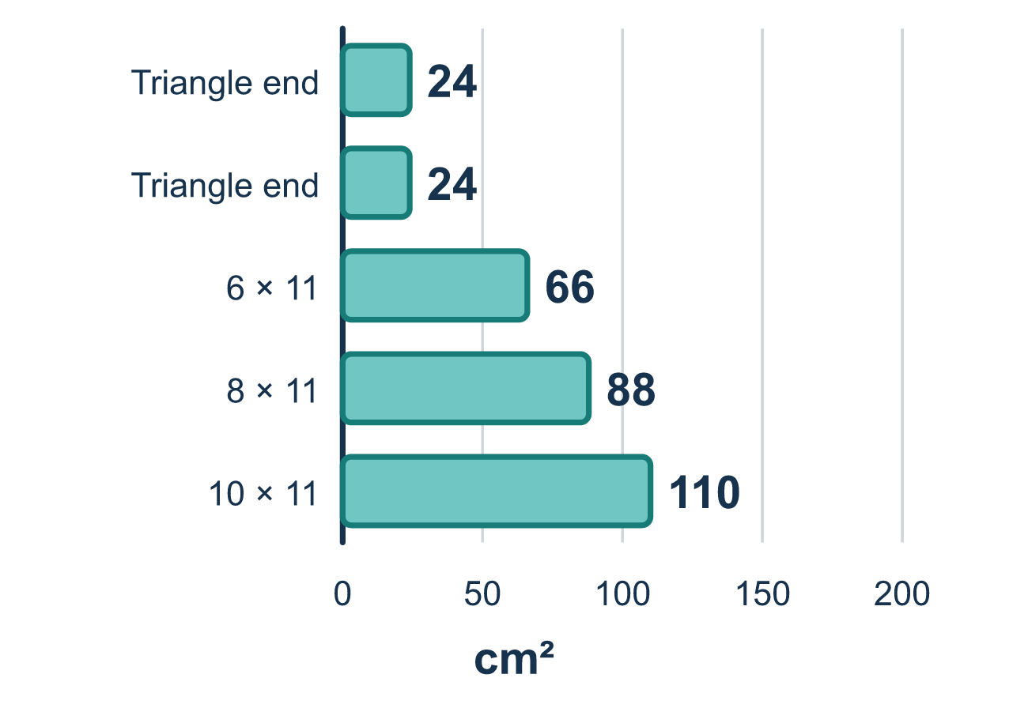
Our class model: the net with five faces

Try it
Work it out on paper. Write one answer on each line.
- A triangular prism has how many triangle ends and how many rectangles?
A. 3 triangles and 2 rectangles B. 2 triangles and 3 rectangles C. 2 triangles and 2 rectangles D. 1 triangle and 4 rectangles
My answer
- A triangle end of a prism has a base of 6 and a height of 4. What is its area?
A. 12 square units B. 24 square units C. 10 square units
My answer
- A tent prism has triangle ends with sides 3, 4 and 5, and its length is 10. What is the area of the rectangle that uses the side of length 4?
A. 14 B. 30 C. 50 D. 40
My answer
- The same tent has rectangles of 30, 40 and 50 square units, and each triangle end is 6 square units. What is the surface area?
A. 126 square units B. 120 square units C. 132 square units D. 264 square units
My answer

Talk about it
Which faces use the length of the tent as one of their sides?

Home mission
Find a tent-shaped box, like a snack package or a toy tent. Count the faces out loud: triangles first, then rectangles. Which rectangle is the biggest?

If we get stuck, ask
- How many faces does this solid have? Name them one by one.
- Which side do all three rectangles share?
- Are we covering the outside or filling the inside?

Do it on a screen
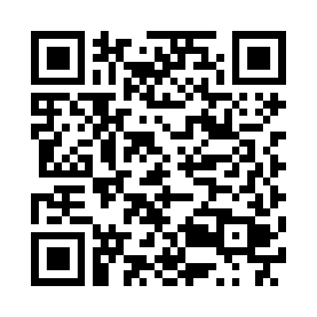
Scan or type the link. Same lesson, with hints. eduwonderlab.com/lessons/5-7-part2/homework.html
How did it feel? (optional) ☐ Tricky ☐ Getting there ☐ Got it

Family Math Studio · For grown-ups Lesson 5.7 · Session 2 · 6.GR.4

Answers and talk notes
Determine Surface Area of Prisms

What your student is learning
Tonight we find the surface area of a triangular prism — a tent shape — by adding its two triangle ends and its three rectangles.

Answers
Ask your student to explain before you look.
- B. 2 triangles and 3 rectangles. 2 triangles and 3 rectangles make the five faces.
- A. 12 square units. 12 square units: ½ × 6 × 4 = 12.
- D. 40. 40: the rectangle is 4 by 10, and 4 × 10 = 40.
- C. 132 square units. 132 square units: 6 + 6 + 30 + 40 + 50 = 132.

Talk about it
Which faces use the length of the tent as one of their sides?

When they are stuck, ask
- How many faces does this solid have? Name them one by one.
- Which side do all three rectangles share?
- Are we covering the outside or filling the inside?

Try not to say
- Multiply length by width by height for surface area.
- One triangle is enough, just remember the other is the same.
- Skip the bottom rectangle, nobody sees it.

Home mission
Find a tent-shaped box, like a snack package or a toy tent. Count the faces out loud: triangles first, then rectangles. Which rectangle is the biggest?

