Family Math Studio Lesson 5.7 · 6.GR.4

Determine Surface Area of Prisms
Find the surface area of rectangular and triangular prisms.
Name Date

Tonight's spark
A rec center makes a model tent from cloth. Each triangle end has a base of 6 inches and a height of 4 inches. The tent is 10 inches long. The two slanted sides are 5 inches each. How much cloth covers every outside face? Guess first: is it more than 100 square inches, or less?
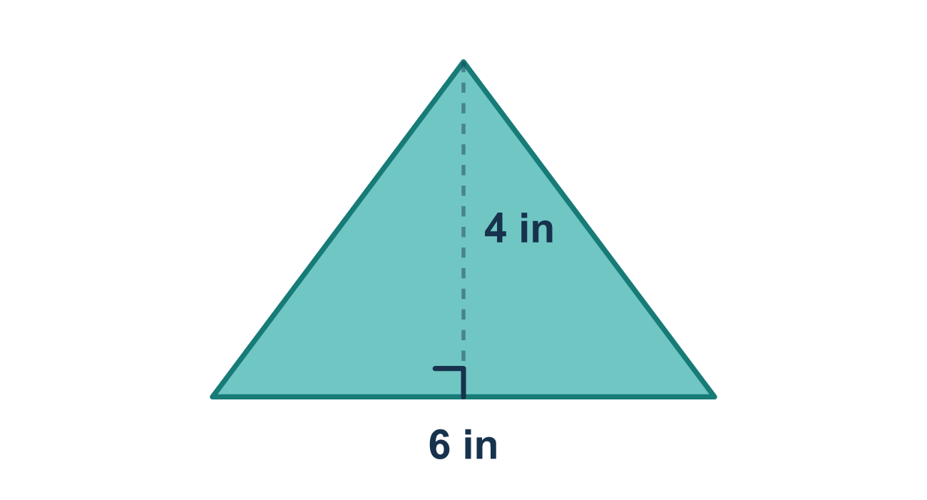
Our class model: add every face

Try it
Work it out on paper. Write one answer on each line.
- How many faces does a triangular prism have?
A. 4 B. 5 C. 6 D. 3
My answer
- A rectangular prism is 5 by 3 by 2. What is the area of the 5 by 3 face?
A. 15 square units B. 8 square units C. 30 square units
My answer
- The faces of a box have areas 6, 8 and 12, and each area appears twice. What is the surface area?
A. 26 square units B. 46 square units C. 52 square units
My answer
- A cube has edges of 4 cm. What is its surface area?
A. 16 cm² B. 24 cm² C. 64 cm² D. 96 cm²
My answer
- A box is 6 cm long, 4 cm wide and 3 cm tall. What is its surface area?
A. 54 cm² B. 108 cm² C. 72 cm² D. 13 cm²
My answer

Talk about it
Which faces are pairs, and why do you double each area?

Home mission
Find a cereal box. Count its faces out loud. Which faces match each other? Then name the biggest face.

If we get stuck, ask
- How many faces does this prism have? Let's list each one.
- Did we add the area of every single face?
- Is this surface area (square units) or volume (cubic units)?

Do it on a screen
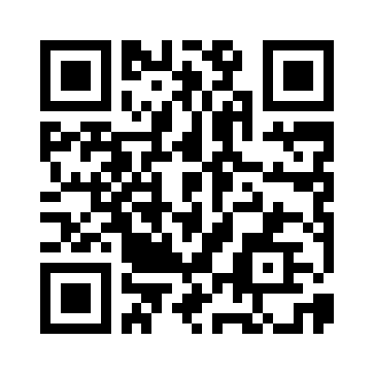
Scan or type the link. Same lesson, with hints. eduwonderlab.com/lessons/5-7/homework.html
How did it feel? (optional) ☐ Tricky ☐ Getting there ☐ Got it

Family Math Studio · For grown-ups Lesson 5.7 · 6.GR.4

Answers and talk notes
Determine Surface Area of Prisms

What your student is learning
Tonight we find the surface area of prisms, including the wedge-shaped triangular prism. For any prism, we find the area of every face and add them all up.

Answers
Ask your student to explain before you look.
- B. 5. A triangular prism has 5 faces: 2 triangles and 3 rectangles.
- A. 15 square units. 15 square units: 5 × 3 = 15.
- C. 52 square units. 52 square units: 6 + 8 + 12 = 26, and 2 × 26 = 52.
- D. 96 cm². 96 cm²: one face is 4 × 4 = 16, and 6 × 16 = 96.
- B. 108 cm². 108 cm²: the faces are 24, 18 and 12, which add to 54, and 2 × 54 = 108.

Talk about it
Which faces are pairs, and why do you double each area?

When they are stuck, ask
- How many faces does this prism have? Let's list each one.
- Did we add the area of every single face?
- Is this surface area (square units) or volume (cubic units)?

Try not to say
- Just multiply length × width × height — that gives surface area.
- A triangular prism has 6 faces like a box.
- Only count one face from each pair.

Home mission
Find a cereal box. Count its faces out loud. Which faces match each other? Then name the biggest face.

