Family Math Studio Lesson 5.8 · Session 2 · 6.GR.4

Determine Surface Area of Pyramids
Find the lateral area of a pyramid: only the slanted faces, with the base left out.
Name Date

Tonight's spark
A model hut is a pyramid with a triangle floor. The floor is 18 cm on each side. Each of the 3 slanted faces has a slant height of 20 cm. You paint only the slanted faces. How many square centimeters get paint? Guess first: is it more than 500 square centimeters, or less?
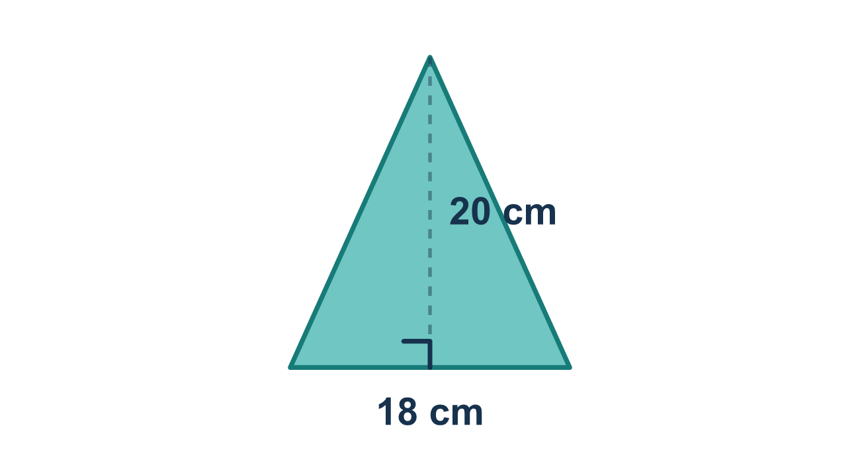
Our class model: slanted faces only

Try it
Work it out on paper. Write one answer on each line.
- What is the lateral area of a pyramid?
A. The area of the base only B. The area of the slanted triangle faces only C. The area of all faces including the base D. The space inside the pyramid
My answer
- The triangle faces of a pyramid are 14 square units each, and there are 4 of them. What is the lateral area?
A. 18 square units B. 28 square units C. 14 square units D. 56 square units
My answer
- A tent is a square pyramid with 4 triangle sides. Each side has a base of 4 and a slant height of 5. How much cloth is needed for the sides only, not the floor?
A. 40 square units B. 56 square units C. 80 square units D. 10 square units
My answer
- A pyramid has a lateral area of 40 and a base area of 16. What is its total surface area?
A. 24 B. 40 C. 56 D. 640
My answer
- You want to paint only the sides of a pyramid-shaped hut, not the floor. Which area do you find?
A. Lateral area B. Total surface area C. Base area D. Volume
My answer

Talk about it
Why do we leave the base out when we only paint or cover the slanted sides?

Home mission
Find a gift box and a lampshade or paper cup. For each one, ask: is the bottom covered? Say when you would add the base and when you would leave it out.

If we get stuck, ask
- Is the bottom being covered in this problem?
- How many slanted faces does this pyramid have?
- Are you using the slant height, or the height through the middle?

Do it on a screen

Scan or type the link. Same lesson, with hints. eduwonderlab.com/lessons/5-8-part2/homework.html
How did it feel? (optional) ☐ Tricky ☐ Getting there ☐ Got it

Family Math Studio · For grown-ups Lesson 5.8 · Session 2 · 6.GR.4

Answers and talk notes
Determine Surface Area of Pyramids

What your student is learning
Tonight we find LATERAL area — the slanted faces of a pyramid only, leaving the base out on purpose.

Answers
Ask your student to explain before you look.
- B. The area of the slanted triangle faces only. The area of the slanted triangle faces only is the lateral area.
- D. 56 square units. 56 square units: 4 × 14 = 56.
- A. 40 square units. 40 square units: one side is ½ × 4 × 5 = 10, and 4 × 10 = 40.
- C. 56. 56: lateral area plus base area is 40 + 16 = 56.
- A. Lateral area. Lateral area is the area of the sides only, which is what you paint.

Talk about it
Why do we leave the base out when we only paint or cover the slanted sides?

When they are stuck, ask
- Is the bottom being covered in this problem?
- How many slanted faces does this pyramid have?
- Are you using the slant height, or the height through the middle?

Try not to say
- Surface area always includes the base.
- Lateral area and surface area are the same thing.
- Any height measurement works in the triangle formula.

Home mission
Find a gift box and a lampshade or paper cup. For each one, ask: is the bottom covered? Say when you would add the base and when you would leave it out.

