Family Math Studio Lesson 5.8 · 6.GR.4

Determine Surface Area of Pyramids
Find the surface area of a pyramid by adding the base and all the triangle faces.
Name Date

Tonight's spark
A museum shop sells a pyramid-shaped gift box. The square bottom is 6 inches on each side. Each triangle side has a slant height of 8 inches. How much paper wraps the whole box? Guess first: is it more than 100 square inches, or less?
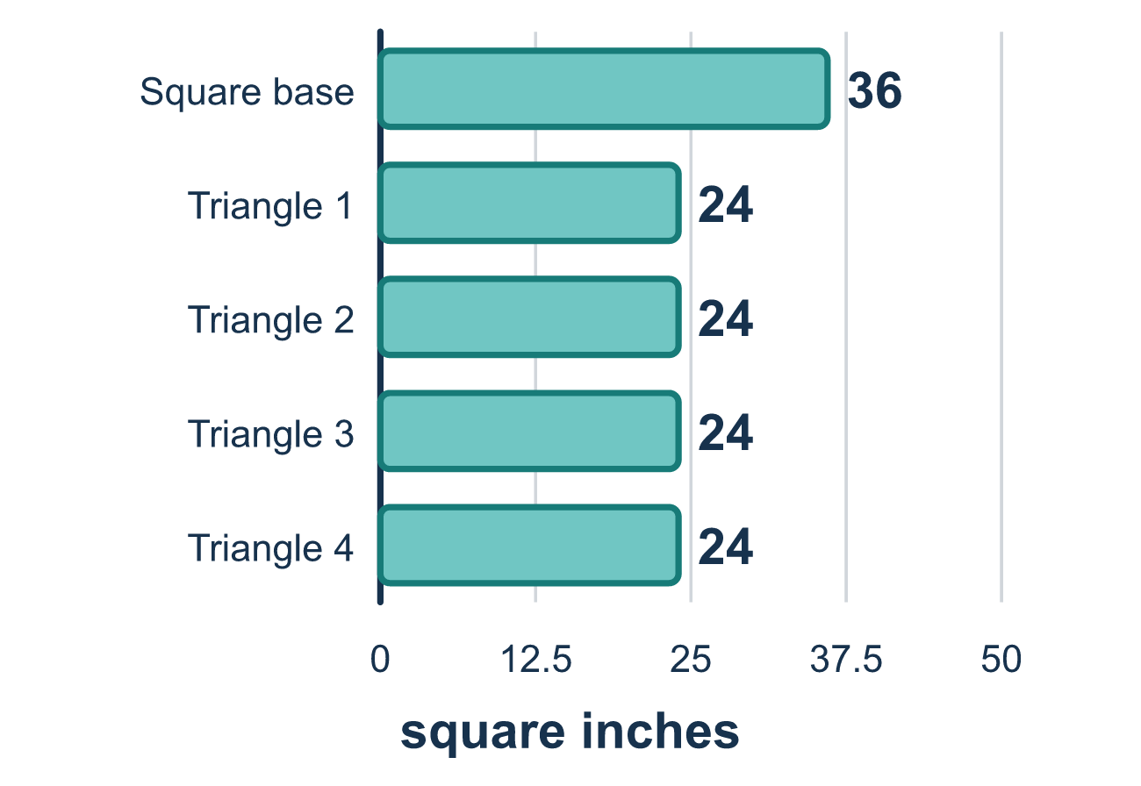
Our class model: base plus triangle sides

Try it
Work it out on paper. Write one answer on each line.
- How many triangular faces does a square pyramid have?
A. 2 B. 3 C. 4 D. 5
My answer
- A triangular face of a pyramid has a base of 6 and a slant height of 5. What is its area?
A. 15 square units B. 30 square units C. 11 square units
My answer
- A pyramid has four triangle faces of 10 square units each and a base of 16 square units. What is its surface area?
A. 26 square units B. 40 square units C. 160 square units D. 56 square units
My answer
- The surface area of a pyramid is the base area plus what?
A. The volume B. The area of all the triangle faces C. The slant height D. The number of edges
My answer
- A square pyramid has a base edge of 6 and a slant height of 4. What is the total area of its four triangle faces?
A. 12 square units B. 24 square units C. 48 square units D. 96 square units
My answer

Talk about it
Does the pyramid have a face on the bottom too?

Home mission
Fold a paper pyramid: draw a square and a triangle on each side of it. Count the faces. Ask: is the square part of the outside? Would you wrap it?

If we get stuck, ask
- What is the base area? Let's find it first.
- How many triangle sides are there? Did we add the base too?
- Which number is the slant height for the triangles?

Do it on a screen

Scan or type the link. Same lesson, with hints. eduwonderlab.com/lessons/5-8/homework.html
How did it feel? (optional) ☐ Tricky ☐ Getting there ☐ Got it

Family Math Studio · For grown-ups Lesson 5.8 · 6.GR.4

Answers and talk notes
Determine Surface Area of Pyramids

What your student is learning
Tonight we find the surface area of a pyramid. We add the area of the flat base plus the area of all the triangle sides that meet at a point on top.

Answers
Ask your student to explain before you look.
- C. 4. A square pyramid has 4 triangular faces, one for each side of the square base.
- A. 15 square units. 15 square units: ½ × 6 × 5 = 15.
- D. 56 square units. 56 square units: 4 × 10 = 40, and 40 + 16 = 56.
- B. The area of all the triangle faces. The area of all the triangle faces is added to the base area.
- C. 48 square units. 48 square units: one face is ½ × 6 × 4 = 12, and 4 × 12 = 48.

Talk about it
Does the pyramid have a face on the bottom too?

When they are stuck, ask
- What is the base area? Let's find it first.
- How many triangle sides are there? Did we add the base too?
- Which number is the slant height for the triangles?

Try not to say
- Just add the four triangles and you're done.
- Forget the ½ — just multiply base times slant height.
- Use the pyramid's straight-up height for the triangle sides.

Home mission
Fold a paper pyramid: draw a square and a triangle on each side of it. Count the faces. Ask: is the square part of the outside? Would you wrap it?

