Family Math Studio Lesson 5.9 · Session 2 · 6.GR.1

Area of Regular Polygons
Find the area of a regular polygon from its triangles, then use it to find a cost.
Name Date

Tonight's spark
A rooftop garden bed is a regular decagon with 10 sides. It splits into 10 equal triangles. Each has a base of 3 feet and a height of 4 feet. Soil costs $5 per square foot. How much to fill the bed? Guess first: is it more than $200, or less?
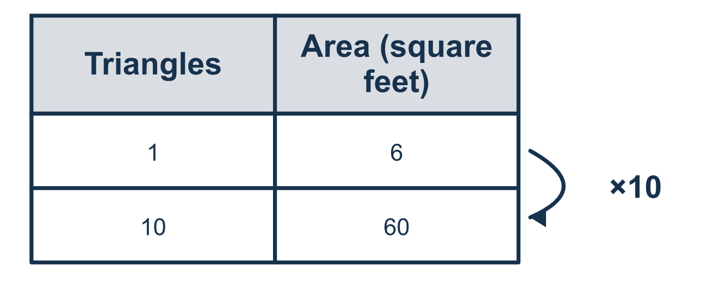
Our class model: one triangle, then multiply

Try it
Work it out on paper. Write one answer on each line.
- A regular polygon has 6 sides. One triangle in it has an area of 8. How do you find the polygon's area?
A. 8 + 6 B. 8 × 6 C. 8 ÷ 6 D. 8 − 6
My answer
- A regular octagon splits into 8 identical triangles of 5 m² each. What is its area?
A. 40 m² B. 13 m² C. 8 m² D. 45 m²
My answer
- A hexagon patio is 6 triangles. Each triangle has a base of 4 m and a height of 3 m. What is the patio's area?
A. 12 m² B. 72 m² C. 6 m² D. 36 m²
My answer
- The patio is 36 m². Tile costs $4 per square meter. How much will the tile cost?
A. $40 B. $9 C. $144 D. $288
My answer
- A pentagon design has an area of 60 square feet. Paint costs $2 per square foot. What is the cost?
A. $120 B. $62 C. $30 D. $240
My answer

Talk about it
Why do you multiply one triangle's area by the number of sides instead of adding?

Home mission
Pick a plate or a rug and imagine it as a hexagon of 6 triangles. If one triangle is 5 square units and tile costs $2 per unit, how would you find the cost out loud?

If we get stuck, ask
- How many identical triangles does this shape split into?
- Did you find one triangle, or the whole shape?
- What does the price tell us we multiply by?

Do it on a screen

Scan or type the link. Same lesson, with hints. eduwonderlab.com/lessons/5-9-part2/homework.html
How did it feel? (optional) ☐ Tricky ☐ Getting there ☐ Got it

Family Math Studio · For grown-ups Lesson 5.9 · Session 2 · 6.GR.1

Answers and talk notes
Area of Regular Polygons

What your student is learning
Tonight we find the area of a regular polygon by splitting it into identical triangles — and then use that area to price a real job.

Answers
Ask your student to explain before you look.
- B. 8 × 6. 8 × 6 gives the area: 6 equal triangles of 8 each.
- A. 40 m². 40 m²: 8 × 5 = 40.
- D. 36 m². 36 m²: one triangle is ½ × 4 × 3 = 6, and 6 × 6 = 36.
- C. $144. $144: 36 × 4 = 144.
- A. $120. $120: 60 × 2 = 120.

Talk about it
Why do you multiply one triangle's area by the number of sides instead of adding?

When they are stuck, ask
- How many identical triangles does this shape split into?
- Did you find one triangle, or the whole shape?
- What does the price tell us we multiply by?

Try not to say
- Add the number of sides to the triangle's area.
- One triangle's area is the answer.
- The cost per square foot is the total cost.

Home mission
Pick a plate or a rug and imagine it as a hexagon of 6 triangles. If one triangle is 5 square units and tile costs $2 per unit, how would you find the cost out loud?

