Family Math Studio Lesson 5.9 · 6.GR.1

Area of Regular Polygons
Find the area of a regular polygon by splitting it into equal triangles.
Name Date

Tonight's spark
A school hallway has a skylight shaped like a hexagon. Each side is 6 feet. A triangle from the center to one side is about 5.2 feet tall. About how many square feet of glass does the skylight need? Guess first: is it more than 50 square feet, or less?
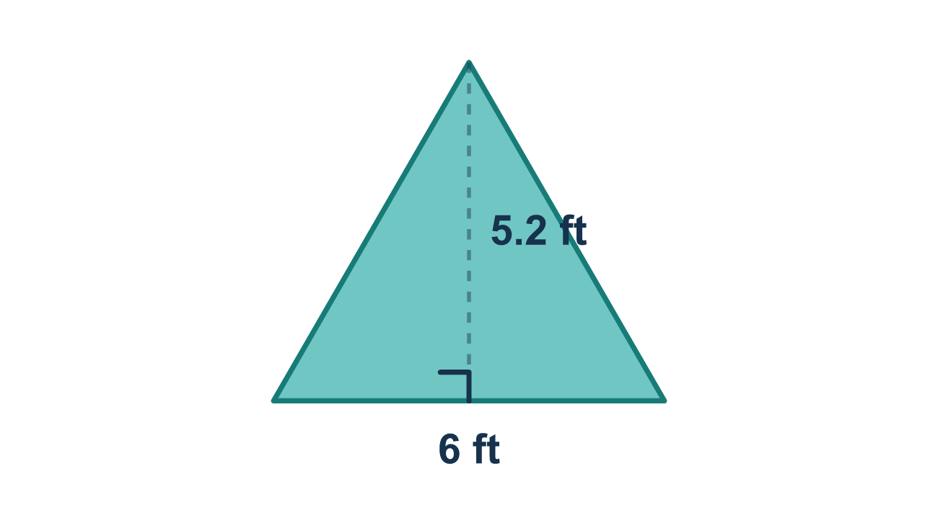
Our class model: split into equal triangles

Try it
Work it out on paper. Write one answer on each line.
- Which describes a regular polygon?
A. All sides equal and all angles equal B. Only two sides equal C. Exactly one right angle D. Sides of any length
My answer
- A regular octagon has 8 sides. Into how many equal triangles can it be split from its center?
A. 6 B. 8 C. 10 D. 4
My answer
- A regular hexagon is split into 6 equal triangles of 10 square units each. What is the area of the hexagon?
A. 16 square units B. 10 square units C. 36 square units D. 60 square units
My answer
- A triangle inside a regular polygon has a base of 4 and a height of 3. What is its area?
A. 12 square units B. 7 square units C. 6 square units D. 24 square units
My answer
- A regular pentagon splits into 5 triangles. Each triangle has a base of 6 and a height of 5. What is the area of the pentagon?
A. 75 square units B. 15 square units C. 150 square units D. 20 square units
My answer

Talk about it
How many triangles fit inside the hexagon?

Home mission
Draw a hexagon on paper. Draw lines from the middle to each corner. Count the triangles. If one triangle is 10 square units, how would you find the whole hexagon?

If we get stuck, ask
- How many sides does the shape have? That is how many triangles we make.
- Let's find one triangle first, then multiply by the number of sides.
- Did we multiply by the number of triangles, or did we stop at one?

Do it on a screen

Scan or type the link. Same lesson, with hints. eduwonderlab.com/lessons/5-9/homework.html
How did it feel? (optional) ☐ Tricky ☐ Getting there ☐ Got it

Family Math Studio · For grown-ups Lesson 5.9 · 6.GR.1

Answers and talk notes
Area of Regular Polygons

What your student is learning
Tonight we find the area of a regular polygon, like a hexagon (6 sides). We break it into equal triangles, find one triangle's area, then add them all up.

Answers
Ask your student to explain before you look.
- A. All sides equal and all angles equal. All sides equal and all angles equal describes a regular polygon.
- B. 8. 8 triangles: a regular polygon splits into one triangle for each side.
- D. 60 square units. 60 square units: 6 × 10 = 60.
- C. 6 square units. 6 square units: ½ × 4 × 3 = 6.
- A. 75 square units. 75 square units: one triangle is ½ × 6 × 5 = 15, and 5 × 15 = 75.

Talk about it
How many triangles fit inside the hexagon?

When they are stuck, ask
- How many sides does the shape have? That is how many triangles we make.
- Let's find one triangle first, then multiply by the number of sides.
- Did we multiply by the number of triangles, or did we stop at one?

Try not to say
- One triangle's area is the whole answer.
- Add the number of sides to the triangle's area.
- Just memorize the steps.

Home mission
Draw a hexagon on paper. Draw lines from the middle to each corner. Count the triangles. If one triangle is 10 square units, how would you find the whole hexagon?

