Family Math Studio Lessons 6.1–6.2 · Extra practice · Session 2 · 6.NOS.1

Fraction Division Practice
Divide a mixed number by a fraction by changing it to a fraction first.
Name Date

Tonight's spark
A bakery has 5 1/4 cups of flour. Each mini-loaf needs 3/4 cup. How many mini-loaves can the baker make? Make a guess first: more than 5 mini-loaves, or fewer?
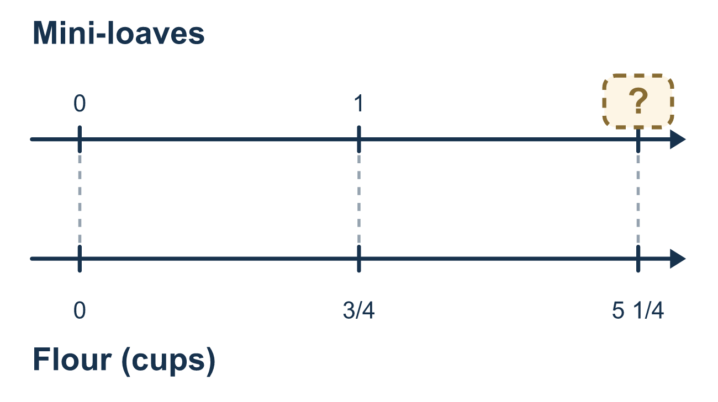
Our class model: convert, then flip

Try it
Work it out on paper. Write one answer on each line.
- Write 2 3/5 as an improper fraction.
A. 6/5 B. 10/5 C. 13/5 D. 23/5
My answer
- To work out 2 1/2 ÷ 3/4, what should you do first?
A. Turn 2 1/2 into 5/2 B. Flip 2 1/2 as it is C. Subtract 3/4 from 2 1/2 D. Multiply 2 1/2 by 3/4
My answer
- Which is the same as 9/2 ÷ 3/4?
A. 9/2 × 3/4 B. 2/9 × 4/3 C. 9/2 ÷ 4/3 D. 9/2 × 4/3
My answer
- What is 9 ÷ 3/4?
A. 27/4 B. 12 C. 1/12 D. 6
My answer
- What is 1 1/2 ÷ 3/4?
A. 2 B. 9/8 C. 1/2 D. 3
My answer

Talk about it
How did you change the mixed number into a fraction, and how many groups did you circle?

Home mission
Pretend 21 coins or beans are the quarter-cups in 5 1/4 cups of flour. Each mini-loaf takes 3 of them. Make groups of 3. How many loaves? Say why 21 quarters equal 5 1/4 cups.

If we get stuck, ask
- Is every number in this problem a fraction yet?
- How do we turn a mixed number into a fraction?
- Which fraction do we flip?

Do it on a screen

Scan or type the link. Same lesson, with hints. eduwonderlab.com/lessons/6-1-6-2-practice-part2/homework.html
How did it feel? (optional) ☐ Tricky ☐ Getting there ☐ Got it

Family Math Studio · For grown-ups Lessons 6.1–6.2 · Extra practice · Session 2 · 6.NOS.1

Answers and talk notes
Fraction Division Practice

What your student is learning
Tonight we bring together everything from 6.1 and 6.2: whole numbers, fractions and mixed numbers all divided with Keep, Change, Flip.

Answers
Ask your student to explain before you look.
- C. 13/5. 2 3/5 = 13/5, because 2 × 5 = 10 and 10 + 3 = 13 fifths.
- A. Turn 2 1/2 into 5/2. Turn 2 1/2 into 5/2 first. Every number has to be a fraction before you use Keep, Change, Flip.
- D. 9/2 × 4/3. 9/2 ÷ 3/4 = 9/2 × 4/3. Keep the first fraction, change ÷ to ×, and flip the divisor.
- B. 12. 9 ÷ 3/4 = 9/1 × 4/3 = 36/3 = 12.
- A. 2. 1 1/2 = 3/2, so 3/2 ÷ 3/4 = 3/2 × 4/3 = 12/6 = 2.

Talk about it
How did you change the mixed number into a fraction, and how many groups did you circle?

When they are stuck, ask
- Is every number in this problem a fraction yet?
- How do we turn a mixed number into a fraction?
- Which fraction do we flip?

Try not to say
- You can flip a mixed number directly.
- Whole numbers do not need to be changed.
- Flip the first fraction, it is the same thing.

Home mission
Pretend 21 coins or beans are the quarter-cups in 5 1/4 cups of flour. Each mini-loaf takes 3 of them. Make groups of 3. How many loaves? Say why 21 quarters equal 5 1/4 cups.

