Family Math Studio Lessons 6.1–6.2 · Extra practice · 6.NOS.1

Fraction Division Practice
Divide whole numbers, fractions and mixed numbers by fractions with Keep, Change, Flip.
Name Date

Tonight's spark
A craft club has a ribbon that is 3/4 yard long. It cuts name tags that each use 1/8 yard. How many tags can the club make? Make a guess first: more than 3 tags, or fewer?
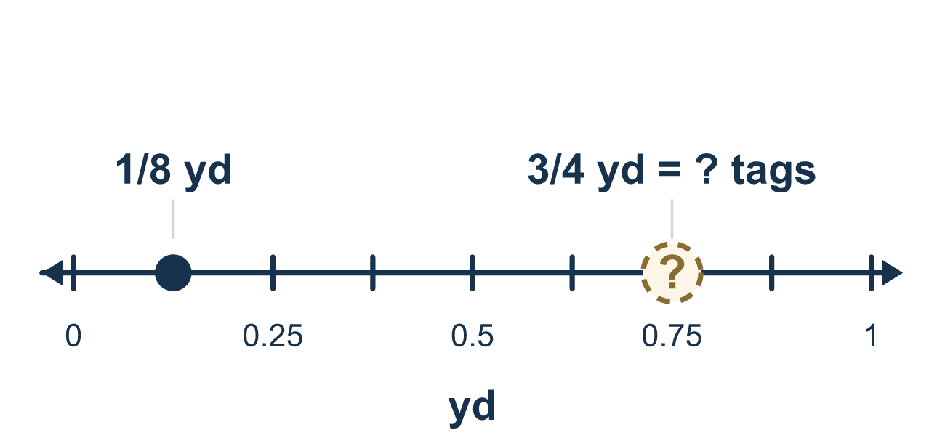
Our class model: Keep, Change, Flip

Try it
Work it out on paper. Write one answer on each line.
- Which fraction is the reciprocal of 3/8?
A. 8/3 B. −3/8 C. 3/8 D. 5/8
My answer
- Which expression asks how many 1/6s fit in 2/3?
A. 1/6 ÷ 2/3 B. 2/3 × 1/6 C. 2/3 ÷ 1/6 D. 2/3 − 1/6
My answer
- What is 6 ÷ 1/2?
A. 3 B. 12 C. 1/12 D. 6 1/2
My answer
- Write 3 1/4 as an improper fraction.
A. 7/4 B. 12/4 C. 31/4 D. 13/4
My answer
- What is 3/5 ÷ 3/10?
A. 1/2 B. 2 C. 9/50 D. 3/2
My answer
- What is 2 1/3 ÷ 1/3?
A. 7/9 B. 1/7 C. 7
My answer

Talk about it
Which number did you flip, and is the answer bigger or smaller than 1 1/2?

Home mission
Cut a paper strip and call it 1 yard. Fold it into 4 equal parts and mark 3 of them. Now fold the whole strip into 8 equal parts. How many 1/8 pieces fit in the 3/4 you marked?

If we get stuck, ask
- Which number do we flip — the first or the second?
- How many of the small pieces fit inside the big one? Let's picture it.
- Should the answer be bigger or smaller than what we started with? Why?

Do it on a screen

Scan or type the link. Same lesson, with hints. eduwonderlab.com/lessons/6-1-6-2-practice/homework.html
How did it feel? (optional) ☐ Tricky ☐ Getting there ☐ Got it

Family Math Studio · For grown-ups Lessons 6.1–6.2 · Extra practice · 6.NOS.1

Answers and talk notes
Fraction Division Practice

What your student is learning
Tonight we review dividing with fractions from Lessons 6.1 and 6.2 — whole numbers, fractions divided by fractions, and mixed numbers.

Answers
Ask your student to explain before you look.
- A. 8/3. The reciprocal of 3/8 is 8/3. Swap the top and bottom numbers.
- C. 2/3 ÷ 1/6. 2/3 ÷ 1/6 asks how many 1/6s fit in 2/3. The total goes first and the piece size is the divisor.
- B. 12. 6 ÷ 1/2 = 12. Each whole holds 2 halves, and 6 × 2 = 12.
- D. 13/4. 3 1/4 = 13/4, because 3 × 4 = 12 and 12 + 1 = 13 fourths.
- B. 2. 3/5 ÷ 3/10 = 3/5 × 10/3 = 30/15 = 2.
- C. 7. 2 1/3 = 7/3, so 7/3 ÷ 1/3 = 7/3 × 3/1 = 7.

Talk about it
Which number did you flip, and is the answer bigger or smaller than 1 1/2?

When they are stuck, ask
- Which number do we flip — the first or the second?
- How many of the small pieces fit inside the big one? Let's picture it.
- Should the answer be bigger or smaller than what we started with? Why?

Try not to say
- Just divide the tops and the bottoms straight across.
- Flip the first fraction instead of the second.
- Start Keep-Change-Flip while it is still a mixed number.

Home mission
Cut a paper strip and call it 1 yard. Fold it into 4 equal parts and mark 3 of them. Now fold the whole strip into 8 equal parts. How many 1/8 pieces fit in the 3/4 you marked?

