Family Math Studio Lesson 6.1 · Session 2 · 6.NOS.1

Division Expressions with Fractions and Whole Numbers
Divide a fraction by a whole number to split it into equal shares.
Name Date

Tonight's spark
A snack bar has a 3/4-pound bag of almonds. A coach splits it evenly into 6 snack cups for the team. How much goes in each cup? Make a guess first: will each cup hold more than 3/4 pound, or less?
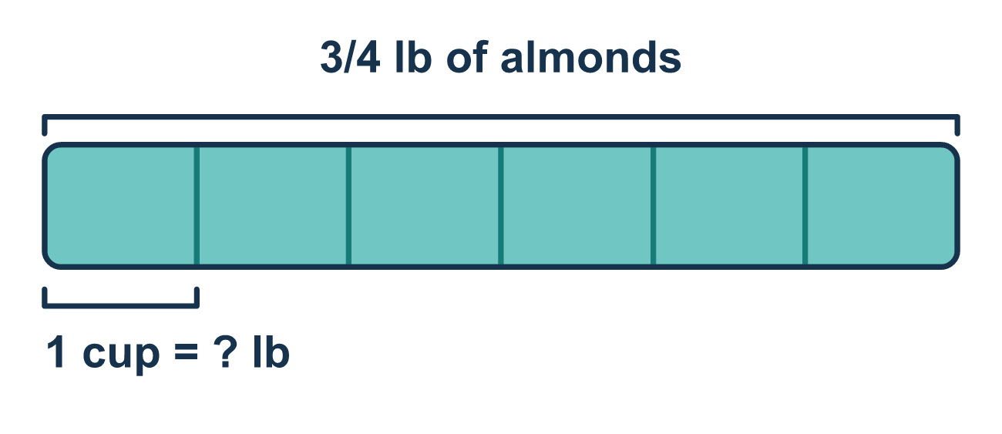
Our class model: splitting into equal shares

Try it
Work it out on paper. Write one answer on each line.
- Which fraction is the same as the whole number 6?
A. 1/6 B. 6/1 C. 6/6 D. 1/1
My answer
- What is the reciprocal of 6?
A. 6 B. −6 C. 6/6 D. 1/6
My answer
- Dividing 2/3 by 5 is the same as multiplying 2/3 by what?
A. 1/5 B. 5 C. 3/2 D. 2/5
My answer
- Use Keep, Change, Flip on 2/5 ÷ 3. Which is the new problem?
A. 5/2 × 3 B. 2/5 ÷ 1/3 C. 2/5 × 1/3 D. 2/5 × 3
My answer
- What is 4/5 ÷ 2?
A. 8/5 B. 2/5 C. 4/7 D. 5/8
My answer
- 2/3 of a gallon of paint is split evenly among 4 jars. How much paint is in each jar?
A. 8/3 B. 2/7 C. 3/2 D. 1/6
My answer

Talk about it
Is one share more or less than the 3/4 you started with, and why?

Home mission
Fold a sheet of paper in half, then in half again, to make fourths. Shade 3 fourths. Pretend it is the bag of almonds. Fold each fourth in half. What fraction of the whole sheet is one cup?

If we get stuck, ask
- How many equal shares are we splitting this into?
- What is the reciprocal of that whole number?
- Should each share be bigger or smaller than what we started with?

Do it on a screen

Scan or type the link. Same lesson, with hints. eduwonderlab.com/lessons/6-1-part2/homework.html
How did it feel? (optional) ☐ Tricky ☐ Getting there ☐ Got it

Family Math Studio · For grown-ups Lesson 6.1 · Session 2 · 6.NOS.1

Answers and talk notes
Division Expressions with Fractions and Whole Numbers

What your student is learning
Tonight we divide a fraction BY a whole number — splitting a part into even smaller equal shares.

Answers
Ask your student to explain before you look.
- B. 6/1. 6 = 6/1. Any whole number can be written over 1.
- D. 1/6. The reciprocal of 6 is 1/6, because 6 = 6/1 and flipping gives 1/6.
- A. 1/5. 2/3 ÷ 5 = 2/3 × 1/5. Dividing by 5 is the same as multiplying by its reciprocal, 1/5.
- C. 2/5 × 1/3. 2/5 ÷ 3 becomes 2/5 × 1/3. Keep 2/5, change ÷ to ×, and flip 3/1 to 1/3.
- B. 2/5. 4/5 ÷ 2 = 4/5 × 1/2 = 4/10 = 2/5.
- D. 1/6. 2/3 ÷ 4 = 2/3 × 1/4 = 2/12 = 1/6 gallon in each jar.

Talk about it
Is one share more or less than the 3/4 you started with, and why?

When they are stuck, ask
- How many equal shares are we splitting this into?
- What is the reciprocal of that whole number?
- Should each share be bigger or smaller than what we started with?

Try not to say
- Flip the first fraction instead.
- Dividing always makes the answer bigger.
- You do not have to simplify the answer.

Home mission
Fold a sheet of paper in half, then in half again, to make fourths. Shade 3 fourths. Pretend it is the bag of almonds. Fold each fourth in half. What fraction of the whole sheet is one cup?

