Family Math Studio Lesson 6.1 · 6.NOS.1

Division Expressions with Fractions and Whole Numbers
Divide a whole number by a fraction and say what the answer counts.
Name Date

Tonight's spark
The rec center has a 3-foot strip of tape. Staff cut it into pieces that are each 1/4 foot long to label lockers. How many pieces do they get? Make a guess first: will there be more than 3 pieces, or fewer?
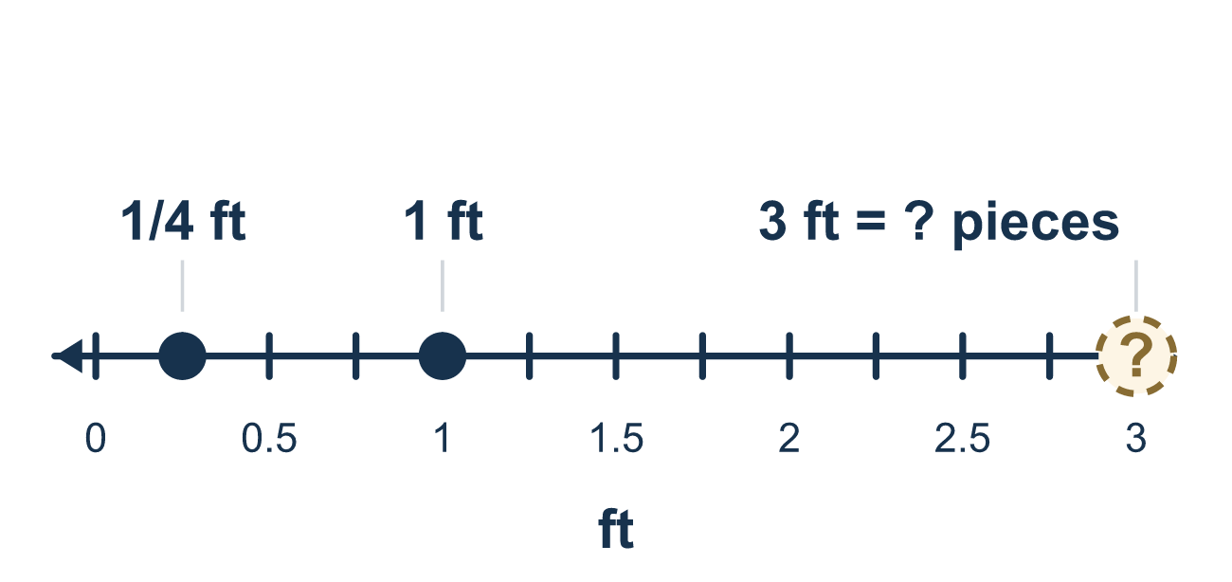
Our class model: the how-many-fit question

Try it
Work it out on paper. Write one answer on each line.
- 3 ÷ 1/2 asks how many halves fit in 3. What is 3 ÷ 1/2?
A. 1 1/2 B. 6 C. 2 1/2 D. 3
My answer
- How many 1/4-foot pieces fit in 2 feet? Find 2 ÷ 1/4.
A. 8 B. 1/2 C. 6 D. 16
My answer
- 1/2 of a pan is split into 4 equal shares. What fraction of the whole pan is one share? Find 1/2 ÷ 4.
A. 2 B. 1/4 C. 1/8 D. 1/6
My answer
- Which expression asks, "How many 1/3-cup scoops fill 4 cups?"
A. 1/3 ÷ 4 B. 4 − 1/3 C. 3 ÷ 1/4 D. 4 ÷ 1/3
My answer
- A baker cuts 5 loaves into slices that are each 1/3 of a loaf. How many slices are there?
A. 8 B. 15 C. 5/3 D. 2
My answer

Talk about it
How many 1/4-foot pieces fit in just one foot?

Home mission
Use a ruler or a strip of paper 1 foot long. Mark every 3 inches. Ask your student: how many pieces fit in 1 foot? How many would fit in a 3-foot strip? Guess out loud, then check.

If we get stuck, ask
- How many small pieces fit into just one whole? Let's start there.
- We have more than one whole. How many wholes are there?
- Will the answer be more or less than what we started with? Why?

Do it on a screen

Scan or type the link. Same lesson, with hints. eduwonderlab.com/lessons/6-1/homework.html
How did it feel? (optional) ☐ Tricky ☐ Getting there ☐ Got it

Family Math Studio · For grown-ups Lesson 6.1 · 6.NOS.1

Answers and talk notes
Division Expressions with Fractions and Whole Numbers

What your student is learning
Tonight we model and write division expressions both ways: a whole number divided by a fraction, and a fraction divided by a whole number.

Answers
Ask your student to explain before you look.
- B. 6. 3 ÷ 1/2 = 6, because each whole has 2 halves and 3 × 2 = 6.
- A. 8. 2 ÷ 1/4 = 8. Each foot holds 4 pieces, and 2 × 4 = 8.
- C. 1/8. 1/2 ÷ 4 = 1/8. Cutting a half into 4 equal parts makes eighths of the whole.
- D. 4 ÷ 1/3. 4 ÷ 1/3 asks how many 1/3-cup scoops fit in 4 cups. The total goes first and the scoop size is the divisor.
- B. 15. 5 ÷ 1/3 = 15. Each loaf makes 3 slices, and 5 × 3 = 15.

Talk about it
How many 1/4-foot pieces fit in just one foot?

When they are stuck, ask
- How many small pieces fit into just one whole? Let's start there.
- We have more than one whole. How many wholes are there?
- Will the answer be more or less than what we started with? Why?

Try not to say
- Dividing always makes the answer smaller.
- 3 ÷ 1/4 is the same as 1/4 of 3.
- Just divide 3 by 4 to get the answer.

Home mission
Use a ruler or a strip of paper 1 foot long. Mark every 3 inches. Ask your student: how many pieces fit in 1 foot? How many would fit in a 3-foot strip? Guess out loud, then check.

