Family Math Studio Lesson 6.10 · Session 2 · 6.NOS.1

Divide Mixed Numbers
Solve a real cutting problem by dividing mixed numbers after converting both.
Name Date

Tonight's spark
A craft store sells ribbon by the yard. A shopper buys 4 1/2 yards. Each bow uses 1 1/2 yards. How many bows can she make? Guess first: will she make more than 4 bows, or fewer?
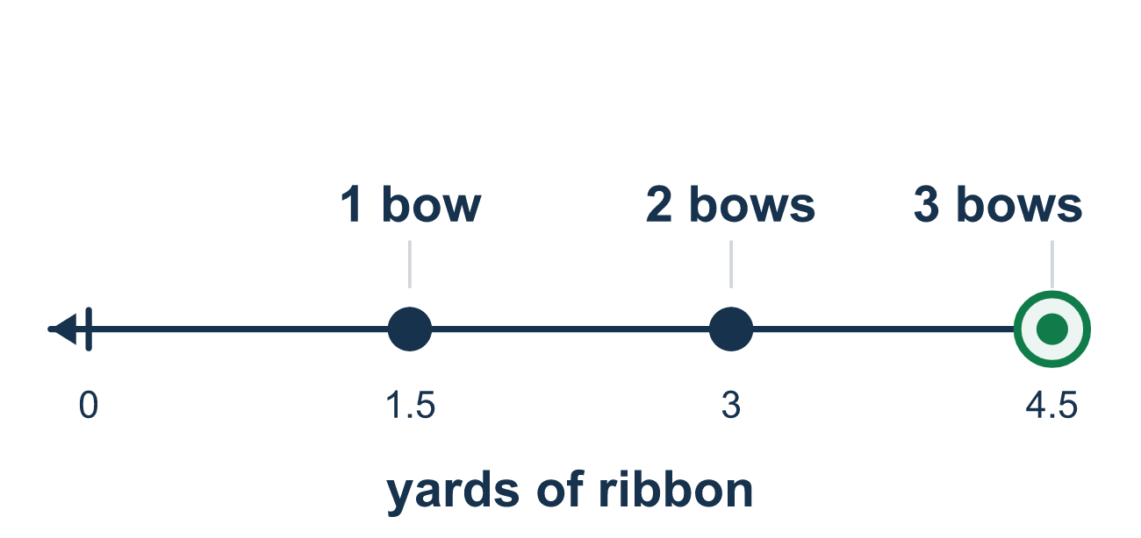
Our class model: convert both numbers first

Try it
Work it out on paper. Write one answer on each line.
- To find 3 1/4 ÷ 1/2, what should you do FIRST?
A. Divide 3 by 1/2 and 1/4 by 1/2 separately B. Change 3 1/4 to an improper fraction C. Flip 3 1/4 upside down D. Add 3 and 1/4 and 1/2
My answer
- A 5 1/4-foot rope is cut into 3/4-foot pieces. Which number sentence fits?
A. 3/4 ÷ 5 1/4 B. 5 1/4 × 3/4 C. 5 1/4 − 3/4 D. 5 1/4 ÷ 3/4
My answer
- Find 2 1/2 ÷ 5/8.
A. 1 9/16 B. 4 C. 3 1/8 D. 2
My answer
- Find 5 1/4 ÷ 3/4.
A. 7 B. 3 15/16 C. 4 1/2
My answer
- A 3 3/4-foot pipe is cut into pieces that are each 1 1/4 feet long. How many pieces?
A. 2 1/2 B. 4 11/16 C. 3 D. 5
My answer
- Which is the closest estimate for 8 1/2 ÷ 1/2?
A. about 4 B. about 9 C. about 17
My answer

Talk about it
Did you change the mixed number into an improper fraction before dividing? How many pieces make sense?

Home mission
Cut a paper strip that is 6 inches long. Ask: how many pieces that are each 1 1/2 inches long can you cut? Guess first, then fold or cut to check.

If we get stuck, ask
- Is the mixed number a single fraction yet?
- How do we turn a mixed number into an improper fraction?
- How many of those pieces fit into the whole length?

Do it on a screen

Scan or type the link. Same lesson, with hints. eduwonderlab.com/lessons/6-10-part2/homework.html
How did it feel? (optional) ☐ Tricky ☐ Getting there ☐ Got it

Family Math Studio · For grown-ups Lesson 6.10 · Session 2 · 6.NOS.1

Answers and talk notes
Divide Mixed Numbers

What your student is learning
Tonight we divide a mixed number by a fraction to answer a real cutting problem — how many pieces a length gives.

Answers
Ask your student to explain before you look.
- B. Change 3 1/4 to an improper fraction. Change 3 1/4 to an improper fraction first: 3 1/4 = 13/4.
- D. 5 1/4 ÷ 3/4. The whole rope is split into 3/4-foot pieces, so 5 1/4 ÷ 3/4.
- B. 4. 2 1/2 = 5/2, and 5/2 × 8/5 = 40/10 = 4.
- A. 7. 5 1/4 = 21/4, and 21/4 × 4/3 = 84/12 = 7.
- C. 3. 3 3/4 = 15/4 and 1 1/4 = 5/4, so 15/4 × 4/5 = 60/20 = 3 pieces.
- C. about 17. Each whole holds 2 halves, so 8 1/2 wholes hold about 17 halves.

Talk about it
Did you change the mixed number into an improper fraction before dividing? How many pieces make sense?

When they are stuck, ask
- Is the mixed number a single fraction yet?
- How do we turn a mixed number into an improper fraction?
- How many of those pieces fit into the whole length?

Try not to say
- Divide the whole numbers, then the fractions.
- Leave it as a mixed number and just flip it.
- A leftover piece does not need to be mentioned.

Home mission
Cut a paper strip that is 6 inches long. Ask: how many pieces that are each 1 1/2 inches long can you cut? Guess first, then fold or cut to check.

