Family Math Studio Lesson 6.10 · 6.NOS.1

Divide Mixed Numbers
Change mixed numbers to improper fractions, then divide.
Name Date

Tonight's spark
A neighborhood walking path is 3 1/2 miles long. A volunteer marks it in sections that are each 1/4 mile. How many sections does the path have? Guess first: more than 10 sections, or fewer?
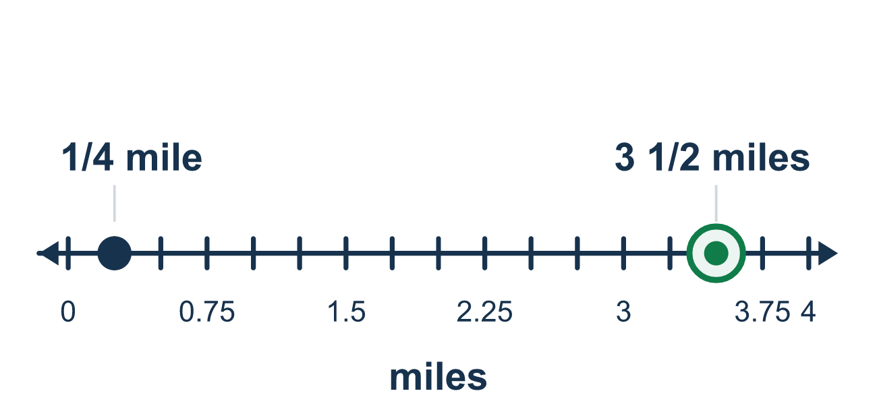
Our class model: convert first, then Keep, Change, Flip

Try it
Work it out on paper. Write one answer on each line.
- Write 2 1/3 as an improper fraction.
A. 21/3 B. 7/3 C. 6/3 D. 5/3
My answer
- Write 11/4 as a mixed number.
A. 2 3/4 B. 3 1/4 C. 2 1/4 D. 11 1/4
My answer
- What is the reciprocal of 5/2?
A. 5/2 B. 2 1/2 C. 2/5
My answer
- Find 1 1/2 ÷ 1/4.
A. 3/8 B. 2 C. 5 1/2 D. 6
My answer
- Find 3 1/2 ÷ 1 3/4.
A. 6 1/8 B. 2 C. 5 1/4 D. 1/2
My answer
- A 4 1/2-foot board is cut into pieces that are each 3/4 foot long. How many pieces?
A. 3 3/8 B. 5 1/4 C. 6 D. 1 1/2
My answer

Talk about it
How many halves are in the 3 wholes of 3 1/2?

Home mission
Find a ruler. Measure a pencil to the nearest 1/2 inch. Ask: how many 1/2-inch pieces would it make? Guess first, then count the halves on the ruler.

If we get stuck, ask
- Before we divide, did we change the mixed number into a fraction?
- To convert, multiply the whole by the bottom, then add the top. What do we get?
- Now which fraction do we flip to divide?

Do it on a screen

Scan or type the link. Same lesson, with hints. eduwonderlab.com/lessons/6-10/homework.html
How did it feel? (optional) ☐ Tricky ☐ Getting there ☐ Got it

Family Math Studio · For grown-ups Lesson 6.10 · 6.NOS.1

Answers and talk notes
Divide Mixed Numbers

What your student is learning
Tonight we divide mixed numbers, like 3 1/2. First we change each mixed number into an improper fraction, then we divide with Keep, Change, Flip.

Answers
Ask your student to explain before you look.
- B. 7/3. 2 × 3 = 6, and 6 + 1 = 7, so 2 1/3 = 7/3.
- A. 2 3/4. 11 ÷ 4 is 2 with 3 left over, so 11/4 = 2 3/4.
- C. 2/5. Flip the top and bottom: the reciprocal of 5/2 is 2/5.
- D. 6. 1 1/2 = 3/2, then 3/2 × 4/1 = 12/2 = 6.
- B. 2. 3 1/2 = 7/2 and 1 3/4 = 7/4, so 7/2 × 4/7 = 28/14 = 2.
- C. 6. 4 1/2 = 9/2, and 9/2 ÷ 3/4 = 9/2 × 4/3 = 36/6 = 6 pieces.

Talk about it
How many halves are in the 3 wholes of 3 1/2?

When they are stuck, ask
- Before we divide, did we change the mixed number into a fraction?
- To convert, multiply the whole by the bottom, then add the top. What do we get?
- Now which fraction do we flip to divide?

Try not to say
- Divide the whole numbers and the fractions separately.
- When converting, multiply but forget to add the top number.
- You can divide a mixed number without changing it first.

Home mission
Find a ruler. Measure a pencil to the nearest 1/2 inch. Ask: how many 1/2-inch pieces would it make? Guess first, then count the halves on the ruler.

