Family Math Studio Lesson 6.11 · Session 2 · 6.NOS.1

Fraction Division Problem Solving
Decide which number goes first in a fraction division word problem.
Name Date

Tonight's spark
A coach has 5/6 hour of game video. Each highlight clip is 1/12 hour long. How many clips can she cut? Guess first: will it be more than 5 clips, or fewer?
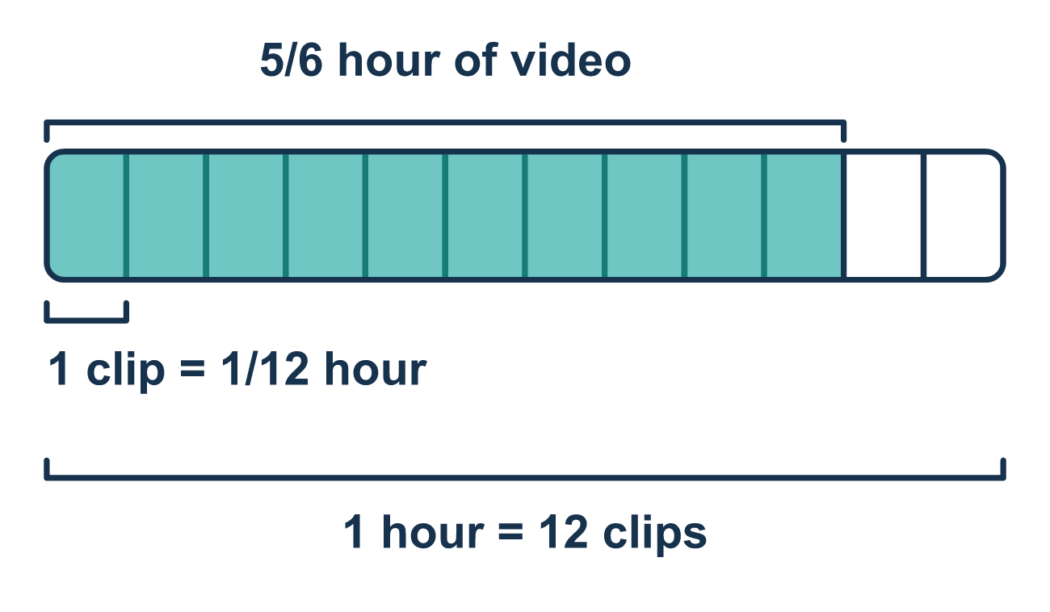
Our class model: say the total, then the group

Try it
Work it out on paper. Write one answer on each line.
- A box holds 5/8 pound of nails. Each bag gets 1/16 pound. In this problem, which fraction is the size of one group?
A. 5/8 B. 1/16 C. 5/16
My answer
- Which equation matches "How many 1/4-cup scoops are in 3/4 cup of flour?"
A. 3/4 ÷ 1/4 B. 1/4 ÷ 3/4 C. 3/4 × 1/4 D. 3/4 − 1/4
My answer
- Find 3/4 ÷ 3/8.
A. 9/32 B. 1/2 C. 1 1/8 D. 2
My answer
- Find 9/10 ÷ 3/20.
A. 1/6 B. 6 C. 3/4 D. 27/200
My answer
- Without solving, which answer makes sense for "How many 1/6-pound slices can be cut from 5/6 pound of cheese?"
A. 5/36 of a slice B. 1/5 of a slice C. 5 slices
My answer

Talk about it
Which number is the total, and which is the size of one group? Does your answer make sense for a "how many" question?

Home mission
Find a cup and a small spoon. Say, "The total is the cup. One group is the spoon." Guess how many spoonfuls fill the cup. Then spoon rice into the cup and count. Which number went first?

If we get stuck, ask
- What is the total amount, and what is one group?
- Which one goes first in the division?
- Does your answer make sense as a number of groups?

Do it on a screen

Scan or type the link. Same lesson, with hints. eduwonderlab.com/lessons/6-11-part2/homework.html
How did it feel? (optional) ☐ Tricky ☐ Getting there ☐ Got it

Family Math Studio · For grown-ups Lesson 6.11 · Session 2 · 6.NOS.1

Answers and talk notes
Fraction Division Problem Solving

What your student is learning
Tonight the hard part is not the arithmetic — it is deciding which number goes FIRST in the division.

Answers
Ask your student to explain before you look.
- B. 1/16. One bag gets 1/16 pound, so 1/16 is the size of one group.
- A. 3/4 ÷ 1/4. The total 3/4 cup is split into scoops of 1/4 cup, so 3/4 ÷ 1/4.
- D. 2. 3/4 × 8/3 = 24/12 = 2.
- B. 6. 9/10 × 20/3 = 180/30 = 6.
- C. 5 slices. Five 1/6s make 5/6, so 5 slices fit.

Talk about it
Which number is the total, and which is the size of one group? Does your answer make sense for a "how many" question?

When they are stuck, ask
- What is the total amount, and what is one group?
- Which one goes first in the division?
- Does your answer make sense as a number of groups?

Try not to say
- Put the smaller number first, it is easier.
- Any order works, division is flexible.
- A fraction answer is fine for how many pieces.

Home mission
Find a cup and a small spoon. Say, "The total is the cup. One group is the spoon." Guess how many spoonfuls fill the cup. Then spoon rice into the cup and count. Which number went first?

