Family Math Studio Lesson 6.11 · 6.NOS.1

Fraction Division Problem Solving
Solve a word problem by putting the total first in a fraction division, then check by multiplying.
Name Date

Tonight's spark
A pitcher has 2/3 gallon of lemonade. Each cup holds 1/6 gallon. How many cups can you fill? Guess first: will it be more than 2 cups, or fewer?
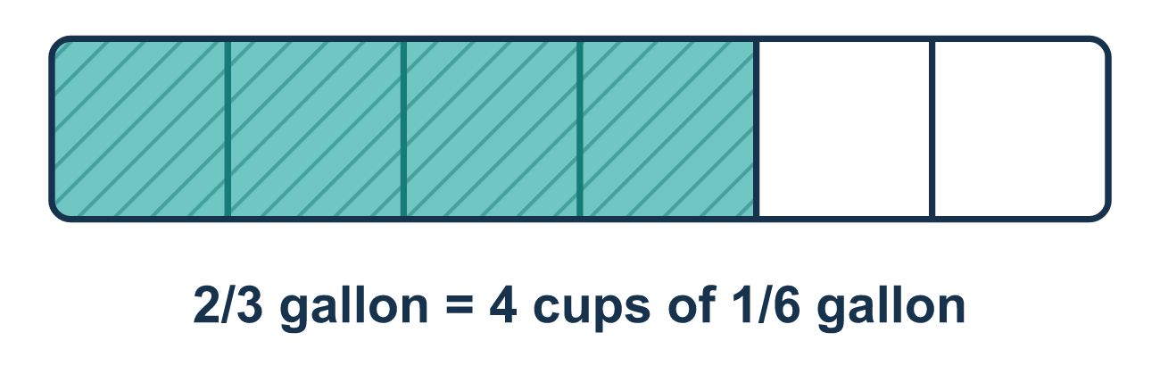
Our class model: total ÷ group size

Try it
Work it out on paper. Write one answer on each line.
- A bottle holds 4/5 liter. Each cup holds 1/10 liter. How many cups can you fill? Which number is the dividend (the total)?
A. 1/10 B. 4/5 C. 5 D. 14/10
My answer
- Which equation finds how many 1/8-pound servings are in 3/4 pound?
A. 1/8 ÷ 3/4 B. 3/4 × 1/8 C. 3/4 ÷ 1/8 D. 3/4 + 1/8
My answer
- Find 3/4 ÷ 1/8.
A. 3/32 B. 5/8 C. 1/6 D. 6
My answer
- Find 7/8 ÷ 1/4.
A. 3 1/2 B. 7/32 C. 1 1/8 D. 2/7
My answer
- Maya finds 1/2 ÷ 1/8 = 4. Which multiplication checks her answer?
A. 4 × 1/2 = 1/8 B. 4 × 1/8 = 1/2 C. 4 ÷ 1/8 = 1/2 D. 4 + 1/8 = 1/2
My answer
- A pitcher has 3/4 quart of juice. Each glass holds 3/16 quart. How many glasses can be filled?
A. 3/64 B. 9/16 C. 4 D. 1/4
My answer

Talk about it
Which amount is the total being split, the pitcher or one cup?

Home mission
Pick a big cup and a small scoop. Say out loud, "The total is the big cup, and one group is the scoop." Guess how many scoops fill the cup. Then scoop and count. Which came first in your division?

If we get stuck, ask
- Which number is the total being split up? That one goes first.
- Does the story ask how many groups fit? Then we divide.
- Let's check: if we multiply the answer by the piece size, do we get the total back?

Do it on a screen

Scan or type the link. Same lesson, with hints. eduwonderlab.com/lessons/6-11/homework.html
How did it feel? (optional) ☐ Tricky ☐ Getting there ☐ Got it

Family Math Studio · For grown-ups Lesson 6.11 · 6.NOS.1

Answers and talk notes
Fraction Division Problem Solving

What your student is learning
Tonight we solve real-world word problems with fraction division. We read the story, write an equation, solve it, and check that the answer makes sense.

Answers
Ask your student to explain before you look.
- B. 4/5. The 4/5 liter is the whole amount being split, so 4/5 is the dividend.
- C. 3/4 ÷ 1/8. The 3/4 pound is split into servings of 1/8 pound, so 3/4 ÷ 1/8.
- D. 6. 3/4 × 8/1 = 24/4 = 6.
- A. 3 1/2. 7/8 × 4/1 = 28/8 = 3 1/2.
- B. 4 × 1/8 = 1/2. Multiply the answer by the divisor to get back to the total: 4 × 1/8 = 1/2.
- C. 4. 3/4 ÷ 3/16 = 3/4 × 16/3 = 48/12 = 4 glasses.

Talk about it
Which amount is the total being split, the pitcher or one cup?

When they are stuck, ask
- Which number is the total being split up? That one goes first.
- Does the story ask how many groups fit? Then we divide.
- Let's check: if we multiply the answer by the piece size, do we get the total back?

Try not to say
- Just put the smaller number first.
- If it says 'each,' you always multiply.
- The answer must be smaller than the total because we are dividing.

Home mission
Pick a big cup and a small scoop. Say out loud, "The total is the big cup, and one group is the scoop." Guess how many scoops fill the cup. Then scoop and count. Which came first in your division?

