Family Math Studio Lesson 6.12 · Session 2 · 6.NOS.4

Least Common Multiple
Use the least common multiple to solve a buying problem with none left over.
Name Date

Tonight's spark
A cookout needs the same number of hot dogs and buns. Hot dogs come in packs of 6. Buns come in packs of 8. What is the fewest of each you can buy with none left over? Guess first: is it more than 20 of each, or fewer?
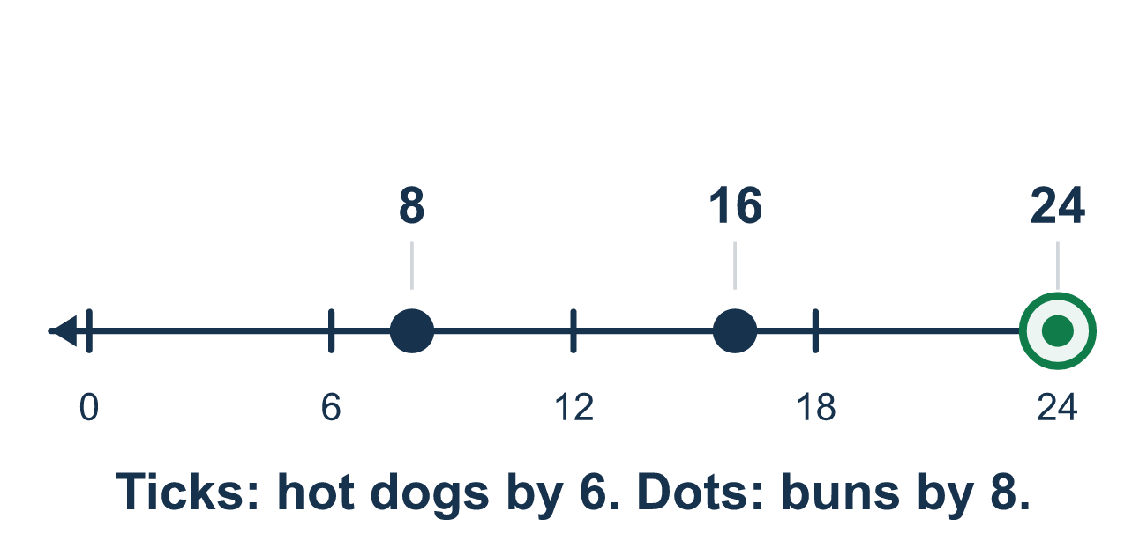
Our class model: the matching-packs LCM

Try it
Work it out on paper. Write one answer on each line.
- Which phrase in a buying problem tells you to find the LCM?
A. the same number of each, none left over B. the biggest number that divides both C. add the two pack sizes D. split into equal groups
My answer
- Stickers come in packs of 3 and cards come in packs of 5. What is the smallest number of each you can have so the counts match?
A. 15 B. 8 C. 30 D. 1
My answer
- Juice boxes come in packs of 6 and straws come in packs of 8. The LCM is 24. How many packs of straws give 24 straws?
A. 4 B. 3 C. 24
My answer
- Find the LCM of 8 and 12.
A. 96 B. 4 C. 48 D. 24
My answer
- Pens come in packs of 6 and caps come in packs of 15. The LCM is 30. How many packs do you buy in all (pens and caps together)?
A. 5 B. 30 C. 7
My answer

Talk about it
What is the smallest number where both packs come out even? How many packs of each is that?

Home mission
Line up cups in groups of 6 on one side and spoons in groups of 8 on the other. Keep adding groups until the totals match. Which total do you reach?

If we get stuck, ask
- What numbers can you reach counting by each pack size?
- What is the first number both can reach?
- Is that the number of items, or the number of packs?

Do it on a screen

Scan or type the link. Same lesson, with hints. eduwonderlab.com/lessons/6-12-part2/homework.html
How did it feel? (optional) ☐ Tricky ☐ Getting there ☐ Got it

Family Math Studio · For grown-ups Lesson 6.12 · Session 2 · 6.NOS.4

Answers and talk notes
Least Common Multiple

What your student is learning
Tonight we use the least common multiple to solve a real buying problem — the same number of two things, with none left over.

Answers
Ask your student to explain before you look.
- A. the same number of each, none left over. Look for the same number of each, none left over: it means finding a number both pack sizes reach, the LCM.
- A. 15. Multiples of 5: 5, 10, 15. Multiples of 3: 3, 6, 9, 12, 15. The first match is 15.
- B. 3. 24 ÷ 8 = 3 packs of straws.
- D. 24. Multiples of 12: 12, 24. Multiples of 8: 8, 16, 24. The first match is 24.
- C. 7. 30 ÷ 6 = 5 packs of pens and 30 ÷ 15 = 2 packs of caps, so 5 + 2 = 7 packs.

Talk about it
What is the smallest number where both packs come out even? How many packs of each is that?

When they are stuck, ask
- What numbers can you reach counting by each pack size?
- What is the first number both can reach?
- Is that the number of items, or the number of packs?

Try not to say
- Multiply the pack sizes, that is always the LCM.
- Buy the bigger number, extras do not hurt.
- The LCM is the number of packs to buy.

Home mission
Line up cups in groups of 6 on one side and spoons in groups of 8 on the other. Keep adding groups until the totals match. Which total do you reach?

