Family Math Studio Lesson 6.12 · 6.NOS.4

Least Common Multiple
Find the least common multiple: the smallest number that two numbers both go into.
Name Date

Tonight's spark
The rec center has swim class every 4 days and art club every 6 days. Both are today. When will both fall on the same day again? Guess first: will it happen before day 10, or after?
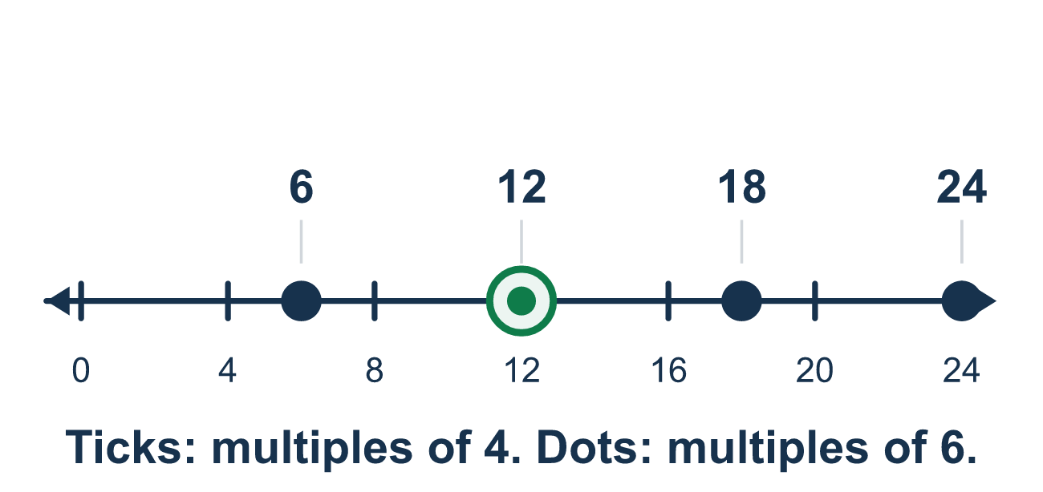
Our class model: two skip-count lists

Try it
Work it out on paper. Write one answer on each line.
- Which list shows the first four multiples of 6?
A. 1, 2, 3, 6 B. 6, 12, 18, 24 C. 12, 18, 24, 30
My answer
- Which number is a common multiple of 3 and 4?
A. 12 B. 9 C. 7 D. 2
My answer
- What is the LCM of 2 and 5?
A. 7 B. 20 C. 1 D. 10
My answer
- What is the LCM of 6 and 9?
A. 54 B. 3 C. 18 D. 36
My answer
- What is the LCM of 4 and 12?
A. 48 B. 12 C. 4 D. 24
My answer
- One bus returns to the station every 6 minutes and another every 8 minutes. They are both there now. In how many minutes will they next be there together?
A. 24 B. 48 C. 14 D. 2
My answer

Talk about it
Is there a smaller number that both 4 and 6 go into?

Home mission
Count by 4s out loud while your student counts by 6s. Stop at the first number you both say. Which number is it?

If we get stuck, ask
- Let's count by each number out loud and write the lists down.
- What is the first number that shows up in both lists?
- Does each number divide evenly into your answer? Let's check.

Do it on a screen

Scan or type the link. Same lesson, with hints. eduwonderlab.com/lessons/6-12/homework.html
How did it feel? (optional) ☐ Tricky ☐ Getting there ☐ Got it

Family Math Studio · For grown-ups Lesson 6.12 · 6.NOS.4

Answers and talk notes
Least Common Multiple

What your student is learning
Tonight we find the least common multiple (LCM) of two numbers. It is the smallest number that both numbers go into.

Answers
Ask your student to explain before you look.
- B. 6, 12, 18, 24. Count by 6s: 6, 12, 18, 24.
- A. 12. 12 is in the list of 3s (3, 6, 9, 12) and in the list of 4s (4, 8, 12).
- D. 10. Multiples of 5: 5, 10. Multiples of 2: 2, 4, 6, 8, 10. The first match is 10.
- C. 18. Multiples of 9: 9, 18. Multiples of 6: 6, 12, 18. The first match is 18.
- B. 12. 12 is already a multiple of 4 (4 × 3), so the LCM is 12.
- A. 24. Multiples of 6: 6, 12, 18, 24. Multiples of 8: 8, 16, 24. They next meet at 24 minutes.

Talk about it
Is there a smaller number that both 4 and 6 go into?

When they are stuck, ask
- Let's count by each number out loud and write the lists down.
- What is the first number that shows up in both lists?
- Does each number divide evenly into your answer? Let's check.

Try not to say
- Just add the two numbers to get the LCM.
- The LCM is just the bigger of the two numbers.
- Any common multiple, like 24, is the answer.

Home mission
Count by 4s out loud while your student counts by 6s. Stop at the first number you both say. Which number is it?

