Family Math Studio Lesson 6.13 · Session 2 · 6.NOS.4

Prime Factorization
Keep splitting a factor tree until every branch is prime.
Name Date

Tonight's spark
A locker tag says 84. Maya splits it into 4 × 21 and says her tree is finished. Her friend says a piece can still split. Who is right? Guess first: is the 4 already prime, or can it split again?
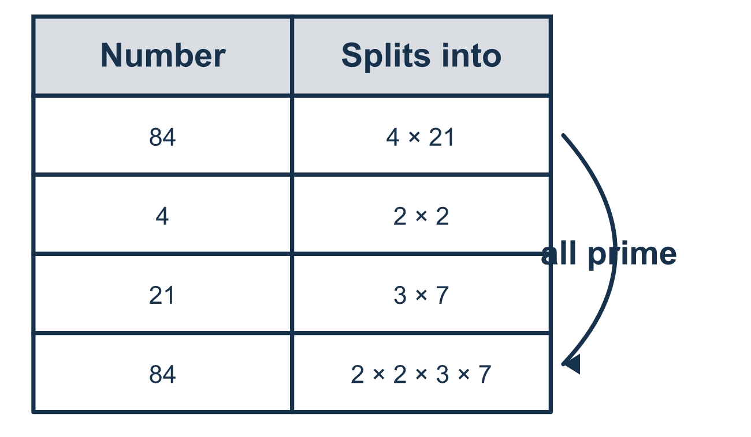
Our class model: the all-primes check

Try it
Work it out on paper. Write one answer on each line.
- Which numbers at the bottom of a factor tree mean the tree is finished?
A. 2, 2, 3, 5 B. 2, 4, 5 C. 3, 6, 5
My answer
- Which number is composite (not prime)?
A. 2 B. 7 C. 9 D. 11
My answer
- Complete: 50 = 2 × 5 × ___
A. 5 B. 10 C. 25 D. 2
My answer
- Maya starts a tree for 48 with 6 × 8. Which numbers must she split further?
A. Only 6 B. Only 8 C. Neither, because the tree is finished D. Both 6 and 8
My answer
- Which shows 63 written with prime factors only?
A. 7 × 9 B. 3 × 21 C. 3 × 3 × 7 D. 1 × 63
My answer

Talk about it
Is every number at the bottom of the tree prime? How can you tell your tree is finished?

Home mission
Write 84 on paper. Ask your student to start with 2 × 42 instead of 4 × 21. Do both trees end in the same primes?

If we get stuck, ask
- Is every number at the bottom of the tree prime?
- Can this number be split into smaller factors?
- Do your primes multiply back to the number you started with?

Do it on a screen

Scan or type the link. Same lesson, with hints. eduwonderlab.com/lessons/6-13-part2/homework.html
How did it feel? (optional) ☐ Tricky ☐ Getting there ☐ Got it

Family Math Studio · For grown-ups Lesson 6.13 · Session 2 · 6.NOS.4

Answers and talk notes
Prime Factorization

What your student is learning
Tonight we build a factor tree all the way down to primes — and learn to tell when the tree is actually finished.

Answers
Ask your student to explain before you look.
- A. 2, 2, 3, 5. The ends 2, 2, 3, 5 are all prime, so nothing can be split further: the tree is finished.
- C. 9. 9 = 3 × 3, so it has more than two factors and is composite.
- A. 5. 2 × 5 = 10 and 50 ÷ 10 = 5, so 50 = 2 × 5 × 5.
- D. Both 6 and 8. Both 6 and 8 are composite: 6 = 2 × 3 and 8 = 2 × 4, and 4 still needs splitting.
- C. 3 × 3 × 7. 63 = 7 × 9 and 9 = 3 × 3, so 63 = 3 × 3 × 7.

Talk about it
Is every number at the bottom of the tree prime? How can you tell your tree is finished?

When they are stuck, ask
- Is every number at the bottom of the tree prime?
- Can this number be split into smaller factors?
- Do your primes multiply back to the number you started with?

Try not to say
- Stop as soon as you have two factors.
- 1 counts as a prime factor.
- You have to start with the smallest factor or it will not work.

Home mission
Write 84 on paper. Ask your student to start with 2 × 42 instead of 4 × 21. Do both trees end in the same primes?

