Family Math Studio Lesson 6.13 · 6.NOS.4

Prime Factorization
Break a number into prime factors with a factor tree.
Name Date

Tonight's spark
Two friends break 60 into smaller numbers. Ana starts with 6 × 10. Ben starts with 4 × 15. Each keeps splitting until no piece can split. Will their last pieces match? Guess first: will Ana and Ben end with the same pieces?
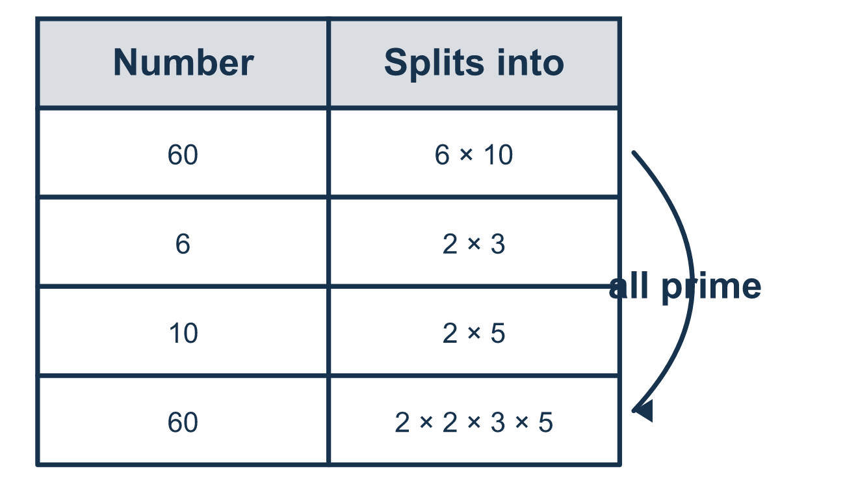
Our class model: the factor tree

Try it
Work it out on paper. Write one answer on each line.
- Which number is prime?
A. 9 B. 13 C. 15 D. 21
My answer
- Which shows 18 as a product of prime factors only?
A. 3 × 6 B. 2 × 9 C. 2 × 3 × 3 D. 1 × 18
My answer
- Complete: 30 = 2 × 3 × ___
A. 5 B. 10 C. 15 D. 6
My answer
- Write 2 × 2 × 2 × 5 with a raised number showing the repeated factor.
A. 3² × 5 B. 2 × 3 × 5 C. 2⁵ D. 2³ × 5
My answer
- Which is the prime factorization of 36?
A. 4 × 9 B. 2² × 3² C. 6² D. 2 × 18
My answer
- Which number has the prime factorization 2 × 3 × 7?
A. 12 B. 21 C. 42 D. 14
My answer

Talk about it
Are 6 and 10 prime numbers, or can they still split?

Home mission
Write 60 on paper. Ask your student to split it a different way than class, like 4 × 15. Does the tree still end in 2, 2, 3 and 5?

If we get stuck, ask
- Is this number prime, or can we still split it into two smaller numbers?
- What two numbers multiply together to make this one?
- Let's multiply our prime pieces back together. Do we get the start number?

Do it on a screen

Scan or type the link. Same lesson, with hints. eduwonderlab.com/lessons/6-13/homework.html
How did it feel? (optional) ☐ Tricky ☐ Getting there ☐ Got it

Family Math Studio · For grown-ups Lesson 6.13 · 6.NOS.4

Answers and talk notes
Prime Factorization

What your student is learning
Tonight we break a number down into the smaller numbers that multiply to make it. We keep splitting until every piece is a prime number.

Answers
Ask your student to explain before you look.
- B. 13. 13 can only be divided by 1 and 13, so it is prime.
- C. 2 × 3 × 3. 18 = 2 × 9 and 9 = 3 × 3, so 18 = 2 × 3 × 3.
- A. 5. 2 × 3 = 6 and 30 ÷ 6 = 5, so 30 = 2 × 3 × 5.
- D. 2³ × 5. There are three 2s, so 2 × 2 × 2 = 2³, and the product is 2³ × 5.
- B. 2² × 3². 36 = 4 × 9 = (2 × 2) × (3 × 3) = 2² × 3².
- C. 42. 2 × 3 = 6 and 6 × 7 = 42.

Talk about it
Are 6 and 10 prime numbers, or can they still split?

When they are stuck, ask
- Is this number prime, or can we still split it into two smaller numbers?
- What two numbers multiply together to make this one?
- Let's multiply our prime pieces back together. Do we get the start number?

Try not to say
- Just stop at 6 × 10; that is the answer.
- 4 is prime, so leave it.
- 1 counts as one of the prime factors.

Home mission
Write 60 on paper. Ask your student to split it a different way than class, like 4 × 15. Does the tree still end in 2, 2, 3 and 5?

