Family Math Studio Lesson 6.14 · Session 2 · 6.AT.7

The Distributive Property
Show that the factored and expanded forms are equal when you total identical kits.
Name Date

Tonight's spark
Seven band-camp rooms each need an $11 music stand and a $6 tuner. The teacher finds the total two ways. One starts with one room. The other starts with all the stands. Will they match? Guess first: is the total more or less than $100?
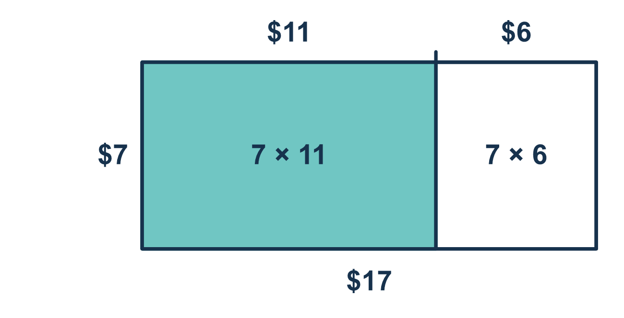
Our class model: two ways, same total

Try it
Work it out on paper. Write one answer on each line.
- Each kit has a $4 stand and a $2 clip. Which expression gives the cost of 3 kits?
A. 3(4 + 2) B. 3 × 4 + 2 C. 3 + 4 + 2 D. 3(4 × 2)
My answer
- What is 5(6 + 3)?
A. 33 B. 14 C. 45 D. 90
My answer
- Which expression is equal to 7 × 4 + 7 × 5?
A. 7(4 + 5) B. 7(4 × 5) C. (7 + 7)(4 + 5) D. 7 + (4 + 5)
My answer
- Expand 8(a + 2).
A. 8a + 2 B. 10a C. a + 16 D. 8a + 16
My answer
- 6 bags each get a $4 notebook and a $3 pen. What is the total cost?
A. $27 B. $42 C. $13
My answer

Talk about it
Do both ways give the same total? Which way was easier for you, and why?

Home mission
A different situation: pretend you buy 5 snack packs. Each pack has a $3 box of crackers and a $2 juice. Say the cost two ways out loud. Try 5(3 + 2) and 5 × 3 + 5 × 2. Which way is easier in your head?

If we get stuck, ask
- Did the outside number reach both things inside?
- What does one kit cost? Now how many kits?
- Can you get the same total the other way?

Do it on a screen

Scan or type the link. Same lesson, with hints. eduwonderlab.com/lessons/6-14-part2/homework.html
How did it feel? (optional) ☐ Tricky ☐ Getting there ☐ Got it

Family Math Studio · For grown-ups Lesson 6.14 · Session 2 · 6.AT.7

Answers and talk notes
The Distributive Property

What your student is learning
Tonight we use the distributive property on a real shopping problem — and show that the factored and expanded forms give the same total.

Answers
Ask your student to explain before you look.
- A. 3(4 + 2). One kit costs 4 + 2, so 3 kits cost 3(4 + 2).
- C. 45. 6 + 3 = 9 and 5 × 9 = 45. Also 5 × 6 + 5 × 3 = 30 + 15 = 45.
- A. 7(4 + 5). Both terms have a factor of 7, so pull it out: 7(4 + 5).
- D. 8a + 16. 8 × a = 8a and 8 × 2 = 16, so 8a + 16.
- B. $42. One bag costs 4 + 3 = $7, and 6 × 7 = $42. Also 6 × 4 + 6 × 3 = 24 + 18 = $42.

Talk about it
Do both ways give the same total? Which way was easier for you, and why?

When they are stuck, ask
- Did the outside number reach both things inside?
- What does one kit cost? Now how many kits?
- Can you get the same total the other way?

Try not to say
- Multiply the outside number by the first price only.
- The two methods give different answers.
- You only need one method, skip the check.

Home mission
A different situation: pretend you buy 5 snack packs. Each pack has a $3 box of crackers and a $2 juice. Say the cost two ways out loud. Try 5(3 + 2) and 5 × 3 + 5 × 2. Which way is easier in your head?

