Family Math Studio Lesson 6.14 · 6.AT.7

The Distributive Property
Multiply a number by every term inside parentheses to write an equal expression.
Name Date

Tonight's spark
A concert bundle is a $15 ticket plus a $5 snack. Three friends each buy one. Ana adds 15 + 5, then multiplies by 3. Ben does 3 × 15 and 3 × 5, then adds. Whose total is right? Guess first: more or less than $50? Will Ana and Ben agree?
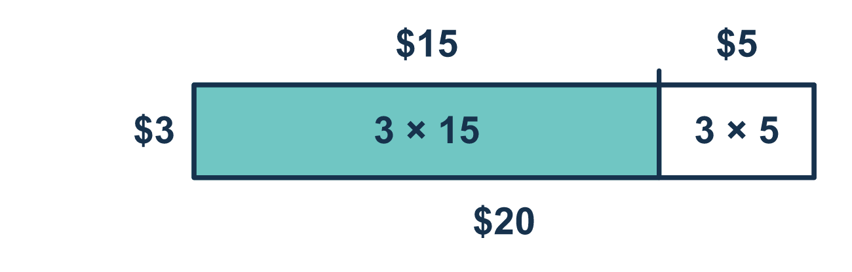
Our class model: share the outside number

Try it
Work it out on paper. Write one answer on each line.
- What is 4(3 + 2)? Add inside the parentheses first.
A. 14 B. 20 C. 9 D. 24
My answer
- Which expression is equal to 5(6 + 4)?
A. 5 × 6 + 4 B. 5 + 6 × 4 C. 6 + 5 × 4 D. 5 × 6 + 5 × 4
My answer
- Expand 6(n + 2).
A. 6n + 12 B. 6n + 2 C. n + 12 D. 8n
My answer
- Expand 3(x − 5).
A. 3x − 5 B. 3x + 15 C. 3x − 15 D. x − 15
My answer
- A rectangle is 4 units tall. Its width is split into a part 7 units wide and a part 2 units wide. What is the total area?
A. 30 square units B. 36 square units C. 13 square units
My answer
- Complete: 12 + 20 = 4(3 + ___)
A. 20 B. 8 C. 16 D. 5
My answer

Talk about it
What does the 3 count in this problem?

Home mission
Pretend you are buying 3 concert bundles: a $15 ticket and a $5 snack each. Can your student say the total two ways out loud? Then pick two prices on a receipt and try 2 bundles.

If we get stuck, ask
- Did the outside number reach both parts inside the parentheses?
- Let's draw an arrow from the outside number to each part.
- Let's try adding inside first and check if we get the same answer.

Do it on a screen

Scan or type the link. Same lesson, with hints. eduwonderlab.com/lessons/6-14/homework.html
How did it feel? (optional) ☐ Tricky ☐ Getting there ☐ Got it

Family Math Studio · For grown-ups Lesson 6.14 · 6.AT.7

Answers and talk notes
The Distributive Property

What your student is learning
Tonight we learn the distributive property. It lets us multiply a number by everything inside the parentheses, one piece at a time.

Answers
Ask your student to explain before you look.
- B. 20. 3 + 2 = 5, and 4 × 5 = 20.
- D. 5 × 6 + 5 × 4. The distributive property shares the 5 with each term: 5 × 6 + 5 × 4.
- A. 6n + 12. Multiply 6 by each term: 6 × n = 6n and 6 × 2 = 12, so 6n + 12.
- C. 3x − 15. 3 × x = 3x and 3 × 5 = 15, and the sign stays a minus: 3x − 15.
- B. 36 square units. 4 × 7 + 4 × 2 = 28 + 8 = 36 square units.
- D. 5. 20 ÷ 4 = 5, and 4 × 3 = 12, so 12 + 20 = 4(3 + 5).

Talk about it
What does the 3 count in this problem?

When they are stuck, ask
- Did the outside number reach both parts inside the parentheses?
- Let's draw an arrow from the outside number to each part.
- Let's try adding inside first and check if we get the same answer.

Try not to say
- Just multiply the outside number by the first part.
- 3(x + 4) is the same as 3x + 4.
- The number outside only goes with the variable.

Home mission
Pretend you are buying 3 concert bundles: a $15 ticket and a $5 snack each. Can your student say the total two ways out loud? Then pick two prices on a receipt and try 2 bundles.

