Family Math Studio Lesson 6.15 · Session 2 · 6.AT.7

Simplify Algebraic Expressions
Combine like terms, then find the value of the expression.
Name Date

Tonight's spark
A team orders 5 shirts and a $7 banner. Later it orders 3 more shirts and a $2 sticker sheet. Each shirt costs $4. What is the total bill? Guess first: is the total more than $40, or less?
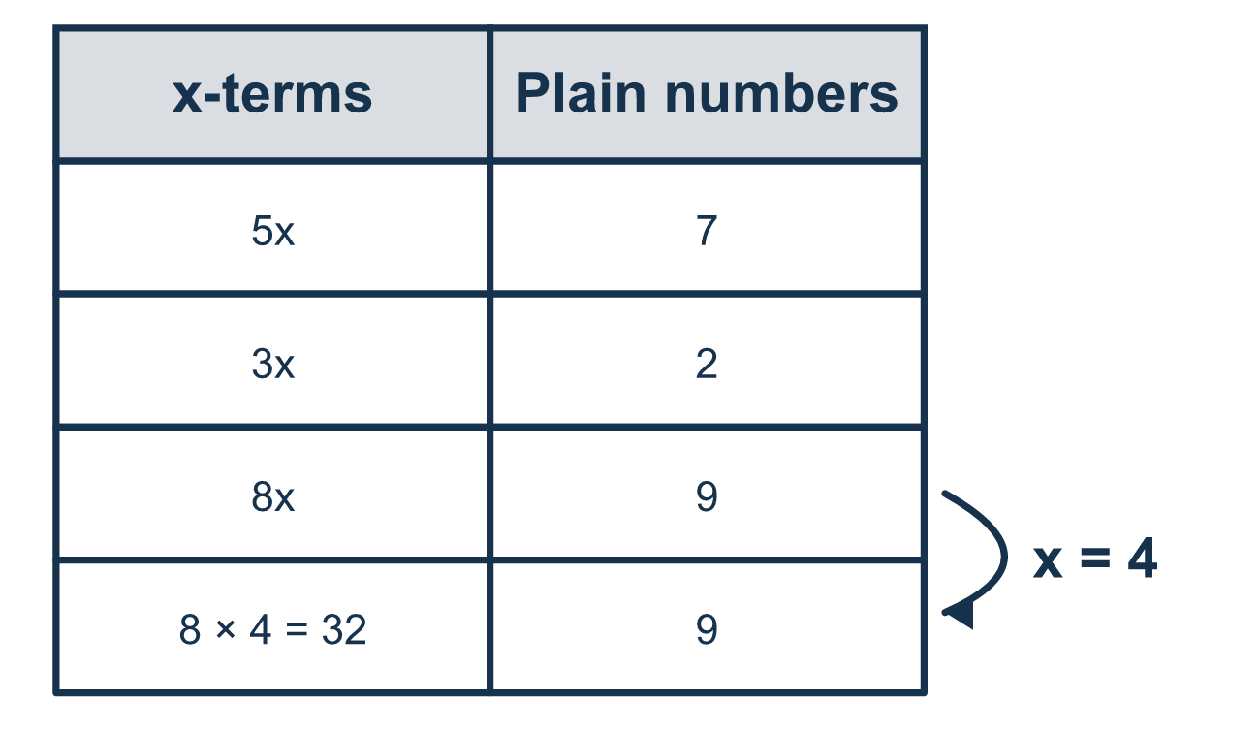
Our class model: combine first, then evaluate

Try it
Work it out on paper. Write one answer on each line.
- Which term can be combined with 6n?
A. 2n B. 2 C. 2m D. 6
My answer
- Simplify 4w + w.
A. 4w B. 5w C. 4
My answer
- Simplify 6c + 3 + 2c + 4.
A. 15c B. 8c + 7 C. 8c + 3
My answer
- What is the value of 5x + 3 when x = 4?
A. 20 B. 35 C. 12 D. 23
My answer
- What is the value of 3z + 2 + z + 4 when z = 2?
A. 12 B. 14 C. 20
My answer
- Which expression is already fully simplified?
A. 4x + 3x B. 6 + 1 + 2y C. 7x + 3
My answer

Talk about it
Which terms are alike? Do the long and the short expression give the same number when x is replaced?

Home mission
Pick x = 4 for the price of one shirt. Ask your student to find 5x + 7 + 3x + 2 two ways: simplify first, or put in 4 first. Do the answers match?

If we get stuck, ask
- Which terms have the same letter part?
- Does this number have a variable attached to it?
- Does the original expression give the same value as the simplified one?

Do it on a screen

Scan or type the link. Same lesson, with hints. eduwonderlab.com/lessons/6-15-part2/homework.html
How did it feel? (optional) ☐ Tricky ☐ Getting there ☐ Got it

Family Math Studio · For grown-ups Lesson 6.15 · Session 2 · 6.AT.7

Answers and talk notes
Simplify Algebraic Expressions

What your student is learning
Tonight we simplify an expression by combining like terms, then evaluate the simplified version for a given number.

Answers
Ask your student to explain before you look.
- A. 2n. 2n has the same variable as 6n, so 6n + 2n = 8n.
- B. 5w. w means 1w, so 4w + 1w = 5w.
- B. 8c + 7. 6c + 2c = 8c and 3 + 4 = 7, so 8c + 7.
- D. 23. 5 × 4 = 20, and 20 + 3 = 23.
- B. 14. Simplify to 4z + 6. When z = 2, 4 × 2 + 6 = 14.
- C. 7x + 3. 7x + 3 has one x term and one plain number, so nothing more can combine.

Talk about it
Which terms are alike? Do the long and the short expression give the same number when x is replaced?

When they are stuck, ask
- Which terms have the same letter part?
- Does this number have a variable attached to it?
- Does the original expression give the same value as the simplified one?

Try not to say
- Add all the numbers together, that is simplifying.
- 3x + 2x is 5x squared.
- The plain number can join the x-term if it is close by.

Home mission
Pick x = 4 for the price of one shirt. Ask your student to find 5x + 7 + 3x + 2 two ways: simplify first, or put in 4 first. Do the answers match?

