Family Math Studio Lesson 6.15 · 6.AT.7

Simplify Algebraic Expressions
Make an expression shorter by combining like terms.
Name Date

Tonight's spark
The music room needs 4 microphones and 3 stands. The gym needs 2 microphones and 5 stands. The hall needs 6 microphones and 1 stand. How many of each in all? Guess first: do the rooms need more microphones or more stands?
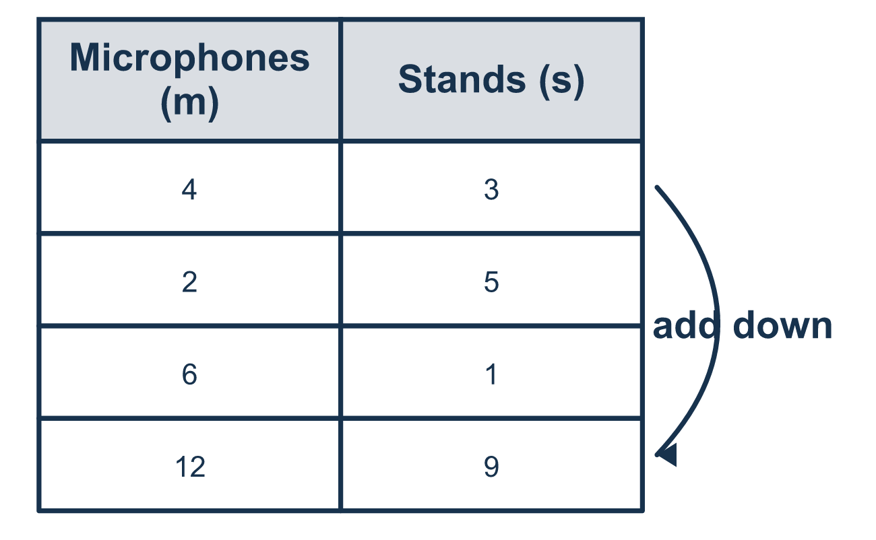
Our class model: adding like items

Try it
Work it out on paper. Write one answer on each line.
- Which two terms are like terms?
A. 4x and 9 B. 4x and 9x C. 4x and 9y D. x and y
My answer
- Simplify 5a + 2a.
A. 10a B. 7 C. 7a
My answer
- What is the coefficient of m in 6m + 4?
A. 6 B. 4 C. m D. 10
My answer
- Simplify 3x + 4 + 2x + 1.
A. 10x B. 5x + 4 C. 5x + 5
My answer
- Simplify 9y − 4y + 3.
A. 13y + 3 B. 8y C. 5y − 3 D. 5y + 3
My answer
- A cart has 3 apples (a) and 4 pears (p). Then 5 more apples and 2 more pears are added. Which expression shows the whole cart?
A. 14ap B. 8a + 6p C. 8a + 6
My answer

Talk about it
Does a microphone count the same thing as a stand?

Home mission
Use spoons for microphones and forks for stands. Make piles of 4 spoons and 3 forks, 2 and 5, and 6 and 1. How many spoons and forks in all?

If we get stuck, ask
- Which terms have the same variable and exponent? Only those can be combined.
- When we combine, we add the numbers in front and keep the letter the same.
- Does this number have a letter? If not, it stays on its own.

Do it on a screen

Scan or type the link. Same lesson, with hints. eduwonderlab.com/lessons/6-15/homework.html
How did it feel? (optional) ☐ Tricky ☐ Getting there ☐ Got it

Family Math Studio · For grown-ups Lesson 6.15 · 6.AT.7

Answers and talk notes
Simplify Algebraic Expressions

What your student is learning
Tonight we make an expression shorter by combining like terms. Like terms are terms that have the same variable and exponent.

Answers
Ask your student to explain before you look.
- B. 4x and 9x. 4x and 9x both have the variable x, so they are like terms.
- C. 7a. 5 + 2 = 7, and the variable stays, so 7a.
- A. 6. The coefficient of m is the number multiplying it, which is 6.
- C. 5x + 5. 3x + 2x = 5x and 4 + 1 = 5, so 5x + 5.
- D. 5y + 3. 9y − 4y = 5y, and the plain 3 stays, so 5y + 3.
- B. 8a + 6p. Apples: 3a + 5a = 8a. Pears: 4p + 2p = 6p. Together: 8a + 6p.

Talk about it
Does a microphone count the same thing as a stand?

When they are stuck, ask
- Which terms have the same variable and exponent? Only those can be combined.
- When we combine, we add the numbers in front and keep the letter the same.
- Does this number have a letter? If not, it stays on its own.

Try not to say
- Just add every number you see together.
- 3x + 5 combines into 8x.
- When you add 4x + 3x you get 7x² (change the little number).

Home mission
Use spoons for microphones and forks for stands. Make piles of 4 spoons and 3 forks, 2 and 5, and 6 and 1. How many spoons and forks in all?

