Family Math Studio Lesson 6.2 · Session 2 · 6.NOS.1

Division Expressions with Fractions and Mixed Numbers
Divide one mixed number by another by changing both to fractions first.
Name Date

Tonight's spark
A gift shop has a ribbon that is 6 3/4 meters long. Each bow uses 2 1/4 meters. How many bows can the shop make? Make a guess first: more than 2 bows, or fewer?
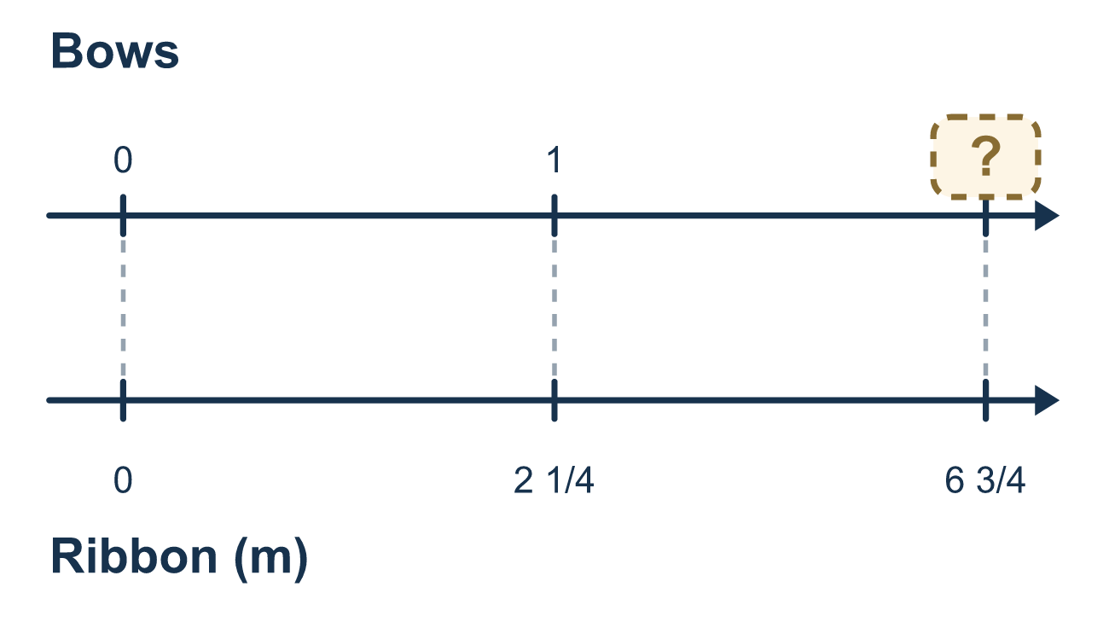
Our class model: both to improper fractions

Try it
Work it out on paper. Write one answer on each line.
- Write 6 2/5 as an improper fraction.
A. 12/5 B. 32/5 C. 8/5 D. 62/5
My answer
- Write 3 3/4 as an improper fraction.
A. 6/4 B. 9/4 C. 33/4 D. 15/4
My answer
- To work out 5 1/2 ÷ 1 1/4, what should you do first?
A. Write each mixed number as an improper fraction B. Flip 1 1/4 and leave 5 1/2 as it is C. Subtract the whole numbers D. Divide 5 by 1 and 1/2 by 1/4
My answer
- What is 7/2 ÷ 7/4?
A. 1/2 B. 49/8 C. 2
My answer
- What is 1 1/2 ÷ 2 1/4?
A. 27/8 B. 2/3 C. 3/2
My answer

Talk about it
What are your two improper fractions, and how many pieces fit?

Home mission
Grab any string or ribbon and pretend it is 6 3/4 meters long, with 2 1/4 meters for each bow. Ask: about how many bows? Then count in quarters: how many quarters are in each length?

If we get stuck, ask
- Is every number a fraction yet?
- Which fraction gets flipped — the first or the second?
- How many groups of that size fit inside the total?

Do it on a screen

Scan or type the link. Same lesson, with hints. eduwonderlab.com/lessons/6-2-part2/homework.html
How did it feel? (optional) ☐ Tricky ☐ Getting there ☐ Got it

Family Math Studio · For grown-ups Lesson 6.2 · Session 2 · 6.NOS.1

Answers and talk notes
Division Expressions with Fractions and Mixed Numbers

What your student is learning
Tonight we divide mixed numbers — and the whole trick is turning them into improper fractions BEFORE anything else.

Answers
Ask your student to explain before you look.
- B. 32/5. 6 2/5 = 32/5, because 6 × 5 = 30 and 30 + 2 = 32 fifths.
- D. 15/4. 3 3/4 = 15/4, because 3 × 4 = 12 and 12 + 3 = 15 fourths.
- A. Write each mixed number as an improper fraction. Write each mixed number as an improper fraction first. Only then can you use Keep, Change, Flip.
- C. 2. 7/2 ÷ 7/4 = 7/2 × 4/7 = 28/14 = 2.
- B. 2/3. 1 1/2 = 3/2 and 2 1/4 = 9/4, so 3/2 × 4/9 = 12/18 = 2/3.

Talk about it
What are your two improper fractions, and how many pieces fit?

When they are stuck, ask
- Is every number a fraction yet?
- Which fraction gets flipped — the first or the second?
- How many groups of that size fit inside the total?

Try not to say
- Divide the whole numbers, then divide the fractions.
- Flip both fractions to be safe.
- Leave it as a mixed number, it is easier to read.

Home mission
Grab any string or ribbon and pretend it is 6 3/4 meters long, with 2 1/4 meters for each bow. Ask: about how many bows? Then count in quarters: how many quarters are in each length?

