Family Math Studio Lesson 6.2 · 6.NOS.1

Division Expressions with Fractions and Mixed Numbers
Divide a fraction or mixed number by a fraction and say what the answer means.
Name Date

Tonight's spark
Your family has 2 1/2 cups of rice for dinner. The serving scoop holds 1/2 cup. How many scoops of rice is that? Make a guess first: more than 2 scoops, or fewer?
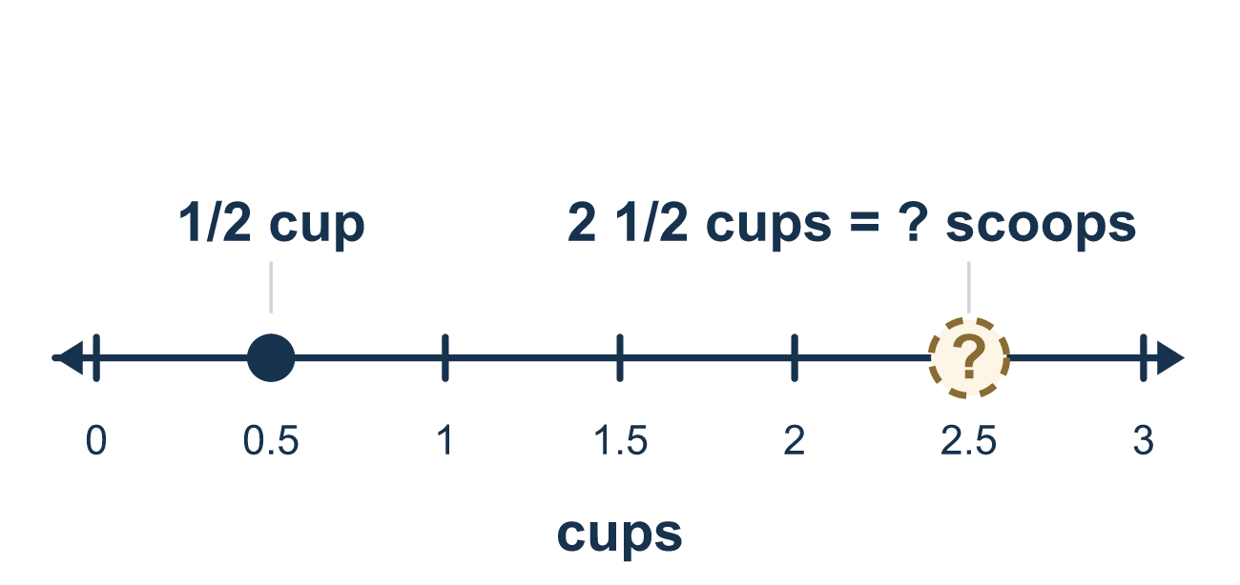
Our class model: one fraction first

Try it
Work it out on paper. Write one answer on each line.
- What is 1/2 ÷ 1/8?
A. 1/16 B. 1/4 C. 8 D. 4
My answer
- To compute 2/3 ÷ 5/7, change ÷ to × and flip 5/7. Complete: 2/3 × ?
A. 7/5 B. 5/7 C. 3/2 D. 14/15
My answer
- Use common denominators: 2/3 = 4/6. What is 2/3 ÷ 1/6?
A. 1/4 B. 6 C. 4 D. 4/6
My answer
- What is 5/6 ÷ 5/12?
A. 25/72 B. 2 C. 1/2 D. 1
My answer
- What is 3 1/3 ÷ 5/6?
A. 25/9 B. 8/5 C. 1/4 D. 4
My answer
- A ribbon is 2 1/4 yards long. Each piece is 3/4 yard. How many pieces can be cut?
A. 3 B. 27/16 C. 1/3 D. 1 1/2
My answer

Talk about it
Which number are we dividing BY: the rice or the scoop?

Home mission
Use any 1/2-cup scoop and a bowl. Pretend the bowl holds 2 1/2 cups of rice. Ask your student: how many scoops? Listen for "two and a half cups is five halves."

If we get stuck, ask
- What do we do first when we see a mixed number like 2 1/2?
- Which fraction gets flipped — the first one or the second one?
- After we multiply, can we make the answer smaller? Let's simplify.

Do it on a screen

Scan or type the link. Same lesson, with hints. eduwonderlab.com/lessons/6-2/homework.html
How did it feel? (optional) ☐ Tricky ☐ Getting there ☐ Got it

Family Math Studio · For grown-ups Lesson 6.2 · 6.NOS.1

Answers and talk notes
Division Expressions with Fractions and Mixed Numbers

What your student is learning
Tonight we divide with mixed numbers like 2 1/2. The trick: turn the mixed number into one simple fraction first, then divide the same way as always.

Answers
Ask your student to explain before you look.
- D. 4. 1/2 = 4/8, so 1/2 ÷ 1/8 = 4. Four eighths fit in one half.
- A. 7/5. 2/3 ÷ 5/7 = 2/3 × 7/5. Flip the divisor, 5/7, to 7/5.
- C. 4. 4 sixths ÷ 1 sixth = 4, so 2/3 ÷ 1/6 = 4.
- B. 2. 5/6 ÷ 5/12 = 5/6 × 12/5 = 60/30 = 2.
- D. 4. 3 1/3 = 10/3, so 10/3 ÷ 5/6 = 10/3 × 6/5 = 60/15 = 4.
- A. 3. 2 1/4 = 9/4, so 9/4 ÷ 3/4 = 9/4 × 4/3 = 36/12 = 3 pieces.

Talk about it
Which number are we dividing BY: the rice or the scoop?

When they are stuck, ask
- What do we do first when we see a mixed number like 2 1/2?
- Which fraction gets flipped — the first one or the second one?
- After we multiply, can we make the answer smaller? Let's simplify.

Try not to say
- Flip the mixed number without making it one fraction first.
- Flip the first fraction instead of the second.
- Just divide the tops and the bottoms straight across.

Home mission
Use any 1/2-cup scoop and a bowl. Pretend the bowl holds 2 1/2 cups of rice. Ask your student: how many scoops? Listen for "two and a half cups is five halves."

