Family Math Studio Lesson 6.3 · Session 2 · 6.AT.5

Explore Numerical Expressions with Exponents
Write a power as repeated multiplication and find its value.
Name Date

Tonight's spark
A school phone tree starts when you text 3 friends. Then each new person texts 3 more friends. In round 4, how many people get the text? Make a guess first: more than 50 people, or fewer?
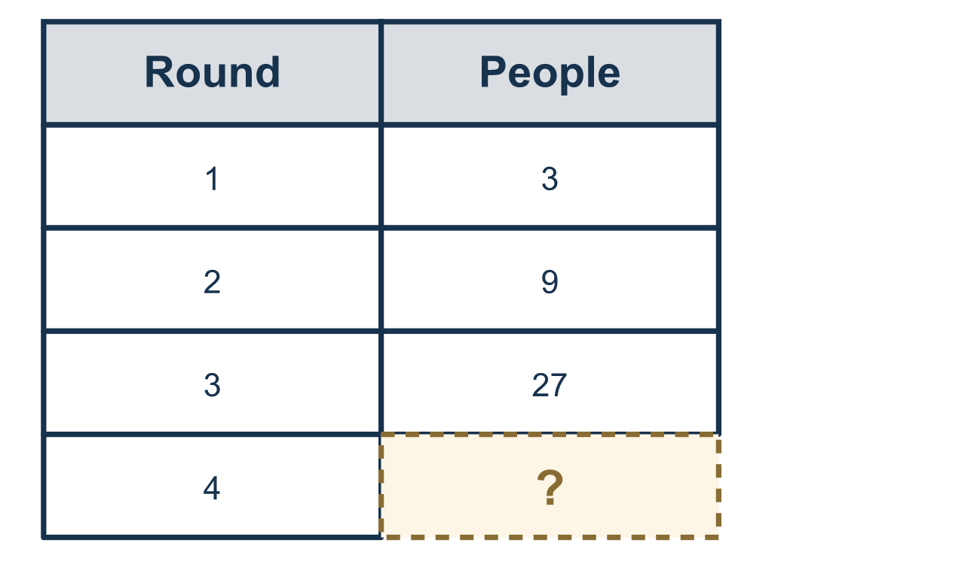
Our class model: write it out as copies

Try it
Work it out on paper. Write one answer on each line.
- How many factors of 8 are multiplied in 8⁵?
A. 8 B. 5 C. 40 D. 13
My answer
- What is the value of 2 × 2 × 2 × 2 × 2?
A. 32 B. 10 C. 25 D. 16
My answer
- What is the value of 5³?
A. 15 B. 53 C. 125 D. 25
My answer
- Which power has the greatest value?
A. 3² B. 2³ C. 1⁵ D. 2⁴
My answer
- What is the value of 7²?
A. 14 B. 49 C. 72 D. 9
My answer
- A scientist writes 10⁴ for the number of cells. How many cells is that?
A. 10,000 B. 40 C. 1,000 D. 100,000
My answer

Talk about it
How many copies of the base did you multiply, and how do you know from the exponent?

Home mission
Use coins or buttons. Put out 3 for round 1. For round 2, add 3 new ones for each one. Count. Then say the powers aloud: 3 to the 1st, 2nd, 3rd. Predict round 4 before you build it.

If we get stuck, ask
- Can you write this out as repeated multiplication first?
- How many copies of the base are there?
- Are we multiplying BY the small number, or multiplying copies together?

Do it on a screen

Scan or type the link. Same lesson, with hints. eduwonderlab.com/lessons/6-3-part2/homework.html
How did it feel? (optional) ☐ Tricky ☐ Getting there ☐ Got it

Family Math Studio · For grown-ups Lesson 6.3 · Session 2 · 6.AT.5

Answers and talk notes
Explore Numerical Expressions with Exponents

What your student is learning
Tonight we evaluate powers — writing them out as repeated multiplication and finding the value.

Answers
Ask your student to explain before you look.
- B. 5. In 8⁵ there are 5 factors of 8, because the exponent counts the copies of the base.
- A. 32. 2 × 2 × 2 × 2 × 2 = 2⁵ = 32. Doubling 5 times: 2, 4, 8, 16, 32.
- C. 125. 5³ = 5 × 5 × 5 = 25 × 5 = 125.
- D. 2⁴. 2⁴ = 16, which is greater than 3² = 9, 2³ = 8 and 1⁵ = 1.
- B. 49. 7² = 7 × 7 = 49.
- A. 10,000. 10⁴ = 10 × 10 × 10 × 10 = 10,000 cells.

Talk about it
How many copies of the base did you multiply, and how do you know from the exponent?

When they are stuck, ask
- Can you write this out as repeated multiplication first?
- How many copies of the base are there?
- Are we multiplying BY the small number, or multiplying copies together?

Try not to say
- Multiply the base by the exponent.
- Squared and times two are the same thing.
- Do it all in one step in your head.

Home mission
Use coins or buttons. Put out 3 for round 1. For round 2, add 3 new ones for each one. Count. Then say the powers aloud: 3 to the 1st, 2nd, 3rd. Predict round 4 before you build it.

