Family Math Studio Lesson 6.3 · 6.AT.5

Explore Numerical Expressions with Exponents
Write and find the value of a number with an exponent.
Name Date

Tonight's spark
A school music studio has a switch that doubles the sound each time you flip it. You flip it 3 times. How many times as loud is it now? Make a guess first: more than 6 times as loud, or fewer?
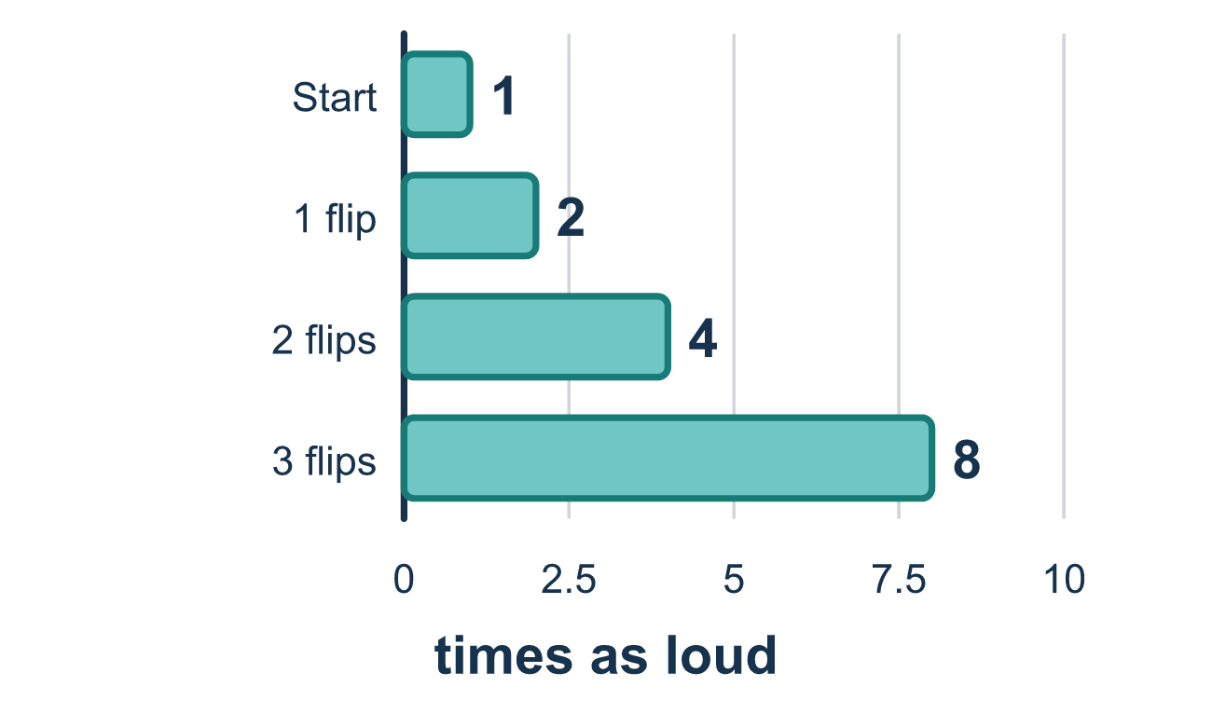
Our class model: repeated multiplication

Try it
Work it out on paper. Write one answer on each line.
- In the power 5⁴, which number is the base?
A. 4 B. 625 C. 5 D. 20
My answer
- Which is 7 × 7 × 7 written with an exponent?
A. 7³ B. 7 × 3 C. 3⁷ D. 21
My answer
- Write 2⁴ as repeated multiplication.
A. 2 × 4 B. 2 + 2 + 2 + 2 C. 4 × 4 D. 2 × 2 × 2 × 2
My answer
- What is the value of 4³?
A. 12 B. 64 C. 7 D. 43
My answer
- What is the value of 10³?
A. 30 B. 100 C. 1,000 D. 10,000
My answer

Talk about it
In 2³, what does the small 3 tell us? How many 2s are multiplied?

Home mission
Put 1 bean or coin on the table. Pretend a switch doubles the sound. Add beans until there are twice as many. Do it 3 times. Ask: how many now? Write the power with a 2.

If we get stuck, ask
- How many times does the small number tell us to write the base? Let's write that many.
- Which number is the base — the one we multiply again and again?
- Let's multiply just two numbers at a time and write each step.

Do it on a screen

Scan or type the link. Same lesson, with hints. eduwonderlab.com/lessons/6-3/homework.html
How did it feel? (optional) ☐ Tricky ☐ Getting there ☐ Got it

Family Math Studio · For grown-ups Lesson 6.3 · 6.AT.5

Answers and talk notes
Explore Numerical Expressions with Exponents

What your student is learning
Tonight we learn what an exponent means. A small raised number tells us how many times a number is used as a factor.

Answers
Ask your student to explain before you look.
- C. 5. In 5⁴ the base is 5. It is the number that gets multiplied, and the small 4 is the exponent.
- A. 7³. 7 × 7 × 7 = 7³. There are three factors of 7, so the exponent is 3.
- D. 2 × 2 × 2 × 2. 2⁴ = 2 × 2 × 2 × 2. The exponent 4 says to use four 2s as factors.
- B. 64. 4³ = 4 × 4 × 4 = 16 × 4 = 64.
- C. 1,000. 10³ = 10 × 10 × 10 = 1,000.

Talk about it
In 2³, what does the small 3 tell us? How many 2s are multiplied?

When they are stuck, ask
- How many times does the small number tell us to write the base? Let's write that many.
- Which number is the base — the one we multiply again and again?
- Let's multiply just two numbers at a time and write each step.

Try not to say
- 2³ means 2 times 3.
- Just add the base and the exponent.
- The little number gets multiplied by the big number.

Home mission
Put 1 bean or coin on the table. Pretend a switch doubles the sound. Add beans until there are twice as many. Do it 3 times. Ask: how many now? Write the power with a 2.

